Registration Form
This form is for other Interested Parties and Contributors, including foreign governments, trades or business associations and others wanting to participate in the Transition Review. Please see party type below.
This form is not to be completed by UK Producers, Importers or Overseas Exporters of biodiesel – please see the relevant Registration and Pre-Sampling Questionnaire.
Transition Review
Case TS0044: Biodiesel originating in Argentina

Period of Investigation: | 1 October 2022 – 30 September 2023
Injury Period: | 1 October 2019 – 30 September 2023
Deadline for response: | 23 October 2023
Case Team Contact: | TS0044@traderemedies.gov.uk
Completed on behalf of: | Click or tap here to enter text.
Party type (select): | ☐ | Contributor
 | ☐ | Government of relevant foreign country or territory (Interested Party)
 | ☐ | Trade or business association of overseas producers, overseas exporters or importers of the goods subject to review (Interested Party)
 | ☐  ☐ | Trade or business association of UK producers of like goods or directly competitive goods (Interested Party)  Overseas producer* of the goods subject to review (Interested Party)  *who does not export. If you are an overseas producer who exports, please complete the exporter Pre-Sampling Questionnaire.

When you have completed this form, indicate the confidentiality status of this document by placing an X in the relevant box below and in the header. We strongly recommend this document to be completed on the computer, so this step is easy to complete:

☐ Confidential
☐ Non-Confidential – will be made publicly available

Please note that you will have to provide two copies of your response – a Confidential and a Non-Confidential version. Both copies must be returned to the TRA using the Trade Remedies Service (www.trade-remedies.service.gov.uk) by 23 October 2023.

Table of Contents

The scope of this review 4
Who should complete this form? 6
Note about confidentiality 6
Section A – Your organisation’s interest in the case 7
Section B – Additional information 8
B1 – Other interested parties 8
B2 – Particular Market Situation 8
B3 - Scope 9
B4 – Economic Interest Test 9
B5 – Anything else 10

The scope of this review

Goods subject to review

This review covers biodiesel exported from Argentina, described as:
Fatty-acid mono-alkyl esters or paraffinic gasoils obtained from synthesis or hydro-treatment, of non-fossil origin, in pure form or as included in a blend.
This biodiesel is currently classifiable within the following commodity code(s):
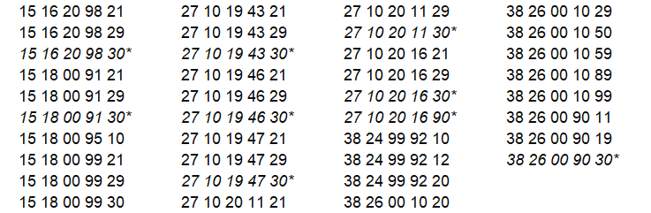

* The commodity codes that are listed above in italics have been replaced by new commodity codes. The code changes do not alter the description of the goods subject to review. The transfer date of these changes was 18 August 2023 and are detailed below:
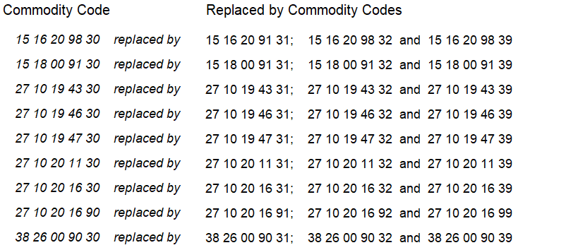

These commodity code(s) are only given for information.

In this document, these goods will be referred to ‘the goods subject to review’. Any reference to ‘goods subject to review’ in this document refers to the goods description above, regardless of the commodity code under which they are exported.

Like goods

Any reference to ‘like goods’ in this document refers to goods produced in the UK or imported to the UK from a country other than Argentina which are like the goods subject to review in all respects, or with characteristics closely resembling them.

Please follow the instructions for each question to provide the appropriate information regarding the goods subject to review or like goods.

For more information about this case, you may refer to the Notice of Initiation published at: www.trade-remedies.service.gov.uk/public/case/TS0044/

Instructions
The Trade Remedies Authority (TRA) will be carrying out a transition review of the EU trade remedy measure which will consider whether the production and/or export of biodiesel from Argentina to the UK is being subsidised and whether this subsidisation is likely to cause injury to the UK industry for these goods if the countervailing amount no longer applied.

Who should complete this form?

You should complete this form if you are one of the party types listed at the beginning of this document.
If you are a UK producer of the like goods, importer or overseas exporter of the goods subject to review, please complete the relevant Pre-Sampling Questionnaire.

Note about confidentiality
You will need to submit one confidential version and one non-confidential version of this document.
Please ensure that each page of information you provide is clearly marked either “Confidential” or “Non-Confidential” in the header.
It is your responsibility to ensure that the non-confidential version does not contain any confidential information, which includes personal contact information, names and signatures.
Please see the TRA’S public guidance for further information on what can be considered confidential and how to prepare a non-confidential version of this document.
All information provided to the Trade Remedies Authority (TRA) in confidence will be treated accordingly and only used for this investigation (except in limited circumstances as permitted by regulation 46 of the Trade Remedies (Dumping and Subsidisation) (EU Exit) Regulations 2019) and will be stored in protected systems.
The non-confidential version of your submission will be placed on the public file, which is available on www.trade-remedies.service.gov.uk/public/case/TS0044

Section A – Your organisation’s interest in the case

To register your organisation’s interest in this review, please complete the text boxes below.

Please describe your role with regards to the like goods and/or goods subject to review:
Click or tap here to enter text.

Please describe your interest in this review:
Click or tap here to enter text.

Section B – Additional information

B1 – Other interested parties

If you believe there are producers, overseas exporters, importers and other interested parties that should receive this document, please provide their organisation name and website details below.
Organisation name | Website

B2 – Particular Market Situation
If you have any concerns or information about the possible existence of a particular market situation in the exporting country or territory, please provide details in the box below. This can include examples such as:
  - Prices are artificially low
  - There is significant barter trade (e.g. goods exchanged for other goods)
  - Prices reflect non-commercial factors; or
  - Anything else

Click or tap here to enter text.

B3 - Scope

Do you agree with the scope of the investigation as outlined on page 4?

☐Yes
☐No

If you have answered no to the above question, please can you explain why?
Click or tap here to enter text.

B4 – Economic Interest Test

It is a requirement of the review to conduct an Economic Interest Test (EIT). The aim of the EIT is to determine whether the implementation of the proposed trade remedy measure is in the wider economic interest of the UK. In order to obtain a complete picture of the UK market, could you please help by providing us with details of any known UK suppliers (upstream companies providing inputs) and UK customers (downstream companies buying the like goods). Please confirm in the final column if we are able to contact these companies.
 | Company name | Company  location  (city, country) | Company  Contact  Information  (email/telephone) | Upstream or  Downstream | Can we contact  Y/N
1
2
3

4

B5 – Anything else

Please use the box below to provide information about anything else you consider relevant to this review:
Click or tap here to enter text.

Now you have reached the end of this document please ensure that you have prepared a confidential and non-confidential version and indicated the status of each within the header. The non-confidential version should redact personal contact information, names, and signatures. Please return both versions to the TRA using the Trade Remedies Service (trade-remedies.service.gov.uk).

