Pre-Sampling Questionnaire (Producer)
Transition Review
Case TS0044: Biodiesel originating in Argentina

Period of Investigation: | 1 October 2022 – 30 September 2023
Injury Period: | 1 October 2019 – 30 September 2023
Deadline for response: | 23 October 2023
Case Team Contact: | TS0044@traderemedies.gov.uk
Completed on behalf of: | Click or tap here to enter text.

When you have completed this form, indicate the confidentiality status of this document by placing an X in the relevant box below and in the header. We strongly recommend this questionnaire to be completed on the computer, so this step is easy to complete:
☐Confidential
☐Non-Confidential – will be made publicly available

Please note that you will have to provide two copies of your response – a Confidential and a Non-Confidential version. Both copies must be returned to the TRA using the Trade Remedies Service (www.trade-remedies.service.gov.uk) by 23 October 2023.
Table of Contents

The scope of this review 3
Instructions 5
Who should complete this form 5
Why you are being asked to complete this pre-sampling questionnaire 5
Deadline for response 5
Note about confidentiality 5
Section A – Activities of your company and any associated parties 7
A1 – Your company’s activities 7
A2 – Associated parties and operational links 8
Section B – Production, sales and imports 9
B1 – Production 9
B2 – Sales volume and value 9
B3 – Imports and Sales 10
B4 – Countries of Import 10
B5 – Conversion 11
B6 – Commodity codes 11
B7 – Hydrotreated Vegetable Oil (HVO) Production 12
Section C – Additional information 14
C1 – Other interested parties 14
C2 – Particular Market Situation 14
C3 – Scope 15
C4 – Product Control Numbers 15
C5 – Economic Interest Test 16
C6 – Anything else 17

The scope of this review

Goods subject to review

This review covers biodiesel exported from Argentina, described as:

Fatty-acid mono-alkyl esters or paraffinic gasoils obtained from synthesis or hydro-treatment, of non-fossil origin, in pure form or as included in a blend.

This biodiesel is currently classifiable within the following commodity code(s):

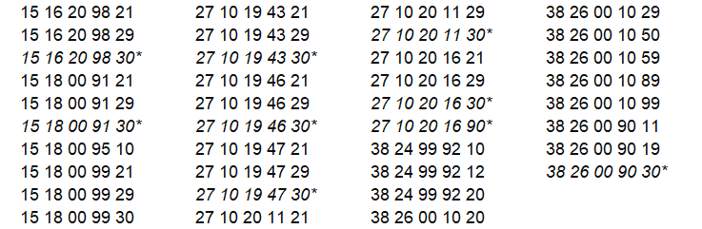

* The commodity codes that are listed above in italics have been replaced by new commodity codes. The code changes do not alter the description of the goods subject to review. The transfer date of these changes was 18 August 2023 and are detailed below:
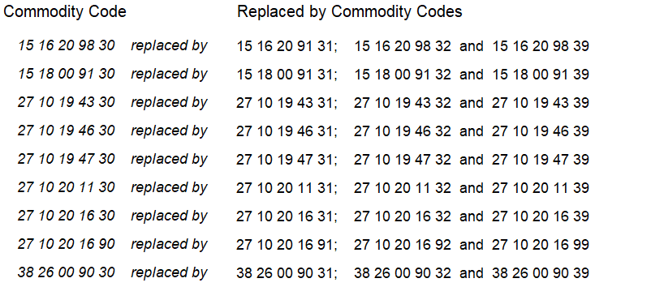

These commodity codes are only given for information.

In this pre-sampling questionnaire, these goods will be referred to as the ‘goods subject to review’. Any reference to the ‘goods subject to review’ in this pre-sampling questionnaire refers to the goods description above, regardless of the commodity code under which they are exported.

Like goods

This pre-sampling questionnaire asks for information about your company’s imports and sales of goods which are like the goods subject to review. Any reference to ‘like goods’ in this pre-sampling questionnaire refers to goods produced in the UK or imported to the UK from a country other than Argentina which are like the goods subject to review in all respects, or with characteristics closely resembling them.

Please follow the instructions for each question to provide the appropriate information regarding the goods subject to review or like goods.

For more information about this case, you may refer to the Notice of Initiation published at: www.trade-remedies.service.gov.uk/public/case/TS0044/

Instructions

The Trade Remedies Authority (TRA) will be carrying out a transition review of the EU trade remedy measure which will consider whether the production and/or export of biodiesel from Argentina to the UK is being subsidised and whether this subsidisation is likely to cause injury to the UK industry for these goods if the countervailing amount no longer applied.

Who should complete this form

You should complete this form if you are a UK producer of the like goods in the review.

If you are not a UK producer, please complete either the relevant Pre-Sampling Questionnaire or the Other Interested Party and Contributor Registration Form if you have information that you wish to be considered during the investigation.

Why you are being asked to complete this pre-sampling questionnaire

We are seeking your cooperation as a UK producer of the like goods to inform our review of whether the current countervailing measure should be maintained, varied or revoked.

This pre-sampling questionnaire allows us to collect basic information and data about your company. If a large number of UK producers complete this pre-sampling questionnaire, we will use the information each one provides to help us decide which companies we want to sample for further investigation. If you are sampled, we will send you a more detailed questionnaire to complete.

Deadline for response

A completed pre-sampling questionnaire must be submitted to the TRA by no later than 23 October 2023. If you are unable to provide a completed submission by the given due date and you wish to request an extension, please contact TS0044@traderemedies.gov.uk and see the TRA’s guidance on extension requests for further information.

Note about confidentiality
You will need to submit one confidential version and one non-confidential version of your pre-sampling questionnaire by the due date.
Please ensure that each page of information you provide is clearly marked either “Confidential” or “Non-Confidential” in the header.
It is your responsibility to ensure that the non-confidential version does not contain any confidential information, which includes personal contact information, names and signatures.
Please see the TRA’s public guidance for further information on what can be considered confidential and how to prepare a non-confidential version of this questionnaire.
All information provided to the TRA in confidence will be treated accordingly and only used for this investigation (except in limited circumstance as permitted by regulation 46 of the Trade Remedies (Dumping and Subsidisation) (EU Exit) Regulations 2019) and will be stored in protected systems.
The non-confidential version of your submission will be placed on the public file, which is available on www.trade-remedies.service.gov.uk/public/case/TS0044

Section A – Activities of your company and any associated parties

A1 – Your company’s activities

To determine your company’s role for the purpose of this review, please select the activity/activities of your company below. For a definition of the goods subject to review, please refer to above section on the scope of this review.

☐ producer of the like goods in the UK
☐ other (please give details below)

If you have selected ‘other’, please describe the role of your company with regards to the goods subject to review or like goods:
Click or tap here to enter text.

Please describe your interest in this review:
Click or tap here to enter text.

A2 – Associated parties and operational links

Please give details of all associated parties involved with the company in the production and sales (export and/or domestic) of the like goods during the POI. Both natural persons (individuals) and legal persons (e.g. companies) are considered to be associated where they meet the definition of ‘Related Persons’ in regulation 128 of the Customs (Import Duty) (EU Exit) Regulations 2018.

Examples of activities with associated parties could include production, domestic sales, export sales, and/or further processing of the like goods.

 | Company name | Company location  (city, country) | Activities | Relationship
Associated Party 1
Associated Party 2
+ Add additional rows as required

Section B – Production, sales and imports

B1 – Production

Please fill in your company’s total UK production volume and capacity for the like goods in the table below.

 | Volume  (Metric tonnes) | Volume  (litres)
Overall production of the like goods during the POI

Total production capacity of the like goods during the POI

B2 – Sales volume and value

Please provide your UK sales data for the like goods produced in the UK by your company.

 | Volume  (Metric tonnes) | Volume  (litres) | Value in original currency (X) | Value  in GBP (£) | Conversion rate
UK sales of the like goods produced in the UK during the POI

B3 – Imports and Sales

If your company has also imported the goods subject to review from Argentina or like goods from any other country and sold them in the UK during the POI, provide your sales data for this imported biodiesel or the like goods.

 | Volume  (Metric tonnes) | Volume  (litres) | Value in original currency (X) | Value  in GBP (£) | Conversion rate
Imports of the goods subject to review from Argentina during the POI

Imports of like goods from countries other than Argentina during the POI

UK sales of the goods subject to review imported from Argentina during the POI

UK sales of the like goods, imported from countries other than Argentina during the POI

B4 – Countries of Import

Please fill in below the top 3 countries from which your company imported like goods during the POI?

Click or tap here to enter text.

B5 – Conversion

Please fill in whether your company primarily uses metric tonnes to measure its production volume and if not, then please describe your conversion method.

Does your company primarily use metric tonnes to measure its production volume? | Yes ☐ | No ☐
If not, then please describe your conversion method to metric tonnes.

B6 – Commodity codes

Please provide details of the commodity code(s) under which you produce the like goods in the UK during the Injury Period in the box below:
Click or tap here to enter text.

B7 – Hydrotreated Vegetable Oil (HVO) Production
Please provide details of any HVO production, including sale and production volumes if applicable: | Volume  (Metric tonnes) | Volume  (litres) | Value in original currency (X) | Value  in GBP (£) | Conversion rate
Overall production of HVO during the POI

Total production capacity of HVO during the POI

UK sales of HVO produced in the UK during the POI

Imports of HVO from Argentina during the POI

Imports of HVO from countries other than Argentina during the POI

UK sales of HVO imported from Argentina during the POI

UK sales of HVO, imported from countries other than Argentina during the POI

Section C – Additional information

C1 – Other interested parties

If you believe there are other interested parties that should receive a questionnaire, please provide their organisation name and website details below.

Organisation name | Website

C2 – Particular Market Situation

If you have any concerns or information about the possible existence of a particular market situation in the exporting country or territory, please provide details in the box below. This can include examples such as:
  - Prices are artificially low
  - There is significant barter trade (e.g. goods exchanged for other goods)
  - Prices reflect non-commercial factors; or
  - Anything else

Click or tap here to enter text.

C3 – Scope

Do you agree with the scope of the investigation as outlined on page 3?

☐Yes
☐No

If you have answered no to the above question, please can you explain why?
Click or tap here to enter text.

C4 – Product Control Numbers

The TRA uses Product Control Numbers (PCNs) to define and distinguish the different types of products that fall under the goods description above.

PCNs, which come in the form of an alphanumeric code, help to create a categorisation system so that comparisons can be made between goods produced in the domestic UK market and those produced in foreign markets.

We have created a draft PCN table and enclose this here for you now.

Please review the draft PCN structure for this review shown in the table above. Please include any comments on the PCN structure in the box provided.
Characteristic | Symbol | Description
Cold Filter Plugging Point (CFPP) | P | Positive value + temperature rounded to nearest degree
Cold Filter Plugging Point (CFPP) | N | Negative value + temperature rounded to nearest degree
Type | 1 | Regular RED (renewable energy directive) certified biodiesel
Type | 2 | Eligible for double-counting
Type | 0 | Other/special purpose sold without any certificate
Form | P100 | Pure form (100)
Form | B(XX) | Included in a blend (blend rate)

Under this PCN structure, biodiesel assigned PCN P1B30 would be a product that corresponds with the following:
- A positive Cold Filter Plugging Point (CFPP)
- Regular RED certified biodiesel
- A 30 percent blend rate

C5 – Economic Interest Test
It is a requirement of the review to conduct an Economic Interest Test (EIT). The aim of the EIT is to determine whether the implementation of the proposed trade remedy measure is in the wider economic interest of the UK. In order to obtain a complete picture of the UK market, please provide us with details of your UK suppliers (upstream companies providing inputs) and UK customers (downstream companies buying your like goods). Please confirm in the final column if we are able to contact these companies.

 | Company name | Company location  (city, country) | Company Contact Information  (email/telephone) | Relationship | Can we contact  Y/N
1
2
3

4

C6 – Anything else

Please use the box below to provide information about anything else you consider relevant to this review:
Click or tap here to enter text.

Now you have reached the end of this questionnaire please ensure that you have prepared a confidential and non-confidential version and indicated the status of each within the header. The non-confidential version should redact personal contact information, names, signatures, and exact sales quotes. Redacted figures should be replaced with a range where possible. Please return both versions to the TRA using the Trade Remedies Service (trade-remedies.service.gov.uk).

