Prices in Turkey

As per your request we have been provided with quotes for steel from various Turkish suppliers and have also had a quote for ironing board fabric. We have summarised in the below table and supplied a copy of the quotations we have received; quotations cannot be provided in the non-confidential version they are commercially sensitive and making public could jeopardise trading relationships.

Supplier* | Material* | Price (Range) | Currency | Unit of Measure | Incoterms
Confidential | Steel | 900 - 1,000 | USD | Tonne | FOB
Confidential | Steel | 900 -1,000 | USD | Tonne | CFR
Confidential | Steel | 850 to 950 | USD | Tonne | EXW
Confidential | Steel | 950 to 1,100 | USD | Tonne | EXW
Confidential | Fabric | 1.00 to 1.50 | USD | Linear metre | EXW

*All suppliers who quoted operate outside a free zone
*Material grade specifics are commercially sensitive information

We wish to draw your attention to the volatility of pricing in the last 2 years to ensure that comparisons are fair and like for like. Below is an index of our steel pricing from October 2020 to January 2023 and a publicly available cold rolled steel pricing index.
Both indexes show that pricing during the period Jul 2021 through to Jul 2022 was incredibly high and we kindly request that any comparisons take this into consideration.
Quarter | Index
Oct-20 | 61
Jan-21 | 71
Apr-21 | 98
Jul-21 | 145
Oct-21 | 145
Jan-22 | 133
Apr-22 | 133
Jul-22 | 107
Oct-22 | 100
Jan-23 | 100

https://tradingeconomics.com/united-states/producer-price-index-by-commodity-for-metals-and-metal-products-cold-rolled-steel-sheet-and-strip-fed-data.html

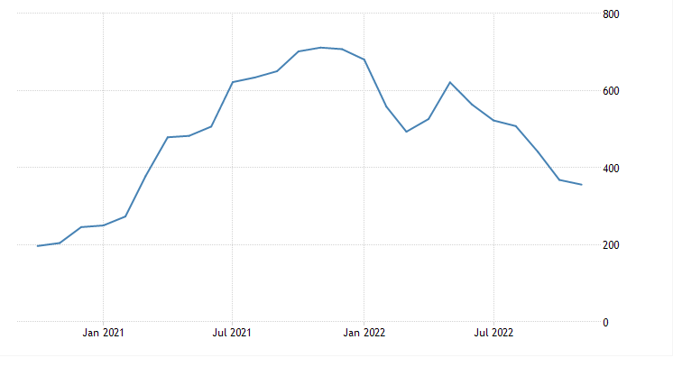

The impact of subsidisation
In April 2021 we received pricing for a range of ironing boards from a Turkish manufacturer who operate within a Turkish Free Zone.
The indexed steel pricing indicates that the Turkish pricing we have recently received is broadly in line with the pricing back in April 2021. We have used this pricing to demonstrate that costs within the free zone must be significantly lower to enable manufacturers to offer these sorts of prices.

Ref | Quote $  Indexed | Weight | 90% weight | Steel $ | Labour | Fabric | Other | Total  Indexed | Diff to quote  Indexed
1 | 100 | 3.65 | 3.29 |  |  |  |  | 106 | -6
2 | 100 | 3.45 | 3.11 |  |  |  |  | 102 | -2
3 | 100 | 4.30 | 3.87 |  |  |  |  | 102 | -2
4 | 100 | 5.10 | 4.59 |  |  |  |  | 106 | -6
5 | 100 | 5.25 | 4.73 |  |  |  |  | 99 | 1
6 | 100 | 6.50 | 5.85 |  |  |  |  | 75 | 25

Quote $ - Ironing board quote provided in April 2021
90% weight - assuming 90% of the nett weight of an ironing board is the steel content
Steel $ - based on $900 to $1,000 (indexed) per tonne
Labour & other - costs use the lowest equivalent UK cost base converted to $ at £1 : $1.20
Fabric - using the recent Turkish pricing, most ironing boards need 0.5m per ironing board cover

It is clear within the above table that the quoted price is less than the likely direct material and labour manufacturing cost demonstrating the significant level of subsidy provided by the Turkish Free Zones.

