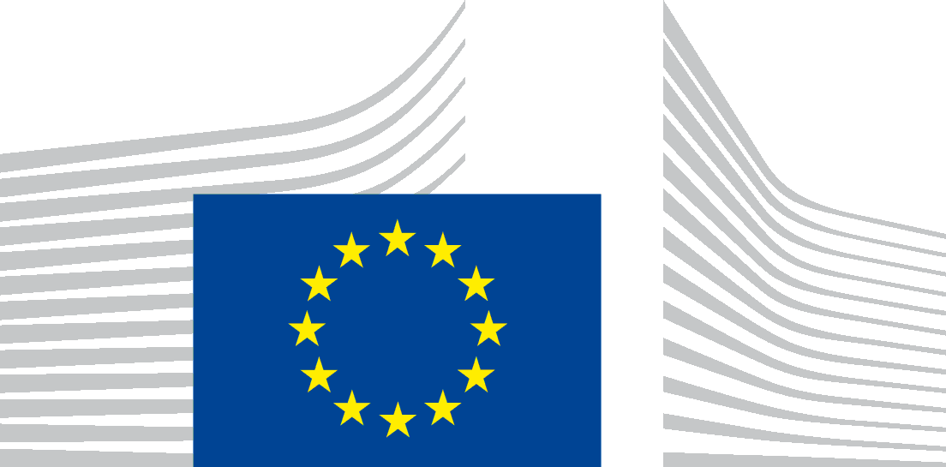 | EUROPEAN COMMISSION  Directorate-General for Trade  Directorate G - Trade Defence  Investigations IV. Relations with third Countries for Trade Defence Matters

Brussels, 8 July 2024
anti-dumping investigation by the United Kingdom on imports of certain engine oils and hydraulic fluids from Lithuania
Submission of the European Commission - Initiation of the investigation

The European Commission (‘the Commission’) would like to thank the UK Trade Remedies Authority (’TRA’) for the opportunity to present comments in the framework of the above-mentioned proceeding.
Following the initiation of the investigation and after analysis of the Notice of Initiation and the non-confidential version of the industry complaint, the Commission would like to raise the following concerns.
- Procedural issues - Industry support
According to Article 5.4 of the WTO Anti-dumping Agreement (‘ADA’), 5.4 ”An investigation shall not be initiated (…) unless the authorities have determined, (…) that the application has been made by or on behalf of the domestic industry. The application shall be considered to have been made "by or on behalf of the domestic industry" if it is supported by those domestic producers whose collective output constitutes more than 50 per cent of the total production of the like product produced by that portion of the domestic industry expressing either support for or opposition to the application. However, no investigation shall be initiated when domestic producers expressly supporting the application account for less than 25 per cent of total production of the like product produced by the domestic industry
In this regard, the application has been submitted by one producer Aztec Oils Ltd., which allegedly has a market share of around 7%. The application does not mention how much this producer produces and what % his production represents in terms of total production in the UK. The complainant however submits a letter supporting the application by the United Kingdom Lubricants Association. This association allegedly represents 20 members who are blenders of finished lubricants which in total account for 75% of the market approximately. However, all data is provided in confidential format, mixed with data from 2019. Furthermore, it is not clear whether the Association is impowered to represent its members in an anti-dumping proceeding.
Moreover, the said letter grants support to an application to investigate alleged dumping of imports from the United Arab Emirates but does not grant support to an application covering imports from Lithuania.
Therefore, the evidence as to the representativeness of the applicant is insufficient to justify the initiation of an investigation regarding UAE imports, and even more so regarding Lithuanian imports.

- Evidence at initiation
Article 5.2 of the WTO ADA determines that: “An application under paragraph 1 shall include evidence of (a) dumping, (b) injury within the meaning of Article VI of GATT 1994 as interpreted by this Agreement and (c) a causal link between the dumped imports and the alleged injury. Simple assertion, unsubstantiated by relevant evidence, cannot be considered sufficient to meet the requirements of this paragraph. […]”
2.1 Evidence of dumping
Concerning the price information provided in the application, the complainant submits a series of price offers from a UK importer, price offers from the Lithuanian producer to unrelated customers and also from one UAE producer. With prices taken from these offers, the complainant makes a rough dumping calculation for some models.
It is however not possible to reconcile the data in the dumping calculation with the offers submitted as price evidence. In addition, evidence of dumping refers to 3 models only and may not be representative of the whole product under investigation. In any case, no proper explanation of the calculation is provided in Annex 2 (Imports & Offers). Therefore, the evidence regarding alleged dumping from Lithuania is insufficient.
Additionally, UAE export volumes to the UK are substantially higher than Lithuanian exports to the UK (from total imports analysed, UAE represents around 80% of imports and Lithuania 20%); and UAE average prices are considerably lower than Lithuanian prices. Therefore, Lithuanian and UAE imports should be de-cumulated for the purpose of the injury analysis.
2.2 Evidence of material injury
The WTO ADA, establishes in Article 5.2, that the application should contain information on the “impact of the imports on the domestic industry as demonstrated by relevant factors and indices having a bearing on the state of the domestic industry, such as those listed in paragraphs 2 and 4 of Article 3”.
However, injury information in Annex 8 is fully confidential. In this regard, according to Article 6.5.1 of ‘ADA’ “The authorities shall require interested parties providing confidential information to furnish non-confidential summaries thereof. These summaries shall be in sufficient detail to permit a reasonable understanding of the substance of the information submitted in confidence […]”.
Unfortunately, no meaningful summaries have been provided. The only information available is that the UK complainant claims to operate below expected profit levels of the lubricant manufacturing industry due to imports allegedly made at dumped prices by a particular importer. This information is insufficient as it refers only to one company who is not representative of the domestic industry, as explained above.
In sum, regarding sufficient evidence of material injury, the non-confidential version submitted by the complainant is highly deficient in this regard, as the majority of information in the complaint is redacted and does not allow for a reasonable understanding of the substance. Thus, interested parties cannot exercise their rights of defence. Therefore, the Commission requests that the UK authorities provide summaries of the information provided in confidence, e.g. in the form of indexes or ranges, in particular regarding dumping margins and injury indicators, and that they are made available on the public file as soon as possible.
2.3 Causality
Unfortunately, no information regarding a causal link is contained in the complaint. The complainant did not provide any information on other factors that may have had an impact on the situation of the domestic industry such as e.g. the important decrease in demand.
Based on the above, it appears that the complaint was not complete and therefore not compliant with the WTO ADA and established jurisprudence, in particular, as the Panel in Guatemala – Cement II agreed that “statements of conclusion unsubstantiated by facts do not constitute evidence of the type required by Article 5.2”

- Conclusion
The Commission trusts that the TRA will take the arguments raised above appropriately into account, in particular:
- The complaint lacks important elements such as those relating to the industry standing; in particular, imports from Lithuania, based on the current complaint, should be removed from the scope of the investigation.
- Evidence of dumping is not clear enough and calculations should be further explained.
- Evidence of injury is vague and relates to one company only. On that basis, the current analysis is not representative and therefore not sufficient to initiate an investigation.
- The complainant makes excessive use of confidentiality, thus depriving the parties of their rights of defence.
- The complaint is not compliant with the WTO requirements and established jurisprudence since it does not contain a causality analysis.
In view of the above, it appears that the evidence provided was insufficient in many respects to justify the initiation of an investigation and thus it should be terminated without further delay.

Panel Report, Mexico –Steel Pipes and Tubes, para. 7.380.
PanelReport, Guatemala –Cement II, para. 8.53.

