Document submitted by Aztec Oils Ltd for AD0059 investigation regarding pricing from Lubriage in May 2025.
The below emails and pricelists were circulated from Mannol to a customer on 21st May.
Lubriage’s latest price list shows them selling hydraulic oil at £0.84 per litre, well below the average import cost from the UAE this year, which stands at £0.91.

They’re also offering 5W-30 engine oil at £1.25 per litre, despite the average import cost being £1.48.

These prices were published with full knowledge of the 24.95% tariff and 3% import duty, not to mention freight, insurance, and other associated costs.

Import Stats:

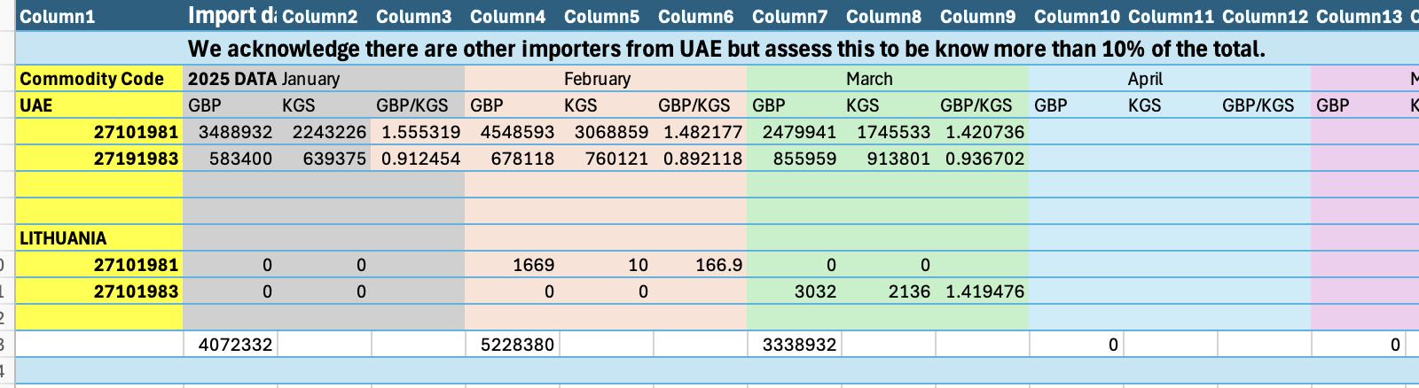

Mannol Pricing Spreadsheet from 21st May 2025:

Redacted: Mannol price list from May 2025 showing sales prices per litre, per product for the goods concerned

Email:

