TRADE REMEDIES AUTHORITY
INVESTIGATION NO: AD0059

_______________________________________________________
SUBMISSIONS BY LUBRIAGE LTD IN RESPONSE TO THE
PROVISIONAL AFFIRMATIVE DETERMINATION AND RECOMMENDATION
DATED 16 APRIL 2025
_________________________________________________________

- These submissions are made by Lubriage Ltd in response to the Provisional Affirmative Determination (“PAD”) dated 16 April 2025 that import duties be imposed and a guarantee given in respect of the payment of the suggested duties pursuant to paragraphs 11(3), 13(3)(a) and 13(8A) of schedule 4 to the Taxation (Cross-border Trade) Act 2018.

- The public file indicates that responses by Interested parties and contributors should be submitted by 23:59 UK time on 1 May 2025.

- The goods concerned are passenger car motor oils, heavy duty commercial vehicle oils and hydraulic oils, grades: 5W-30, 5W-40, 0W-16, 0W-20, 0W-30, 10W-40, 10W-30, 20W-50, SAE40, SAE50, 15W-40, ISO32, ISO46, ISO68, HV32, HV46 and HV68. These goods are imported into the UK under the following UK Global Tariff commodity codes: - 2710198120 - 2710198130 - 2710198140 - 2710198190 – 2710198300. The period of investigation(“POI”) in respect of the importation of these products is stated to be 1 April 2023-31 March 2024.

- The PAD has concluded that Tariffs should be imposed on overseas producers and exporters as set out in the following table:

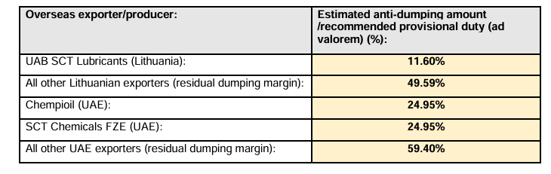

- Lubriage Ltd is a UK based importer employing 57 staff from its headquarters in Kettering, Northamptonshire. There is a clear potential to provide additional employment prospects as its business grows.

- This growth and the associated employment prospects in the locality are threatened by the Preliminary Determination of Tariffs and Recommended guarantee set out in section B of the PAD at p6-7.

- The preliminary findings are fundamentally anti-competitive and present a real risk that UK Jobs are threatened and that there is a loss to the national economy caused by capital flight and the relocation of business from UK. Further, downstream interests of industries reliant on the goods in question such as the farming sector and logistics operations will be adversely impacted and the low-cost provision of the goods to the UK consumer will be unnecessarily impaired.

- The response to the PAD concentrates on the following issues:

- The provisional findings on dumping
- The provisional findings on injury
- The economic interests test
- The anti-competitive nature of the recommedations

- It is suggested that the approach of the Trade Remedies Authority (“TRA”) to these issues has been affected by a mistaken approach to its analysis of the UK market

Analysis of UK Market

- It is submitted that the analysis of the UK market is flawed and this has resulted in recommendations which are unnecessary, disproportionate and ultra vires the provisions of the primary and secondary legislation as they promote the interests of Aztec Oils Ltd as a single “Producer” over the national interests of other producers and UK importers as a whole.

- The TRA summarises the UK market in the supply chain diagram at paragraph 67 of the PAD.

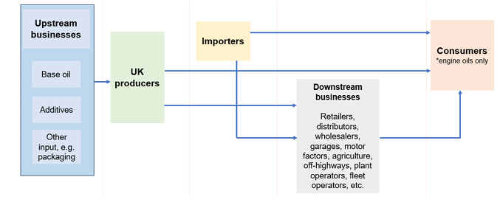

- The distinction given by the TRA between “UK Producers” and “Importers” in the investigation is somewhat artificial. For example, Lubriage Ltd imports the finally blended and packaged products whilst the identified domestic “producers” blend and package the product in the UK. Both are fundamentally reliant on the availability and pricing of the base oil and additives obtained upstream from the overseas market.

- The ability of producers to “pivot” to an importing or hybrid model in response to the need to increase costs efficiencies demanded by market forces such as the downward pressure of base oil pricing and reducing blending and packaging costs has not been taken into sufficient consideration.

- Further, and fundamentally, the analysis of the UK market is based on insufficient data to be reliable and is applied and relied upon in an inconsistent way.

- The following interested parties submitted full questionnaires which are found on the public file:

- Domestic Producers:
Aztec Oils Ltd
Paterson Enterprises Ltd
- Importers:
Lubriage Ltd
- Exporters / Overseas Producers
UAB SCT Lubricants (Lithuania)
Chempioil (UAE)
SCT Chemicals FZE (UAE)
•Trade Bodies:
United Kingdom Lubricants Association

- In paragraphs 64, 65, 66 and 68 of the PAD the TRA records that:

“64. UK producers are located across the UK, a selection of which are shown in figure 3 below, and not concentrated in any particular area. Most producers are small businesses employing less than 100 people on average.”

“65. For the purposes of this investigation, we have defined UK industry as all the producers in the UK of the like goods. The TRA considered whether it would be appropriate to define UK industry as only the two, cooperating domestic producers. However, the TRA concluded that such an approach could mean that the TRA is overly focussed on the two domestic producers who are cooperating with the investigation.

“66. Based on the information we have received in the response to our questionnaires and publicly available sources, the TRA has therefore concluded that in accordance with paragraph 6(1)(a) of Schedule 4 of the Act, the TRA considers UK industry to be all of the producers in the UK of like goods.”

“68. In addition to 21 known UK producers, the TRA identified 425 importers from HMRC’s trader search who imported goods under the two commodity codes during 2023. The TRA estimates that more than half of the UK demand of CEOHF are supplied by imports”

- In paragraph 65 the TRA confirmed that it was not appropriate to define UK industry as only the two co-operating domestic producers. Clearly this is correct, but it is completely at odds with the previous statement at paragraph 35 of the PAD that:

“35. The TRA considers that the sampled domestic producers who returned a full questionnaire response (Aztec and Paterson) are representative of UK industry.”

- The reality is that the TRA has given undue weight to and uncritical acceptance of the case of Aztec Oils Ltd (“Aztec”) when purporting to examine the interests of UK industry and considering the interests “all the producers in the UK of like goods” (PAD paragraph 65- 66) when the stated position at PAD paragraph 35 was that Aztec and Paterson are representative of UK industry.

The provisional findings on dumping

- The primary legislation is contained in Schedule 4 Taxation (Cross-border Trade Act) 2018 (“the Act”) as follows:

“PART 1

Key definitions

Meaning of “dumped”
1(1)For the purposes of this Schedule, goods are “dumped” in the United Kingdom if—
(a)they are imported into the United Kingdom, and
(b)their export price is less than their normal value;
and references to the “dumping” of goods are to be read accordingly.
(2)The “normal value” of goods means—
(a)the comparable price, in the ordinary course of trade, for like goods (see paragraph 7) when destined for consumption in the exporting foreign country or territory, or
(b)such other price or value as may be determined in accordance with provision made by regulations for specified cases where it is not appropriate to use the price in paragraph (a).
(3)Regulations may make provision for the purposes of this paragraph—
(a)about what constitutes or does not constitute—
(i)the “export price” of goods;
(ii)“the comparable price”;
(iii)“in the ordinary course of trade”;
(iv)“the exporting foreign country or territory”;
(b)about how any of those matters are to be determined;
(c)to ensure that a fair comparison is made between the export price of goods and their normal value;
(d)about the use of sampling to determine the export price or normal value of goods.”

Meaning of “the margin of dumping”
2. For the purposes of this Schedule, “the margin of dumping”, in relation to goods, means the amount which is the difference between—
(a)their export price as determined in accordance with paragraph 1, and
(b)their normal value as determined in accordance with that paragraph.”

- The Trade Remedies (Dumping and Subsidisation) (EU Exit) Regulations 2019 (“the Regulations”) provide the additional framework within which the TRA have assessed the question of whether product dumping has occurred during the POI.

- In approaching the exporting country analysis the TRA have again placed undue reliance on the views of Aztec as reflected by the contents of section 1 which provides:

“Based on information submitted in the application form by Aztec, in registration and questionnaire submissions from other interested parties, and from open sources, the TRA has established that:

- There was at least one Lithuanian producer of the goods in scope of the investigation during the period of investigation, which exported the goods concerned into the UK; and
- there were more than twenty UAE producers of the goods in scope of the investigation during the period of investigation, of which at least one exported the goods concerned into the UK”
Lithuania

- It is submitted that the TRA has had insufficient data with which to calculate the margin of dumping and to propose the application of tariffs to Lithuania as a whole.

- In the absence of sufficient information from Lithuanian exporters the constructed normal value of the goods ex works in Lithuania dealt with in PAD paragraphs 87-107 is highly speculative. The TRA based the constructed administration, selling and general costs pursuant to Regulation 12 on the costs of the UAE exporter as confirmed by PAD paragraph 102:
“102. The TRA did not receive sufficient information to use either option a) or option b) as set out above, as no costs for in scope or out of scope goods in Lithuania were submitted, and no other overseas (Lithuanian) exporters subject to investigation have provided data. The TRA therefore used 12(3)c), any other reasonable method, to establish AS&G costs for Lithuania. To determine the normal value in relation to Lithuania in the PAD, the TRA has used the domestic AS&G costs for the UAE that were submitted by the related UAE exporter, as these were assessed to be the most reasonable method of calculation that was available at the time.”
- However, the fundamental objection to the assessment of product dumping with regards to Lithuania is not simply to the methodology employed by the TRA but that the investigation has not been terminated. It is submitted that the TRA should have already terminated the investigation pursuant to the mandatory direction of Regulation 64 which provides:

“Termination
64.—(1) The TRA must terminate an investigation where, at any stage during the investigation, it determines that—
(a)the margin of dumping or the amount of subsidy is minimal;
(b)the volume of dumped goods or subsidised imports is negligible; or
(c)the injury is negligible.
(2) The TRA may, where it considers it appropriate, terminate an investigation on the request of the applicant UK industry.
(3) Where the TRA rejects a request referred to in paragraph (2), it must—
(a)publish a notice of its determination setting out the reasons for its determination; and
(b)notify interested parties and contributors.
(4) Where the TRA terminates an investigation under this regulation, it must—
(a)publish a notice of its determination in accordance with paragraph 65(8); and
(b)notify interested parties and contributors.”

- In this regard Regulation 4 provides:

“Meaning of “negligible” in relation to dumped goods
4. For the purpose of these Regulations, the volume of dumped goods is negligible where the exporting country or territory accounts for less than 3 per cent. of imports of the like goods imported into the United Kingdom, except where the exporting countries or territories individually account for less than 3 per cent. of imports of the like goods imported into the United Kingdom but collectively account for more than 7 per cent. of imports of the like goods into the United Kingdom.”

- The provisions are reflected in the statement by the TRA at PAD paragraph 124 that:
“124. For the import volumes from a foreign country or territory to be more than negligible, the dumped goods or subsidised imports must account for at least 3% by volume of all goods concerned and like goods imported into the UK. This does not apply however where imports from a foreign country or territory individually account for less than 3% of total imports, but collectively account for more than 7% (less than 4% individually but more than 9% collectively for subsidised imports from developing countries).”

- It is submitted that TRA made an incorrect determination at PAD paragraph 86 stating that during the POI that the UK import share by volume for Lithuania was 3.11%.

- The data set out in PAD 126 is disputed.

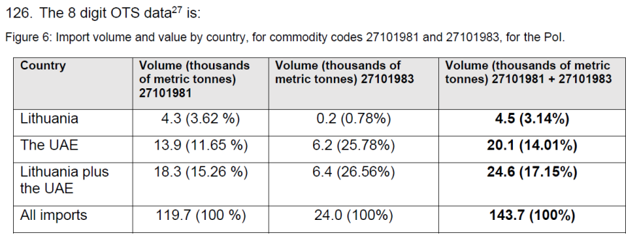
- However, according to the factual import volume from Lithuania, the import share by volume for Lithuania was just 2.88 %:

COUNTRY | Volume (thousands of metric tonnes) 27101981 | Volume (thousands of metric tonnes) 27101983 | Volume (thousands of metric tonnes) 27101981 +27101983
Lithuania (metric tonnes) | 3,97265616 | 0,1663087 | 4,13896486
Lithuania (%) | 3.32% | 0.69% | 2.88%
All Imports (metric tonnes) | 119,7 | 24,00 | 143,7
All Imports (%) | 100% | 100% | 100%

29(a) The source for the above table is as follows. UAB SCT Lubricants have submitted [Redacted. Commercially Sensitive Information] the totals of their exports to the UK. [Redacted. Commercially Sensitive Information].
29(b) UAB SCT Lubricants figures include goods classifed under Product Codes that are not the subject of this investigation. Attached at Non Confidential 27101981 (Engine Oils) and Non Confidential 27101983 (Industrial Oils) are the corresponding tables for goods that ARE within scope, representing the volume purchased by Lubriage from UAB SCT Lubricants crucially totalling the figures set out in the “Metric Tonnes“ column. The percentages are recalculated as against the TRA table (figure 6) that is in paragraph 28.

- As the import of goods under the scope of investigation from Lithuania to UK was less the 3% (by volume) the TRA should conclude its investigation with regard to Lithuania as the imports levels are negligible.

- Furthermore, even if the TRA findings were correct it is submitted that the margin over the negligible threshold is just 0.11 % - 0.14 % more than the negligible threshold set by Regulation 4. In such circumstances the data should be re-evaluated so that any margin of error can be discounted.

- The TRA itself stated at PAD paragraph 84 that:

“The most reliable import data that the TRA has access to is the publicly available, 8-digit OTS import data. This data may include some goods that are out of the scope of this investigation, so it is not a reliable source for average pricing“ .

- There is no reliable data to support the conclusion that the negligible threshold has been crossed as out of scope products such as aviation oil may be distorting the calculations.

- It is submitted that goods that are out of the scope of this investigation (for example aviation oil) cannot be included in the calculation of the import share and this would account for at least 0.11 % - 0.14 %of imports by volume.

- On this basis it is again maintained that the TRA investigation with regard to Lithuania should be terminated.

- As the data used in the PAD from interested parties is, at the time of calculation (October 2024), unverified [PAD para 48], it is submitted that the calculations in PAD and the preliminary conclusions, are incorrect as they are based on assumptions and unverified information, rather than on documents and specific information that was provided for the investigation.

- Further, the TRA investigation into Lithuanian exports should not continue on the basis of reliance on “Cumulation” of the import together with that of UAE as that is not permitted by Regulation 34:

“34.—(1) This regulation applies where goods from more than one foreign country or territory are subject to simultaneous dumping or subsidisation investigations by the TRA.
(2) Where this regulation applies, the TRA may cumulatively assess the effects of all the dumped goods or subsidised imports, as the case may be, pursuant to paragraph 5(4) of Schedule 4 to the Act, provided that—
(a)the amount of dumping or subsidisation established in relation to the dumped goods or subsidised imports from each foreign country or territory is more than minimal;
(b)the volume of the dumped goods or subsidised imports imported from each foreign country or territory is not negligible; and
(c)the TRA considers that a cumulative assessment is appropriate in light of the conditions of competition.

- The TRA is particularly asked to reconsider its position with regard to Lithuania in accordance with Regulation 34 2(c ). It is submitted that even if the negligible threshold is minimally passed, the circumstances of the case and the questionable nature of the evidence available to it should justify the exercise of discretion by the TRA against Cumulation given the impact on Lithuanian producers, UK importers, UK downstream businesses and UK consumers.

United Arab Emirates (“UAE”)

- It is accepted that the imports from the UAE are in excess of the negligible criteria under the Regulations.
- As set out previously the relevant exercise when assessing whether there has been product dumping in accordance with paragraph 1(1) of Schedule 4 to the Act is to determine whether the export price is less than the “normal” value of the goods.
- The dumping margin is then the difference between the export price and the normal value of the goods. This is expressed as a percentage of the export price at CIF level.
- It is submitted that the determination of the issue as to whether there has been product dumping has been distorted by an uncritical acceptance of data and submissions made by Aztec Oils as set out in the PAD:
“72. The applicant, Aztec, have submitted that “base oils are procured on the open market with a price indicator (ICIS - Independent Commodity Intelligence Services). Additives are also procured on the open market mainly through distribution companies.” This means that prices are dynamic across the industry as both customers and suppliers use ICIS as a basis for cost indication.
73. Oil products are distributed in a variety of pack sizes (Bulk, IBC (Intermediate bulk containers), Barrels, Drums, 5Litre, 4Litre + 1Litre) which are standard across the industry with few variations. Cost differences can arise between plastic and metal containers.

74. UK industry is “…suffering injury from the product dumping activities as we are facing prices in the marketplace which are substantially below our raw material costs”. The TRA has, based on preliminary data, found this to be the case.
75. Aztec claim to have first noticed dumping activity in 2019, which then increased following the outbreak of war in the Ukraine, when prices of some imports of the goods concerned and like goods dropped significantly. Volumes of these imports have been increasing during 2024.”

- It is submitted that the assessment of whether there has been product dumping has failed to take sufficiently into account the effect of (a) efficiencies in base oil purchasing by the UAE producer SCT Chmicals FZE and (b) the global decline in base oil prices. Both factors pass on the benefits of lower priced goods via importers to UK downstream businesses and UK consumers without product dumping occurring.

- The statement at paragraph 72 that “prices are dynamic across the industry as both customers and suppliers use ICIS as a basis for cost indication” does not represent a complete factual matrix of how pricing of base oils operates within the industry.

- It is important to note that Argus is another major provider of base oil price data. Both ICIS and Argus are independent, competing agencies that publish weekly base oil spot prices across global markets in the US, Europe, and Asia. The pricing between the two agencies is usually slightly different. The following tables illustrate recent price differentials between ICIS and Argus.

Argus price indication for base oils Group 1 grades of March 14, 2025

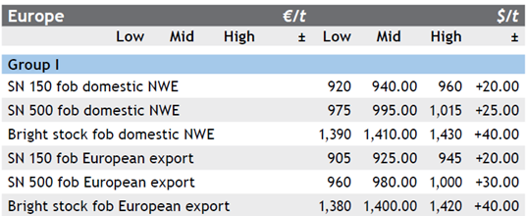

ICIS price indication for base oils Group 1 grades, of March 11, 2025

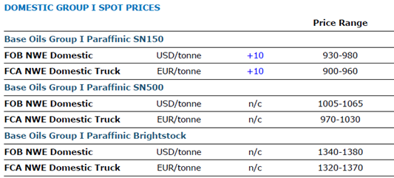

- Sellers and buyers of base oils can therefore choose which price source to follow, ICIS or Argus when negotiating deals, depending on which one better reflects their market position or offers more favourable pricing. The attached Excel file (marked ‘Lubriage Limited 01 May 2025 Annex 1’) contains a comparison of Argus prices from 2020 to 2024, all shown in USD (with original European market EUR prices converted to USD for a fair comparison) comparing the US and Europe markets for base oils group 1, group 2 and group 3. This illustrates that prices vary for the same base oil grade, during same period of time in the US market and the European market.

- To illustrate this point further is a screenshot from the excel file showing each group (Group 1 / 2/ 3) of base oils appears below and is divided into the US and EU market. The screenshot compares Group 1, grade SN150 prices in US and Europe.

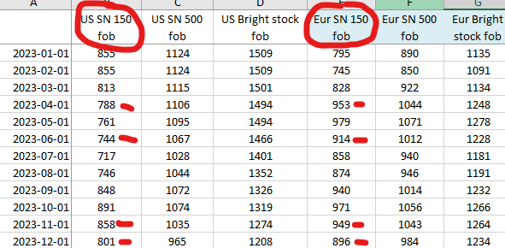

- It is immediately apparent that there is considerable difference in the price for the same product. Further, buying on spot market and being able to accept bigger volumes of base oils, gives the advantage of having competitive raw material prices unlike a competitor who buys on a term contract based on a ICIS linked price quotation.

- Pricing formulae vary from contract to contract, and on a deal specific basis. The agreement of the price formula depends on the buyer/seller negotiation and their final agreement is based on volume, price and credit terms.

- When buying on the spot market, the buyer and seller are free to choose which pricing reference to use whether ICIS or Argus, depending on which suits them better and then fix the price. Spot market purchases allows the industry to thoroughly compare offers and prices across different markets and regions and choose the most competitive price available which is how SCT Lubricants UAB operates and is then able to pass on the lower price benefits of market arbitrage to importers and ultimately to downstream UK businesses and end consumers.

- In addition, the TRA has not taken into sufficient account the downward pressure of global base oil prices during the POI.

- The relevant paragraphs at PAD para 156 and 162 provide:

“156. Price depression occurs when the UK industry is forced to reduce its prices to compete against lower priced dumped goods.”
162. To conclude, the TRA have established that imported prices are lower than UK sales prices (see price undercutting, above). Whilst domestic sales prices have increased, domestic interested parties have stated that these dumped, lower priced imports are affecting their ability to set sales prices and sell at a profit (profitability is assessed in more detail below). The TRA has therefore determined that the dumped goods have suppressed domestic prices of the like goods produced in the UK to a significant degree, on the basis of the evidence available at the time that the assessments were conducted.
- It is submitted that the decline in prices during the POI is also explained by the decline in global base oil prices. The decline in pricing noted by the TRA aligns with the downward pressure on the base oil prices across the markets. Illustrative of this the ICIS Base Oils price chart for 2022–2023, which shows a price decrease during the same time period Aztec Oils claims they were forced to lower their prices:

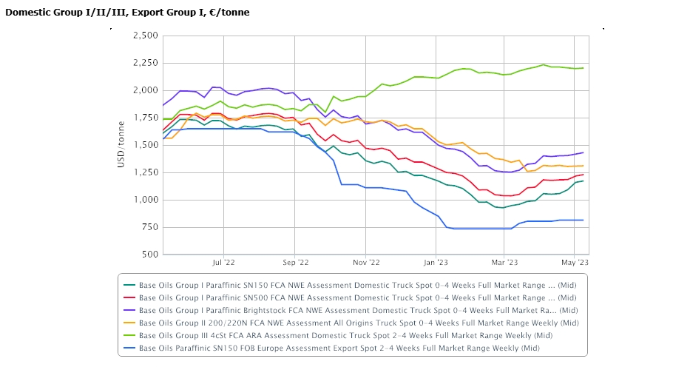

- In addition, the Argus reports of years 2022 to 2024 also demonstrate the base oils prices across the markets were decreasing during the same timeframe:
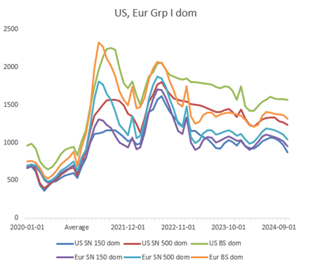
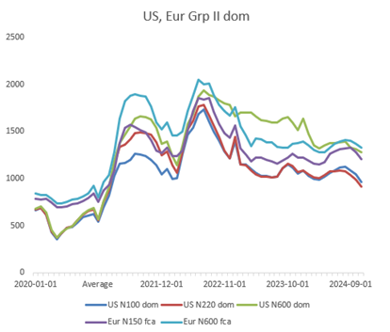

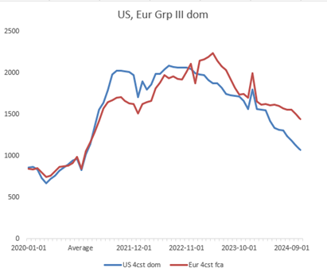

- The TRA has failed to take sufficient account of the fact that the inability to compete of Aztec may be due to its own internal failures to compete and respond to market forces when other producers and importers are able to do so rather than any causative effect of product dumping. In particular Aztec may not be purchasing base oil at competitive prices when it is possible to do so.
The provisional findings on injury
- The inconsistency of approach identified previously with regard to the overidentification of the interests of UK Industry with that of Aztec is further prevalent in the PAD when the TRA deal with injury to the UK market. Contrary to their own indication at paragraphs 65-66 of the PAD para 164 provides:

“164. The UK industry that has participated fully in this investigation are the sampled UK domestic producers, Aztec, and Paterson. As can be seen from the non-confidential questionnaires that they have submitted to the public file, these two companies have experienced differing levels of injury. The TRA has assessed that these differing levels of injury are likely to be caused by the different market positions, and sales prices, of the two companies.”

“192. Aztec and Paterson, who form part of UK industry and are representative of it, have claimed that they are subject to injury.

193. The TRA has determined that UK industry, as a whole, has actually suffered from material injury in relation to sales, profitability, output, productivity, return on investments, capacity utilisation, the margin of dumping, employment, wages, and growth. This is because, whilst the injury data for the two cooperating domestic producers (Aztec and Paterson) is contrasting, both producers are being undercut and undersold, and the actual injury suffered by Aztec is representative of injury which is being suffered by UK industry as a whole, whilst Paterson have been able to limit the extent of the actual injury that they have suffered due to a differing market position.”

- Far from assessing the whole of the UK industry the TRA has relied on two “producers”. Of these two producers only Aztec has suffered any loss or injury as the statements with regard to Paterson confirm:

“167. Paterson has submitted that its profitability has increased over the IP, with net operating profits after tax increasing by approximately 13% for engine oils, and 7% (with a high of plus 12%) for hydraulic fluids. Paterson has therefore not suffered an actual decline in profits over the IP.

“173. Paterson has estimated its market share, based on the estimates of the total UK market that were submitted to the TRA by the UKLA. The TRA assesses that these estimations by Paterson are likely lower than the actual market share that Paterson has. This is because the Paterson submitted market share has been calculated by comparing a smaller category of like goods (which are only engine oils and hydraulic fluids) against a market amount submitted by the UKLA for all lubricants and greases, which includes out of scope goods.”

“176. Paterson has submitted that the productivity of its employees has increased over the IP, by 38% in relation to engine oils, and 16% in relation to hydraulic fluids. This is against a backdrop of an increase in 8% of the number of employees. This makes it clear that Paterson has not suffered an actual drop in productivity.”

“189 Paterson has not suffered an actual negative effect on growth,”

- It is submitted that the market analysis is flawed and partial and that TRA are basing a recommendation of Tariffs that can damage importers, downstream business and UK consumers on the complaints of a single producer who is not competing successfully in the current market or responding appropriately to prevailing market conditions. [See previously submitted response to Dumping Questionnaire with deadline for response of 30 September 2024, published by TRA 8 November 2024]

- The distorting and potentially bias effect of the TRA’s market analysis is encapsulated in paragraph 193 PAD where the position of the UK market is conflated solely with that of Aztec Oils Ltd:

“193. The TRA has determined that UK industry, as a whole, has actually suffered from material injury in relation to sales, profitability, output, productivity, return on investments, capacity utilisation, the margin of dumping, employment, wages, and growth. This is because, whilst the injury data for the two cooperating domestic producers (Aztec and Paterson) is contrasting, both producers are being undercut and undersold, and the actual injury suffered by Aztec is representative of injury which is being suffered by UK industry as a whole, whilst Paterson have been able to limit the extent of the actual injury that they have suffered due to a differing market position. Figures 12 and 13 demonstrate, that if the data is aggregated, both Paterson and Aztec have experienced injury in relation to sales volumes and values.

194. The TRA has therefore determined that UK industry is suffering from actual material injury.”

The economic interests test
- The determination of the economic interests test is again distorted by a protectionist strategy in favour of the applicant Aztec Oils Ltd rather than UK industry as a whole:

“K2. Injury caused by dumping and benefits to UK industry in removing injury 225. Section I sets out the injury assessment. This concluded that UK industry has suffered from actual material injury. One of the two sampled domestic UK producers is suffering from a decline in most of the injury factors considered (including sales, profits, and employment). This material injury and potential injury is likely to put the market participation of some or all of the UK producers at risk so removing this injury is likely to result in significant benefits to UK industry.

- It is submitted that the recommendation to the Secretary of State in accordance with paragraph 13(3)(a) of Schedule 4 to the Act is unjustified and in conflict with other findings of the TRA:

“K3.2. UK Producers
232. The TRA has identified 21 known UK producers through research and evidence submitted and examined six UK producers which employed around 750 staff with a total GVA of around £65m. The examined businesses included the five largest businesses which submitted pre-sampling questionnaires and the largest known producer that did not engage with the investigation. On average, during the most recent years over 50% of their total turnover was accounted for by sales of CEOHF which indicated that these goods are very important to them.

233. Most of the selected businesses had strong growth and rising employment which indicated that they are unlikely to be as vulnerable to economic shocks. Nevertheless, Paterson and Aztec showed a medium vulnerability with decreasing employment in 2023 and a slight decrease in sales for Aztec. This assessment considers financial data for the entire company whereas the injury assessment in Section H1 considers only data relating to the like goods.

234. Based on the product ranges of the selected businesses and their questionnaire responses, selling the CEOHF appears to be their main business activity which suggests that CEOHF is very important to them.

- The TRA found with regard to Importers as follows:

“236. The TRA selected 10 importers who imported goods under both codes every month in 2023 but classified two of these as downstream businesses based on their primary business activity. This left eight selected importers including Lubriage.
237. The selected importers collectively employed around 3,334 staff, had a combined turnover of around £20,858m and a combined GVA of around £1,582m. The evidence suggests that the like goods are very important to Lubriage and somewhat important to the other businesses.
238. More than half of the selected businesses show moderate vulnerability to economic shocks, with declining employment and EBITDA but growing turnover and GVA. One business experienced negative EBITDA, highlighting their vulnerability to economic shocks.”

- It is submitted that it is unnecessary and irrational to recommend the imposition of duties in this case when there has been a finding that UK Producers as a whole had businesses with strong growth and only identifying one business that had suffered injury.

- Further, the imposition of duties is clearly not in the interests of Importers, Downstream businesses or UK end consumers.

The anti-competitive nature of the recommendations

- As a result of the investigation the following provisional recommendations have been made:
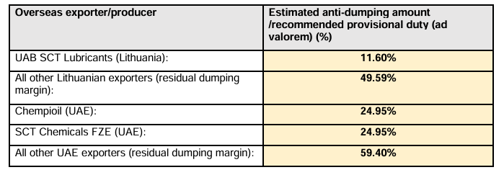

- It is submitted that the recommendations reduce the ability of UK “Producers” to pivot to an import model where they are importing premixed and packaged goods into the UK or a hybrid model where they import pre blended products in bulk to UK and package in UK.

- The reason for this stems from the calculation of the dumping margin for producers who have not taken part in the investigation as set out in PAD paragraph 119:

“G5. Dumping margin
118. In accordance with regulation 17(1)(a) of the Regulations, the TRA compared a weighted average normal value with a weighted average export price by PCN, to calculate the dumping margin for each overseas exporter for which the TRA is determining an individual estimated anti-dumping margin.

119. For all other overseas exporters, the TRA established a residual amount according to regulation 38 of the Regulations, which has been determined by taking the PCN with the highest dumping margin.”

- The effect of this is to reduce competition in UK market as any UK business approaching a Lithuanian exporter other than UAB SCT Lithuania will have to purchase goods with a 49.59% tariff rather than an 11.60% tarriff and any UK business approaching UAE exporters other than Chempioil UAE and SCT Chemicals FZE will face tariffs of 59.40% rather than 24.95%.

Conclusion
- By reason of all the matters set out in this response to the Provisional Affirmative Determination the TRA is respectfully requested to review its provisional recommendations for the imposition of tariffs and to rescind its recommendation to require that a guarantee is made pursuant to paragraphs 11(3), 13(3)a and 13(8A) of Schedule 4 to the Taxation (Cross-border)Trade Act 2018.

On behalf of:
Lubriage Ltd
01 May 2025

