TD0037 & TS0038: Brompton Report

SUBMISSION DATE – 27TH AUGUST 2023

Table of Contents

Introduction

Background

Growth opportunities in the UK bicycle market

Product Compliance

B Corporation

Understanding the market

Market competitors

Market challenges

Safety

Production

Supply Chain issues

Conclusion

Introduction

This report has been generated as a direct response from the Trade Remedies Authority UK, for Brompton Bicycle Ltd to be an active participant in this review process.

The Trade Remedies Authority (TRA) exists to defend the UK against unfair international trade practices. They investigate whether new trade remedies are needed to prevent injury to UK industries caused by unfair trading practices and make recommendations on appropriate measures to defend UK economic interests. The Trade Remedies Authority operates as an independent body at arm’s length from government, sponsored by the Department for Business and Trade (DBT (Department for Business and Trade) (Department for Business and Trade)). The goal is to create a UK-specific trade remedies system outside the European Union. The TRA carry out transition reviews into existing EU (European Union) trade remedy measures which affect UK industries. These reviews test if the measures in place are right for the UK or what changes potentially might need to be made.

The TRA mission is to defend UK economic interests against unfair international trade practices.

TRA case tracking process model

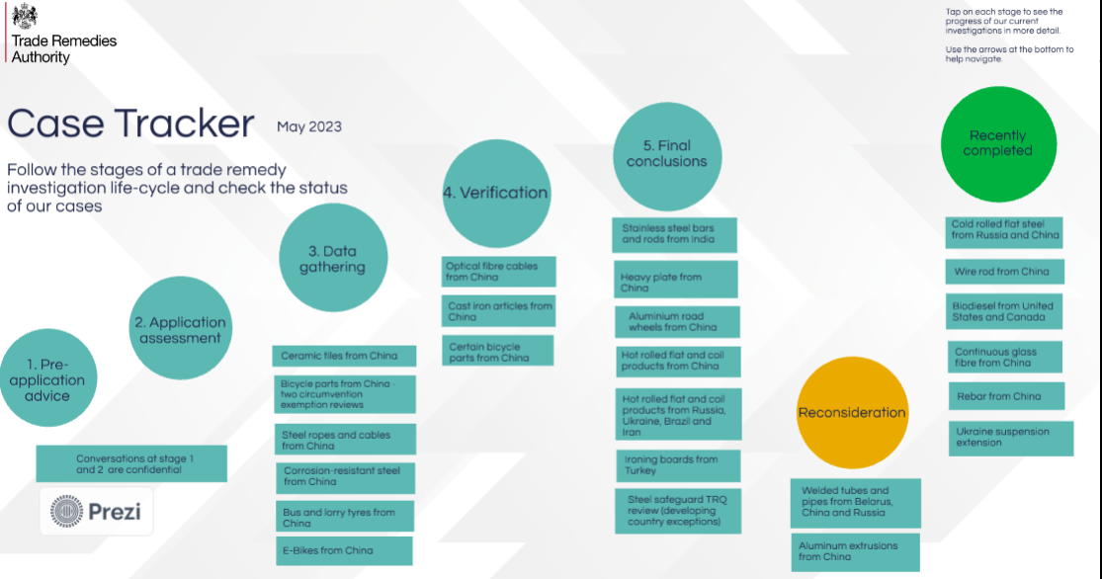

This report is in direct response to cases TD0037 and TS0038 which have been raised by the TRA.

TD0037

This case relates to consideration of whether dumping of electric bicycles originating in the People’s Republic of China and injury to the UK industry in the like goods would be likely to continue or recur if the anti-dumping amount currently applicable were no longer applied to those goods.

TS0038

This case review will consider whether the importation of electric bicycles originating in the People’s Republic of China and injury to the UK industry in the like goods would be likely to continue or recur if the countervailing amount currently applicable were no longer applied to those goods.

A subsidy currently exists if there is:

- a financial contribution by a foreign authority which confers a benefit on the recipient (usually an industry or business manufacturing goods); or
- a form of income or price support.

Not all subsidies are countervailable (meaning they can be offset through trade remedies). A subsidy is countervailable if it is specific to certain companies or industries and granted either directly or indirectly for the manufacture, production, export, or transport of goods.

The TRA review covers electric bicycles exported from the People’s Republic of China and is described as:

- Cycles, with pedal assistance, with an auxiliary electric motor.

These electric bicycles are currently classifiable within the following commodity codes: 8711 60 10 00 and 8711 60 90 10.

As a domestic producer in the United Kingdom, Brompton Bicycle Ltd have produced this report to confirm their request for no changes to occur to the current anti-dumping and countervailing duties that are currently in place.

Under this review it also includes “like goods,” any reference to ‘like goods’ refers to goods produced in the UK or imported to the UK from a country other than China which are like the goods subject to review in all respects, or with characteristics closely resembling them. For Brompton Bicycle Ltd, like goods refers to our non-electric bicycles which are similar apart from the auxiliary motor, with same components and raw materials being used.

Period under review

The period under investigation in these TRA cases is from 1st April 2022 to 31st March 2023, with the injury period from 1st April 2019 to 31st March 2023.

Background

As of 18th July 2018, all e-bike categories (including pedicels and tricycles) bought from China are subject to anti-dumping duties (ADD).

Anti-dumping duty is a duty on imports. It protects against damage to UK industry caused by the dumping of goods in the UK at prices much lower than the normal value. Each anti-dumping duty measure covers specified goods originating in, or exported from, named countries or exporters. It is charged in addition to other duties that apply to the imported goods. For example, customs duty or rebalancing duties.

Where a safeguard duty is also applied to an import, the anti-dumping duty is amended so that only the highest of either the safeguard or anti-dumping duties apply.
This was at 83.6% but has subsequently been reduced to 62.1%

At the same time, all e-bike categories (including pedicels and tricycles) bought from China are subject with a countervailing duty (CVD) of 17.2%.

Countervailing duty is a duty on imported goods that have received countervailable subsidies in the originating or exporting country. It is treated in the same way as anti-dumping duty for customs purposes. It is possible to have both anti-dumping duty and countervailing duty on the same product.
Both duties are calculated on the cost for you to buy and import your e-bikes (unless your supplier has been allocated a reduced rate by the UK).

This new measure from the European Union has been put in place following complaints from the European Bicycle Manufacturers Association. They alleged that the import of e-bikes from China, at a reduced cost to that considered the market rate for buying e-bikes within the EU, would have drastic effects on European manufacturers. This was transposed into UK law following the UK’s decision to the leave the European Union.

This regulatory change also included circumvention, this is when traders try to avoid anti-dumping and countervailing duties by sending their goods to a different country to undergo processes that do not change the origin of the goods.

Where circumvention is identified, anti-dumping or countervailing duty measures may be extended to goods from the country of export. Exporters not involved in circumvention can apply to the Trade Remedies Authority for exemption from the extended duties.

Chinese manufacturers have also been granted new tariff rates if they are approved exporters by the HMRC and came into force in November 2022. The Government approved the Trade Remedies Authority’s recommendation that two China-based electrical bicycle and tricycle manufacturers be given new exporter status and be allowed to pay a lower import tariff rate to export their products to the UK.
The new exporters, Jinhua Otmar Technology Co Limited, PRC and Jinhua Seno Technology Co Limited, PRC, currently pay an anti-dumping tariff rate of 16.2%, rather than the 62.1% they previously had to pay but still must pay a countervailing duty, meaning the combined duty for the new exporters will move from 79.3% to 33.4%.
This new exporter reviews allow new exporters to enter the UK market at a fair rate, rather than being penalised for not taking part in the original investigation. In this case, the TRA recommended that:
- the applicants are new exporters.
- they should pay a non-sampled, co-operating overseas exporter anti-dumping amount of 16.2%, rather than the 62.1% they previously had to pay.
- the new rate should be backdated to the initiation of the review on 23 June 2022.
Although this provides trade remedies and reduction on trade barriers for these manufacturers and any new Chinese exporters, this is not reciprocal for UK businesses wishing to export e-bikes to China.
It must be noted that Brompton Bicycle Ltd were not consulted over the TRA review prior to this being approved.
UK businesses are still impacted through technology requirements and technical specifications insisted on by the relevant Chinese authorities – this puts UK businesses at a significant disadvantage and anti-competitive position for any Chinese market domestic supply. Not only do UK importers to China face a 45% customs duty rate but additional exporting licensing is required for these goods to be exported from UK.
The cost to buy and import e-bikes from China has been at a lower than market price over the past few years and as such puts pressure on the cost to UK manufacturers. The current trade barriers provide protection to UK manufacturers and safeguard UK industry.

Growth opportunities in the UK bicycle market

Opportunities for market growth in the bicycle market are positively affected by factors like:

- Participation levels in the UK remain much lower than in many other European countries. Despite the increase in popularity of the sport in recent years, the number of bikes sold in the UK has remained broadly flat.
- The shift to cycling as a mode of transport.
- UK target to reach net zero.
- Improved urban cycling infrastructure.
- UK government desire to reduce carbon emissions and improve health through active travel.
- Urban cycling in London is circa 5% and in other cities circa 2.5%, across norther Europe it is between 15-25%
- The level of female participation also remains exceptionally low. Recent data suggests that, in the UK, women make up to 27% of cycle journeys compared to 55% in Denmark and the Netherlands.
- The health and wellbeing benefits associated with cycling.
- Government infrastructure investment in London and other UK cities.
- The rapidly growing electric ("e-bike") segment, which makes cycling more accessible to both commuters and older generations; and
- Existing customers spending more as they increase the amount, they use their bikes.

One of the most significant growth opportunities for both manufacturers and retailers in the UK market is rising demand for electric bicycles ("e-bikes").

In countries such as the Netherlands, Germany, Denmark, Belgium, and France where cycling has a high participation rate amongst the public, consumers have long embraced e-bikes. For example, almost 30% of all new cycles sold in Holland are e-bikes and over 50% of revenue coming from Ebikes is due to their higher recommended retail price (RRP)

E-bike sales in the UK have so-far been low. However, they rose from 5% of the UK bike market in 2015 to 12% in 2016. Halfords dubbed 2017 the “year of the E-bike” after achieving 220% sales increase.
Much of the new product innovation and new product launches in the bicycle market is now focused on e-bikes, this is a key focus of the Brompton Bicycle Ltd strategic focus.

A recent survey of 2,000 commuters commissioned by leading bicycle retailer Evans Cycles estimated that by switching from car, bus, tube or train to e-bikes, commuters could save an average of £7,791 over five years. This might suggest that it is the cost-savings for commuters that ought to be the focus for the promotion of e-bikes, as public awareness builds, and new models enter the UK market.

Folding bikes are a small segment of the overall UK bicycle market, with a share of around 4% of all bicycles sold. But in dense urban areas the convenience of the folding bike excels where over 15% bike being used are folding.

Product Compliance

Electrically assisted pedal cycles (EAPCs) - which are also known as electrically power assisted cycles (EPACs) and e-bikes - have become increasingly popular in recent years as a means of transport. As they can be made available at affordable prices, concerns have been raised about their safety, particularly as they have been developed by enthusiasts with a growing cottage industry of adapting ordinary pedal cycles that are then supplied to consumers.

When assessing the safety of a product, several matters are taken into consideration and anyone in the supply chain can be held liable for the supply of unsafe products, and this is why Brompton puts this as one of the key factors for compliance and ensuring we attest to all standards.

The law requires that any product sold to consumers must be safe. Products should not present any unnecessary risk to anyone when used in a normal or reasonably foreseeable way. When assessing the safety of a product, the following is considered:

- packaging, labelling and instructions.
- effect of the product on other products with which it might be used.
- special needs of types of people, such as elderly people or those with disabilities

Where there are national, European, or international standards relating to the product, these standards are also an integral part of the Brompton compliance activities. Not all personal light electric vehicles are approved for use in the same way. EAPCs are a particular type of motorised or electric vehicle designed for carrying persons and goods; they have their own set of regulations and standards governing their safety.

EAPCs are vehicles that are cycles with two or more wheels and are defined as follows:
- cycle must be fitted with pedals that can propel it.
- continuous rated power of the electric motor must not exceed 250 W.
- electrical assistance must cut off when the cycle reaches 15.5 m/h or 25 km/h.
An EAPC that complies with the above is not considered to be a motor vehicle within the meaning of the Road Traffic Act 1988. As a result, it is not required to be registered and is not subject to vehicle excise duty (road tax), nor does it have to be insured as a motor vehicle. EAPCs must not be ridden by anyone under the age of 14.
The Department for Transport is aware that there are electric bikes limited to 15.5 m/h, but are fitted with off-road switches or modes that enable the bike's motor to continue assisting at speeds beyond 15.5 m/h. Any electric bike that does not meet the EAPC rules is classed as a motorcycle or moped and needs to be registered and taxed to comply with DVLA requirements. A driving licence is required to ride one as well as a motorcycle crash helmet.
Further details and explanatory notes from “The Electrically Assisted Pedal Cycles Regulations 2015” can be seen on this link.
The electrically assisted information sheet from “Department of Transport” provides greater information.
Brompton Bicycle Ltd adheres under the International Electrotechnical Commission, which provides a global, independent institutional framework that allows policymakers to accelerate the implementation of policy goals and build a quality infrastructure. It helps regulations and laws to remain state-of-the-art, promotes broad collaboration, encourages innovation, and enhances economic development. These standards provide Brompton the technical frameworks, metrics, and specifications. As technologies evolve, standards are revised and legislation remains up to date, to ensure Brompton conform to the latest international standards.
By incorporating IEC International Standards and testing and certification, this avoids island solutions and improves safety, affordability, and interoperability.

Brompton also attests to ISO standards that are internationally agreed by experts within all industries. ISO (International Organisation for Standardisation) is an independent, non-governmental international organisation with a membership of 169 national standards bodies. For this, Brompton aligns itself with Quality Management Standards, Environmental Management Standards and Health and Safety Standards.

Another regulatory standard that Brompton must adhere with is the “Electromagnetic Compatibility Regulations 2016”. This relates to all electrical and electronic equipment which is liable to generate electromagnetic disturbance.

For Brompton Bicycle Ltd, this places the following obligations on our business:

- Before placing apparatus on the GB market, the manufacturer must ensure that it has been designed and manufactured in accordance with the essential requirements as set out in Schedule 1 to the 2016 Regulations and that they have had a relevant conformity assessment procedure carried out and technical documentation drawn up.
- Once this has been done, the manufacturer must draw up a declaration of conformity and affix the UKCA marking, except where it is not possible or warranted to affix the UKCA marking to the apparatus, in which case it must be affixed to the packaging and the enclosed documents.
- Qualifying Northern Ireland goods can be placed on the GB market with the CE and CE UKNI conformity markings.
- The manufacturer must keep technical documentation and the declaration of conformity for 10 years after the apparatus has been placed on the GB market.
- The manufacturer must label apparatus with their name, registered trade name or registered trademark, a postal address and the type of batch or serial number (or other identification). Where it is not possible to indicate the type, batch, or serial number (or other identification) on the apparatus due to its size or nature and /or it is not possible to include the manufacturer’s name, registered trade name or registered trademark or a postal address on the apparatus, the manufacturer must ensure the information is included on the packaging or in a document accompanying the apparatus.
- The manufacturer must ensure that the apparatus is accompanied by relevant instructions in English.
- The manufacturer must ensure that procedures are in place for series production to remain in conformity with Part 2 of the 2016 Regulations. In doing so, they must take account of any changes in electrical equipment design or characteristics, and any change in a harmonised standard or in another technical specification by reference to which the Declaration of Conformity was drawn up.
- Manufacturers must act where they have reason to believe that the apparatus that they have placed on the GB market is not in conformity with the 2016 Regulations by bringing the apparatus into conformity, withdrawing the apparatus, or recalling the apparatus. Where the apparatus presents a risk, the manufacturer must immediately inform the market surveillance authority (MSA), giving details of how the apparatus is not in conformity and any corrective measures taken.
- The manufacturer must also cooperate with and provide information to enforcing authorities following any requests.

B Corp

Brompton is also B Corp certified; B Corp Certification is a designation that a business is meeting exacting standards of verified performance, accountability, and transparency on factors from employee benefits and charitable giving to supply chain practices and input materials.

Under this certification Brompton must show the following:

- Demonstrate a high social and environmental performance by achieving a B Impact Assessment score of 80 or above and passing our risk review. Multinational corporations must also meet baseline requirement standards.
- Make a legal commitment by changing their corporate governance structure to be accountable to all stakeholders, not just shareholders, and achieve benefit corporation status if available in their jurisdiction.
- Exhibit transparency by allowing information about their performance measured against B Lab’s standards to be publicly available on their B Corp profile on B Lab’s website.

B Corp Certification is holistic, not exclusively focused on a single social or environmental issue. And the process to achieve and maintain certification is rigorous and requires engaging teams and departments across your company. Taking company size and profile into account, verification involves documentation of Brompton’s business model and information about your operations, structure, and various work processes, as well as review of potential public complaints and site visits. Recertification confirms these standards continue to be met on an ongoing basis. This is paramount when setting out one of the governance mechanisms that drives our focus on sustainability.

Understanding the market

We passionately believe that while Brompton bikes may have a higher initial cost, many customers find that their durability, safety, functionality, and compact size to be a worthwhile investment, particularly for urban commuters and those with limited storage space.

We also understand that the perceived value of a product can often be influenced by factors beyond its technical specifications, including brand reputation, design, and exclusivity. We have reasons to believe that Brompton has built a formidable reputation, not only in UK and Europe but also overseas: in 2023 China has become the main market for Brompton in terms of net sales and, interestingly, it is the market where we see the largest amount of counterfeit (‘fake Brompton’s’) being offered.

More details on electric bike characteristics can be found on our website:

Electric C Line Explore | Brompton Bicycle UK
Electric P Line Urban with Roller Frame | Brompton Bicycle UK

Brompton has an extensive range of accessories that are offered for general sale, which are not included under this review or fall under the “like goods” category.

The Brompton shop or retail locations known as Brompton Junction allow anybody to purchase any additional products from the Brompton range. This offers a vast range of Brompton Bikes, components, spares, and accessories in the UK. These products are useful add on-features engineered to enhance the Brompton experience.

The end use for our bicycles is to be used as such, and there are no other uses these products can be used for under the product under review or “like goods.” Currently, the proportion of sales is 74% for the “like goods” and 26% of sales fall under the product under review.

In the UK, Brompton Bicycle Limited sells electric folding bicycles across 3 channels: The company’s network of 3rd party bicycle dealers, eCommerce (through Brompton.co.uk), as well as in the company’s flagship retail Junction store in central London. The channel mix by both units and revenue is listed below for FY23.

The pandemic has provided a lasting boost to the cycling industry and consumer demand remains strong.

- Bicycle market growth: 21% of adults cycle at least once a week, a rise of 7 percentage points since January 2019.
- Bicycle market value: Bike sales value dipped only slightly in 2021, totalling an estimated £1.25 billion.
- Bicycle market share: 2020 saw UK e-bike volumes surge by an estimated 70%, reaching around 170,000 units.

Supply chain problems have been the major challenge for the bike industry over the past 12 months, although the severity of these problems have gradually begun to ease during 2022 and beyond. The mounting cost-of-living crisis, exacerbated by the Russian invasion of Ukraine in February 2022, could dampen demand for bicycles and e-bikes over the coming months.

The customer base for adult cycling is affluent compared to the population, which should help to partly mitigate the impact. Kids’ bike sales amongst families on tighter budgets are likely to be the most heavily affected.

There is significant future potential for an increase in cycling activity supported by the rising public investment in safe-cycling infrastructure. Supply-side problems will remain a threat to meeting any future rise in consumer demand, as the cycling industry is heavily reliant on imports.

E-bike ownership has doubled in the past two years, and consumer purchase intentions point to a further doubling in the short to medium term. E-bikes are not yet challenging standard mechanical bikes as the primary purchase choice for cyclists in Britain as they are in other countries.

However, there is significant growth potential in the bike market for this high-value category.
‘Sporting Enthusiasts’ were the main driver of cycling market growth prior to the COVID-19 outbreak. They are the group to spend on premium bikes, accessories and clothing and will be key for the post-pandemic bicycle apparel and accessories market growth.

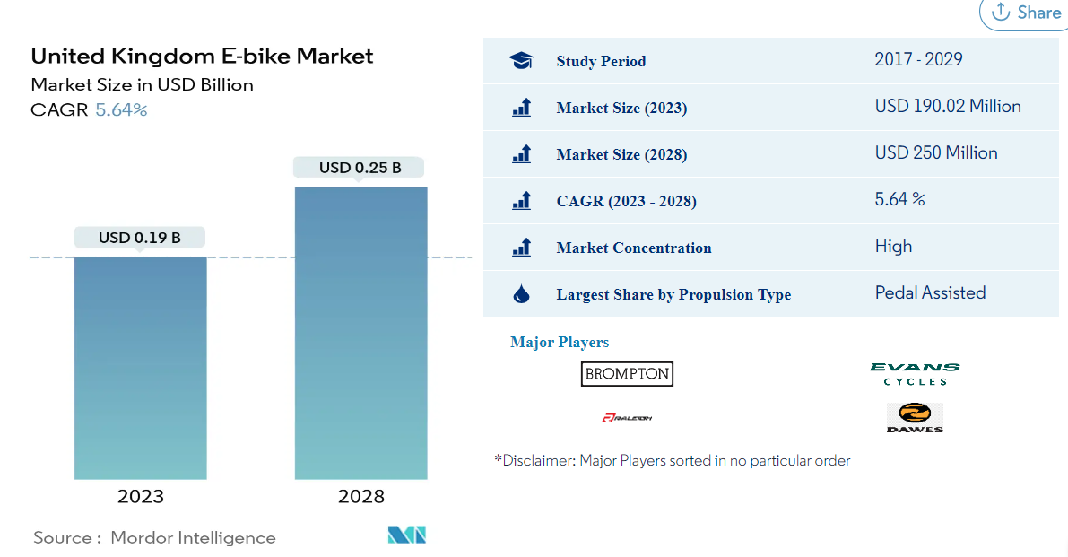

The United Kingdom E-bike Market size is expected to grow from USD 190.02 million in 2023 to USD 250 million by 2028, at a CAGR of 5.64% during the forecast period (2023-2028).

- Largest Segment by Propulsion Type - Pedal Assisted: Due to the national regulation that forbids the widespread use of continuous throttle-assisted propulsion, the pedal-assisted bikes segment is expected to dominate the market.
- Largest Segment by Application Type - City/Urban: Currently, the city/urban e-bikes segment has the biggest share in application type due to various advantages such as fuel efficiency, easy parking, timesaving, and less buying cost.
- Largest Segment by Battery Type - Lithium-ion Battery: Lightweight, fast-charging ability, the capability of providing a high range, long life span and high energy are some of the factors that make Li-ion battery the largest segment by battery type.
- Fastest-growing Segment by Propulsion Type - Throttle Assisted: An increase in leisure activities, like off-road riding and long-distance trips, and people's preference for bikes over cars for daily commutes make speed pedicels the fastest-growing segment by propulsion type in the market.

Pedal Assisted is the largest segment by Propulsion Type.

The record year in the United Kingdom for electric bike sales was 2018. Along with increased consumer awareness of what an electric bike is, a significant amount of e-bike market growth is anticipated due to a wider selection of electric bikes, ranging from entry-level, priced e-bikes to premium e-bikes with longer-lasting batteries and performance frames and components.
The e-bike market in the United Kingdom is poised for growth in the long term, fuelled by the rise of bike-sharing companies, the growth of e-commerce and delivery services using e-bikes, and government efforts to promote bicycles through improved cycling infrastructure.

The policy improvements to support growth in infrastructure contribute to the UK e-bike market's expansion. The United Kingdom has prioritised building e-bike infrastructure and is attempting to increase yearly spending to speed up the development of a connected and secure bike network. The increased number of municipal bike-sharing schemes in Scotland and the United Kingdom has increased the demand for electric bikes.

Due to the need for more accessible and safe public transit choices and social distancing, locals and visitors are utilising e-bikes more regularly. Raising Consumer Awareness of Electric Bikes' Health Benefits research from the University of Colorado Boulder quantified the health benefits of converting from driving to a class 1 e-bike for commuting. According to the research, utilising an electric bike instead of a car allowed participants to reach their prescribed levels of physical activity in a month while improving blood sugar management and cardiovascular endurance.

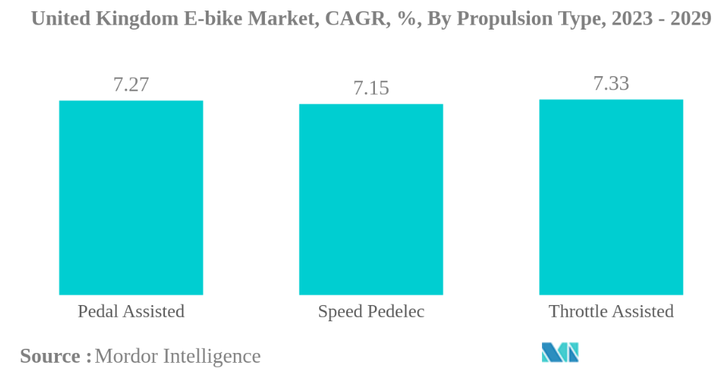

The United Kingdom E-bike Market is moderately consolidated, with the top five companies occupying 43.50%. The major players in this market are Brompton Bicycle Ltd., Evans Cycles Limited (Pinnacle), Raleigh Bicycle Company, Tandem Group Cycles (DAWES) and Tandem Group Cycles (Falcon Cycles) (sorted alphabetically).

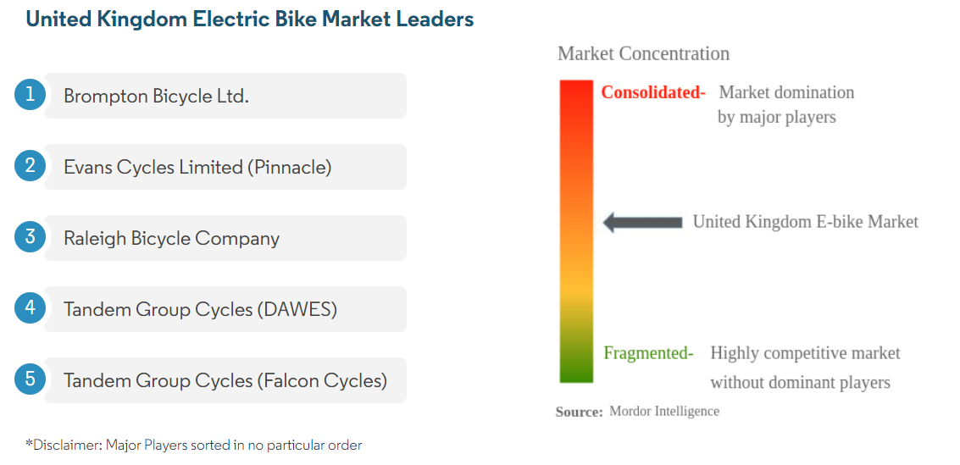

Regarding the assessing the impact of waiving the import duty on electric Chinese bikes into the UK and understanding the effects on our electric segment. At the moment according to the latest data available on the UK market from an internal business analysis report, the % share of the electric bikes on the total bicycle market is 8%, despite being below 10% the Compound Annual Growth Rate (CAGR) is predicted to overcome the 10% already at the end of 2023 and is predicted to grow further.

The immediate impact of waiving the duties for Chinese electric bikes would be to facilitate the import of these products in the UK and increase the supply of e-bikes priced at the entry level of the market widening the gap with top tier products like Brompton’s products under review (electric C Line £ 3000 and electric P Line £ 3650).

Below we can see the Average Selling Price (AVSP) of e bikes in 2022:

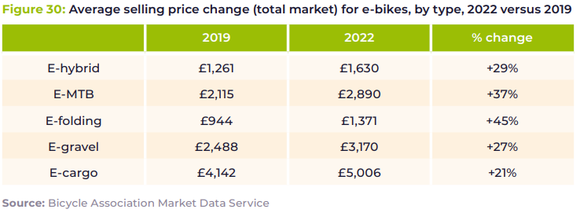

The AVSP for e-folding has been of £1,371 during 2022, the increase of 45% compared to 2019 has been driven largely from the e-bike frenzy fuelled by the pandemic and by the supply chain issues worldwide, but if we look closely to the evolution of the e-bike prices from 2018 we can see that during 2022 prices plateaued during 2022.

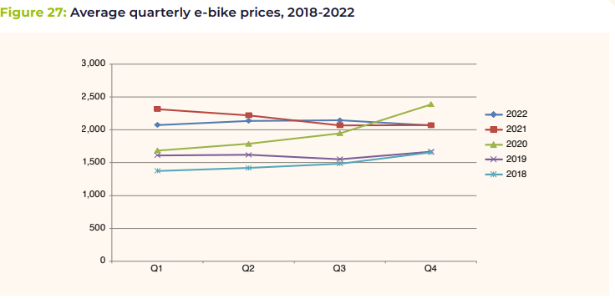

The increase in Chinese import triggered by the waiving of the duties will definitely put downward pressure on e-bike prices helping them to break below the £2,000 mark. The wide availability of cheap e-bikes will have an effect of the willingness to pay of some consumers, undermining Brompton price power and our ability to increase prices in a segment where our product is already in its decline stage.

This analysis was performed on the Brompton product range. However, it still holds true for Electric bikes, with a small shift away from true sporting enthusiasts with more focus on utilitarians.

Market Competitors

Within the Brompton world our products are not meant to compete, as these are part of the Brompton product range and offer different experiences within the customer journey.

There are a small number of direct substitutes (at the Brompton price point) making folding or e-folding products. Although there has been some innovation in the space, two of the traditional competitors in premium folding bikes, Riese and Muller and Tern have both turned their attention to cargo and urban mobility. In recent years, there has been more development in the e-folding space with new brands such as Eovolt (France) and MATE (Denmark) growing at pace.

GoCycle have been a competitor for ten years, but over the last three to five years newer brands such as Eovolt, designed and developed in France or MATE from Denmark have grown. These brands are priced below Brompton’s electric product and have primarily been focussed on consumer direct selling.

Other Electric folding:

The remaining competition comes primarily from central Europe, with brands such as Flyer and Victoria who offer Bosch equipped Electric folding bikes. These are not particularly compact, or lightweight, but provide a storage solution and an excellent ride experience. Indirect substitutes, there are a wide variety of indirect substitutes for a Brompton. In the subsequent table, brands with similar Urban or Compact positioning are considered. However, none of these offer the true flexibility and benefits of a Brompton – an E-Scooter can complete many of the tasks that a Brompton does, equally a VanMoof cannot be carried onto a train at rush hour or stored in a small flat in the same way as a Brompton can.

E-Scooters:

On the edge between a direct and indirect substitute, E-scooters have become more prevalent and even without being legal in the UK are outselling ebikes in terms of volume, with similar patterns in the USA and France. In Germany, sales dropped after legislation was passed, with the slower speed limit than a Ebike putting off potential customers. In Singapore E-scooters were banned in 2022. Beyond legislation, bicycles offer several comfort and safety advantages over E-scooters meaning they will continue to coexist in cities even as the product and law develops.

Shared mobility:

As has been the case for 20 years, shared bike and E-scooter schemes can offer the similar journey solutions to a folding bike. The product and schemes are developing but are a long way from sustainable with Tier mobility making redundancies in 2022.

Shared mobility struggles to deliver on the freedom of Brompton’s purpose without huge investment in fleet size and management, for the commuter there is always the doubt of reliability and for Brompton’s leisure customer, which makes up more than half of the global community, the schemes are not suitable.

Market Challenges

As stated earlier in this report, Brompton have been severely impacted by government regulations including the impact Brexit had on the business’ operations with increased customs debt being incurred. This includes the importation of anti-dumping duties for bicycle parts imported from China, which has meant the business having to obtain special customs procedures and incur additional compliance activities. These were needed for Brompton to stay competitive and ensure the brand’s survival in a post Brexit world.

Within the Ebike industry, the innovations and development of technology is a key driver, to develop the brand further providing our clients with the specifications they are expecting from the Brompton brand. We do face challenges, especially in China which will only allow Chinese platforms with China IP (Inward Processing) to be used – these blockers create a situation where Brompton can only supply non-electric models to China. This is severe trade barrier that has not been addressed by the UK government and has a direct impact for UK manufacturers that are unable to extend their exporting operations.

So, while Chinese Ebike manufacturers can reap the rewards of approved exporter status, UK manufacturers are severely restricted. The UK government is very keen to support exporting Ebikes globally – but when it comes to China “Exporting is not great.” There is extension protectionist approach in the United States of America to China’s restrictive nature on the China domestic marketplace, and as the leading UK bicycle manufacturer in the UK, we would expect the UK government to be more protective of our industry if reciprocal measures are not agreed.

If we analyse the “new money” in countries like China and Russia, the population now having significant disposable income with has led to substantial purchases for quality goods by global brands. Referring to the likes of Gucci, Mont Blanc etc, they are reaping the rewards of the domestic marketplace in these countries, but this is not available to UK manufacturers for Ebikes due to the excessive tariff rates applied by the Chinese customs authority – so there is no even playing field in practice.

When we also examine the factor of potential substitute goods in relation to the products under review and “like goods,” the industry is aware of the development of E-scooters which play a significant role as substitution goods. Although when measured against the craftmanship and components used in the Brompton brand, this is tangible.

We have commented earlier in this report on the factors that can influence the market for the review products and “like goods.” Other factors can include trade restrictions, the rate of inflation, the severe increase in the cost of living, changes in purchasing trends associated to our demographics.

Safety

Of greater concern for trends that can influence market share and business performance is the alarming increase in fires that are occurring from E-bikes and E-scooters. With an increased use of e-bikes and E-scooters, comes a corresponding fire safety concern associated with their charging and storage. The use of these products is expected to continue to rise. Some fire services and fire investigators have seen a rise in e-bike and E-scooter battery fires.

Currently there is limited data relating to the number of fires, but London Fire Brigade has reported 8 fires caused by e-bikes and e-scooters in 2019. This rose to twenty-four in 2020 and fifty-nine by December 2021. On occasions batteries can fail catastrophically, they can ‘explode’ and/or lead to a rapidly developing fire. This is why product testing against international standards is key, as some products on the market would create a risk to the population.

This has prompted the emergency services in the UK, such as the London Fire Brigade to post and information sheet to ensure guide to the public on best practice.

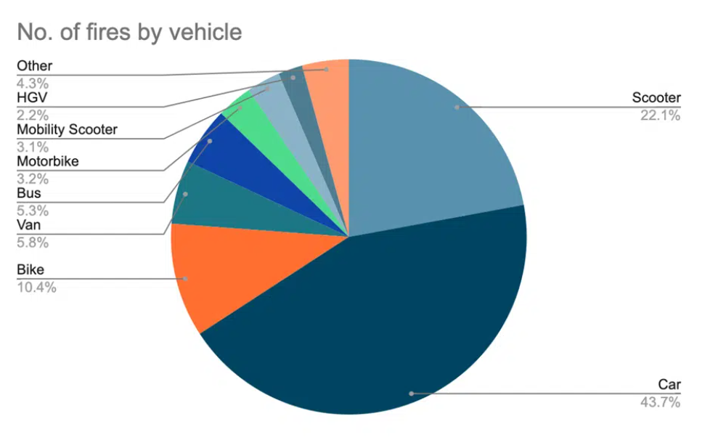

According to a report by the Insurer Zurich, 167 fires in the UK were reported to fire departments and attributed to lithium-ion batteries fitted in electric bikes and scooters in 2022. When you pit this figure against the estimated 1 million electric scooters (a huge number given they're still illegal on public access spaces like road and paths outside of pilot test schemes in a handful of UK cities!) and over 500,000 electrics bikes, this means estimates would show just 0.0113% of electric bike and scooter batteries set fire while charging or in use in 2022.

We have even seen articles by Trading Standards urging public and retailers to avoid non-compliant devices following a dramatic surge in house fires.

The Chartered Trading Standards Institute (CTSI) is warning consumers and businesses about the risks posed by non-compliant e-scooter and e-bike lithium-ion batteries, considering an alarming spate of household fires attributed to the devices.

The number of fires caused by lithium-ion e-scooter and e-bike batteries in the UK has surged almost 150% over the past year. In London alone, firefighters attended 88 fires caused by e-bikes in 2022 – an increase of 80% on the 49 responded to in 2021.

CTSI is urging businesses importing and selling e-scooters, e-bikes, and conversion kits to ensure that the products fully comply with product safety laws. The Institute is also warning consumers to only purchase devices from reputable retailers and to check that they display a valid UKCA or CE mark.

As a business, this concerns Brompton as although we can ensure our products are manufactured and tested to the highest standard, we cannot legislate for non-conformant imports. The fact that the Brompton battery is in a detachable case for simple removal does reduce the risk because our battery is not formed into the bicycle frame.

Such developments and reported incidents can only hinder our market and put the public at risk.

Production

Brompton’s history can be traced back to South Kensington, London in 1975 when engineer and creator Andrew Ritchie was inspired to design a better folding bike. Serenaded by the music from the Brompton Oratory (after which our bikes are named) the prototypes were crafted right there in his small, 1 bedroom flat.
Fast forward over 40 years later and each bike is hand-brazed, now by skilled craftspeople at our London factory. UK engineering and design is respected all over the world. Like Dyson, McLaren, and Rolls Royce – Brompton is a global exemplar of design excellence. Although the essential mechanics of the fold have not changed since the Mark 1 Brompton.
We use a range of leading technologies from rapid prototyping using 3D printers to ensuring precision using automotive industry CAM machines. Once the parts are produced, they are rigorously tested so we know they will be a match for real-world challenges.
Brompton proudly assembles each of its bikes in our west London factory.
Today it is a scene of organisation and efficiency where uniformed staff work alongside machines in areas designed for optimum production. Tasks include brazing frames and assembling bike parts, using state-of-the art bespoke robotics that are also designed to help guard Brompton’s design from copycats.
At Brompton, we have been investing heavily in producing good, efficient manufacturing processes. That investment is now helping Brompton compete with rivals that have not developed their production processes but farmed work out to manufacturers in India and China to save money, only to be hit by a rise in staff and production costs as those countries’ economic growth took off.
Brompton, which makes more than 70 percent of its sales from 43 overseas markets, is now looking to win customers from California-based Dahon and Taiwan-headquartered Tern, which make their folding bikes in Asia on a mass scale. It is also chasing export sales in many other new markets.
The value added within Brompton production surrounds are highly trained engineers, the handcraftsmanship and the quality of components that are used. Significantly, our bicycles have a hand brazed steel frame, produced using traditional techniques by a highly skilled UK labour force. This results in exceptionally durable bikes which have beautiful highly cosmetic joints. This is particularly noticeable on our clear lacquer e-bikes. As such, value added to our product comes from the fact our bikes are hand crafted from raw materials within the UK, and the time taken to train our staff to complete these operations to the elevated level our customers value. Our brand is renowned for manufacturing within the UK, and the European Bicycle Association recognised the high value add that these factors bring to our brand in articles that they have posted online that are freely available.

Supply Chain Issues

Global events over the past few years have impacted the upstream supply chain. Starting with the COVID-19 pandemic, which resulted in nationwide lockdowns that put a temporary stop to raw materials transport. Since most raw materials were imported from China, which was the first to be impacted by the pandemic, there was a long and massive disruption in transportation links and raw materials supply (the Suez Canal crisis).

The 2021 Suez Canal blockage, for example, put a temporary stop to a major portion of the global shipping industry. Each day of the blockage cost anywhere between $14 million and $15 million in lost revenue.

The downstream supply chain involves activities post the manufacturing process, which would mean getting the finished goods to the end consumer.

Just like the upstream supply chain, downstream activities have also been impacted by recent global events. Lockdowns and labour shortages undoubtedly led to supply chain bottlenecks as many warehouses had to be shut down, resulting in fulfilment and distribution processes being upended. Whichever shipping carriers were still operational were stretched beyond capacity, which meant that customers had to wait for much longer to receive their goods.

Even as the supply chain began to resume as normal, there were additional unexpected incidents that highlighted the need for increased supply chain resilience.

Due to the ever-increasing challenges facing the Brompton supply chain, we have mechanisms in place to mitigate the risk this poses to our operations. Below are the key aspects that we focus on:

- Think and plan!
- Diversify our suppliers.
- Monitor latest trends and events to act accordingly.
- Ise Key Performance Indicators to manage and identify pressure points.

Conclusion

It is reasonable to expect that any actions which would reduce the demand from the products manufactured by Brompton Bicycles Limited would have a negative impact on both current and future headcount. It would be expected that production headcount would decrease in line with the per employee production capacity. However, it is also important to note that a wide range of Brompton employees outside of the production team are engaged in the development of impacted goods, including those working in Design, software, R&D etc. By decreasing the potential size of the future market, this puts skilled future UK jobs at risk.

Brompton has always positioned itself as a differentiator, offering a better designed product, manufactured with more advance materials and techniques. This allows Brompton to operate at an appropriate price point, for a highly engineered product which will last years. However, there are strict limitations to the price sensitivity of consumers. Should the current measures be removed, it is expected that there will be materially significant reductions in the domestic sales of the goods subject to review, and consumers will instead be encouraged to buy products made using inferior materials and methods, which will ultimately be disposed of in a short time frame, after posing safety threats to consumers and the public.

All the core products in the Brompton range share the same underlying design principles, as well as the same ‘look and feel’ to the customer, despite operating in different sub-markets. By reducing market share in one subcategory, this will inevitably result in a reduction in brand awareness and word-of-mouth marketing which will have negative consequences across the range.

Brompton Bicycle Ltd do not only compete with other folding bikes, but also other electric forms of personal mobility. Brompton must be able to offer a comprehensive range of products to the consumer, to stay relevant and avoid falling into a niche categorisation by the wider public. The market for electric bikes is increasing, and therefore this will become more amplified in future years. If Brompton is less able to compete in the Ebike market, this will undoubtedly have a negative impact on the full range of our product portfolio.

Potential impact of measure changes

Brompton, like various manufacturers in the UK, would agree with the European Cycling Strategy, that market conditions should encourage industrial investment in innovation, regardless of the source of the bikes.

Brompton have just received an Innovate UK grant for £1.5 million to support some cutting-edge innovation in manufacturing technology and motor development. The UK is positioned to be a global leader in light electric transport, which will be led by Brompton. In the next ten years cities will increasingly exclude automobiles and replace with folding e-bikes, e-cargo bikes, and a range of light electric vehicles. This is a nascent industry with many start-ups gaining traction such as EAV – Powered by People | EAV Cargo Bikes. If anti-dumping is lifted it is likely that this momentum will be snuffed out and the competitive advantage handed over to Europe.

To grow e-bike use to the predicted level, and potentially well beyond this level, significant investment is still needed by industry in further product development. This is an immature market and there is potential for significant innovative technologies to come into the market. ECF welcomes investment in developing new products and technologies in any country but is concerned that for competing with countries which practice dumping is a disincentive to corporate investment.

The gravest concern is that the market could be flooded with cheaper Ebikes that, as already stated, could put the public at risk, due to reported fire incidents, Brompton has a special relationship with its customers and ensuring our goods are not impacting our environment – and ensuring the UK is only permitting safe products into the market – otherwise this would be breaching product standards that should be adhered to.

The National Statistics Office in the UK, has the below facts regarding the China export revolution as stated below:

- In 2021, China was the UK's largest import partner and sixth-largest export partner for goods.
- The UK imported £63.6 billion of goods from China in 2021 (13.3% of all goods imports to the UK) and exported £18.8 billion of goods (5.8% of all goods exports from the UK)
- The main goods import from China in 2021 was machinery and transport equipment (£27.5 billion), primarily office machinery and telecoms and sound equipment; machinery and transport equipment were also the main goods export (£7.7 billion)
- In 2021, the UK imported £2.5 billion of services from China (1.4% of all services imports) and exported £8.2 billion of services (2.7% of all services exports)
- The main services import from China was other business services (£1.1 billion), while the main services export was travel (£2.8 billion), specifically personal travel.
- China is one of the UK's largest trading partners, accounting for £93.0 billion (7.3%) of the UK's total trade in 2021.
- The UK had a £39.1 billion trade deficit with China in 2021, which means we imported more than we exported; we had a £44.8 billion trade deficit in goods which was offset by a £5.7 billion surplus in services.

The TRA has provided exemptions for approved Chinese exporters in November 2022, and UK businesses are seeing no exemptions or reduction of challenges they face to bring goods to the domestic Chinese marketplace. To ensure a fair playing field we would expect any changes to be reciprocal under UK & Chinese legislation.

Brompton also wants to reiterate the TRA mission which is to defend UK economic interests against unfair international trade practices, the additional duties and licensing to import Ebikes into China is an unfair international trade practice and a clear trade barrier. The UK approach should be to safeguard such industries and promote UK business so we can export throughout the world, and therefore add to the GDP of the UK. Any acceptance of the elimination of additional duties would have a negative impact on our domestic marketplace and would only permit dumping of cheap Ebike products on the UK domestic market.

Instead of the proposal, we would urge the UK government to ensure they put a Free Trade Agreement in place with China, and then all businesses in either country could benefit from such an agreement, rather than only aiding one party – as that will only put additional risks and fiscal impact on UK manufacturing.

The UK focus should be geared towards high quality and highly skilled products being delivered onto the UK and global marketplace, otherwise this decline will continue – and cheap imports will only increase the throw away commercial culture.

