Register as a contributor to the case

Anti-dumping investigation
Case AD0012: Aluminium Extrusions exported from the People’s Republic of China

Period of Investigation: | 01/06/2020 – 31/05/2021
Injury Period: | 01/06/2017 – 31/05/2021
Deadline for response: | 06 July 2021
Case Team Contact: | AD0012@traderemedies.gov.uk
Completed on behalf of: | Alvance British Aluminium

When you have completed this form, indicate the confidentiality of this document by placing an X in the relevant box below:

☐Confidential
Non-Confidential – will be made publicly available

Please note that you will have to provide two copies of your response – a Confidential and a Non-Confidential version. Both copies should be returned to the TRA using the Trade Remedies Service (www.trade-remedies.service.gov.uk) by 06 July 2021.

Table of Contents
Table of Contents 2
The scope of this investigation 3
Instructions 4
I – Why you are being asked to complete this form 4
II – Who should complete this form 4
III – Deadline for response 4
IV – Note about confidentiality 5
Section A – Your organisation and your interest in the case 6
A1 Identity and contact details 6
A2 Your organisation’s interest in the case 6
Section B – Additional information 8
Section C – Certification 9

The scope of this investigation

Goods Concerned

This investigation covers Aluminium Extrusions exported from People’s Republic of China (PRC), described as:

The goods under investigation are bars, rods, profiles (whether or not hollow), tubes, pipes; unassembled; whether or not prepared for use in structures (e.g. cut to length, drilled, bent, chamfered, threaded); made from aluminium whether or not alloyed, containing not more than 99.3% aluminium.

The product concerned is commonly referred to as ‘aluminium extrusions’, referring to its most common manufacturing process even if it can also be produced by other production processes such as rolling, forging or casting.

These Aluminium Extrusions are currently classifiable within the following commodity code(s): 76041010, 76041090, 76042100, 76042910, 76042990, 76081000, 76082081, 76082089 and 76109090.

In this form, these goods will be referred to as ‘the goods concerned’. Any reference to ‘goods concerned’ in this form refers to the goods description above, regardless of the commodity code under which they are exported.

Like goods

Any reference to ‘like goods’ in this form refers to goods produced in the UK or imported to the UK from a country other than the People’s Republic of China which are like the goods concerned in all respects, or with characteristics closely resembling them.

Instructions

The Trade Remedies Authority (TRA) is responsible for investigating the allegation that Aluminium Extrusions from the People’s Republic of China (PRC) are being exported to the United Kingdom (UK) at prices less than their normal value and that this dumping (sales at less than normal value) is causing injury to the UK industry for these goods.

I – Why you are being asked to complete this form

We are seeking your cooperation as an interested party or a contributor, who wishes to participate in this investigation by providing information to help TRA conduct this investigation. The information your organisation provides will help us determine a fair and appropriate response which is in the UK’s overall interest. This form allows us to collect basic information and data about your organisation and your interest in this case.

An interested party or a contributor, who could use this form to register their interest in this investigation include, for example:
- a foreign government;
- a trade or business association representing a UK producer of the like goods, or an exporter or an importer of the goods concerned;
- an upstream supplier to a UK producer of the like goods, or an exporter or an importer of the goods concerned;
- a downstream buyer of the goods concerned and/or like goods;
- a natural person or a legal person.

For more information about this case, you may refer to the Notice of Initiation published at: www.trade-remedies.service.gov.uk/public/cases.

II – Who should complete this form

You should complete this form if you are an interested party or a contributor, who wishes to participate in the Aluminium Extrusions investigation.

If you are producer, importer or exporter of the goods concerned or like goods, please complete the relevant Pre-Sampling Questionnaire.

III – Deadline for response

A completed form must be submitted to the TRA by no later than 06 July 2021. If you are unable to provide a completed submission by the given due date and you wish to request an extension, please contact the Case Team at: AD0012@traderemedies.gov.uk.

IV – Note about confidentiality

You will need to submit one confidential version and one non-confidential version of this document. Please ensure that each page of information you provide is clearly marked either “Confidential” or “Non-Confidential” in the header. It is your responsibility to ensure that the non-confidential version does not contain any confidential information.

Please see https://www.gov.uk/government/publications/the-uk-trade-remedies-investigations-process/an-introduction-to-our-investigations-process#how-we-handle-confidential-information for further information on what can be considered confidential and how to prepare a non-confidential version of this document.

All information provided to the TRA in confidence will be treated accordingly and only used for this investigation (except in limited circumstance as permitted by regulation 46 of the Trade Remedies (Dumping and Subsidisation) (EU Exit) Regulations 2019) and will be stored in protected systems. The non-confidential version of your submission will be placed on the public file, which is available on www.trade-remedies.service.gov.uk/public/cases.

Section A – Your organisation and your interest in the case

A1 Identity and contact details

Please complete the table below, ensuring that the point of contact given has the authority to provide this information:

Legal name of company: | Alvance British Aluminium LTD
Legal structure (e.g. limited company, sole trader, partnership etc): | Private Limited Company
Year of establishment: | 5 years
Other operating names: | N/A
Name (point of contact):
Position:
Address: | Lochaber smelter, North Road, Fort William PH33 6TH
Telephone No:
Email:
Website: | www.alvancegroup.com

A2 Your organisation’s interest in the case

To register your organisation’s interest in this case, please complete the text boxes below. You should use this form if you are not a producer, importer or exporter of the goods concerned or like goods. For a definition of goods concerned/like goods, please refer to the Notice of Initiation.

Please describe the role of your organisation with regards to the goods concerned or the like goods:

Please answer here
Alvance British Aluminium are currently working through the project management stage gate methodology, working towards brining major investment to the lochaber and Highlands through the creation of a multimillion-pound investment on a new extrusion billet production facility. This facility will service the upstream supply of extrusion billet to the Like Goods securing the presently employed personnel at the Aluminium smelter and creating many more jobs and safeguarding local businesses servicing the current and future activities.

Please describe your interest in this case:

Please answer here
Any acceptance of the UK to import Like goods without implementing duties currently imposed within Europe would for such products, reduce any business case for the proposed upstream production facility at Lochaber, jeopardize the employment of the current personnel employed at Alvance British Aluminium in Lochaber and the supporting businesses and activities. This would have a negative social and economic impact in an area with few large employers other than Alvance British Aluminium which are not seasonal or linked to tourism.

In the context of the UK Government’s regulations and guidelines associated with the COVID-19 pandemic, please state if this has had any impact on your organisation’s normal business activity during the Period of Investigation (01/06/2020 – 31/05/2021). If applicable, please provide evidence.

Please answer here
Whilst Alvance British Aluminium was able to continue supplying its current downstream customers the adverse effect of the dip in the commodities markets due to covid eroded the EBIDA of the value-added product which Alvance was manufacturing/suppling
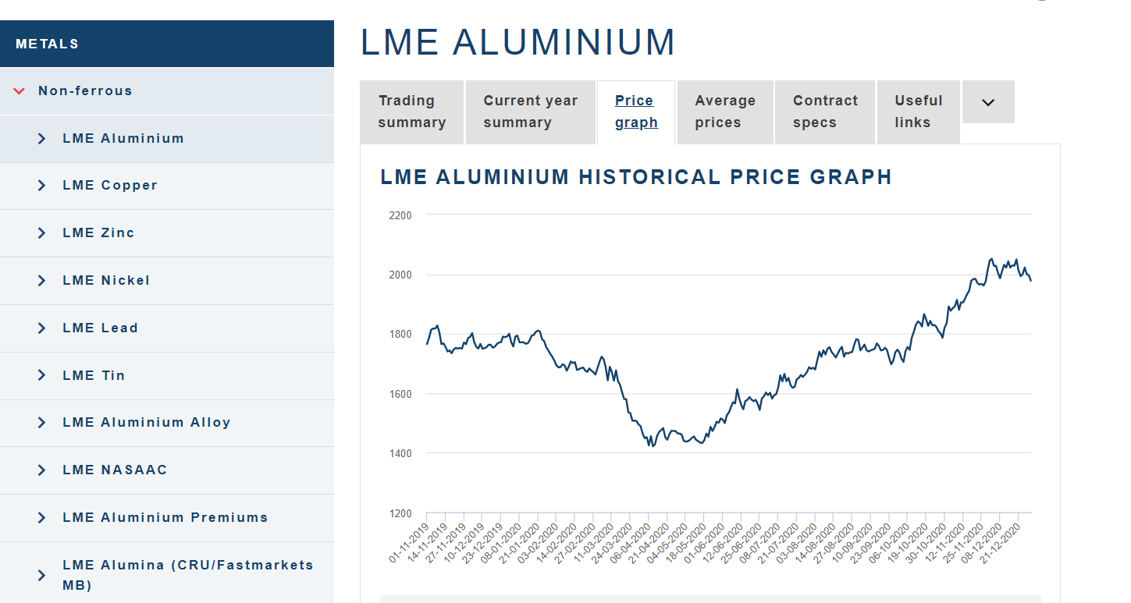

Source: London Metal Exchange: LME Aluminium

Section B – Additional information

Use the box at the end of this section to provide any other relevant information which you think would be useful to help our investigation.

This may include:

- other parties you believe should receive a questionnaire;
- any initial views you have about the possible existence of a particular market situation in the domestic market of the exporting country or territory such as:
  - situations/distortions in the domestic market of the exporting country where prices are artificially low;
  - significant barter trade;
  - prices reflect non-commercial factors; or
  - any other reason
which means it is not appropriate to use the comparable price to determine the normal value of the goods concerned;
- the scope of the investigation; or
- anything else you consider relevant.

Please answer here
Serious concerns around the UK becoming a conduit for the Like goods and the implications of the Irish and other borders being utilised as a means to access the European markets where tariffs are already in place.
Implementation of tariffs will encourage investment and enhance job creation in the UK extrusion sector and its supply chain.

In addition, if your organisation buys the goods concerned and/or like goods, please provide the following information for the POI (01/06/2020 – 31/05/2021):

Number of UK sites using the goods concerned and/or like goods | N/A
Number of employees at UK sites using the goods concerned and/or like goods | N/A
Total production which uses the goods concerned and/or like goods during POI (volume, in metric tonnes) | N/A
Total production which uses the goods concerned and/or like goods during POI (value, in £) | N/A
Name of supplier(s) of the goods concerned and/or like goods | N/A

Section C – Certification

The undersigned certifies that the information supplied herein is correct and complete to the best of his/her knowledge and belief.
The undersigned certifies that he/she has the authority to supply the information contained herein on behalf of his/her organisation.

Signature (including e-signature):

(**Please do not fill in the ‘Name’ or ‘Position at Company’ sections on your company’s non-confidential version of this questionnaire**)

Name: Click or tap here to enter text.

Position at organisation: Click or tap here to enter text.

Date: [5/7/21]

