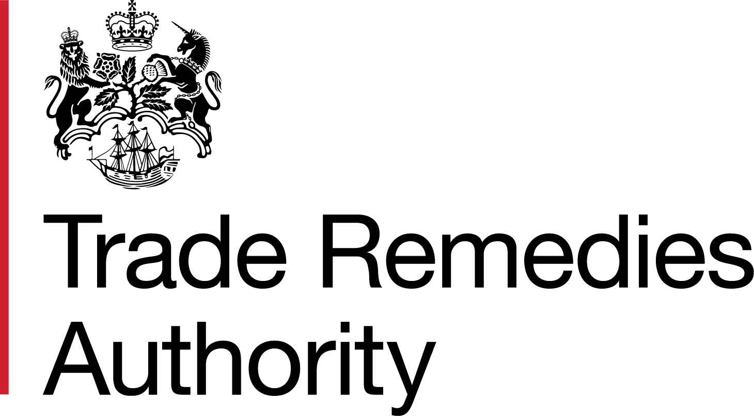
Trade Remedies Authority
North Gate House
21-23 Valpy Street
Reading
Berkshire
RG1 1AF
United Kingdom
[ redacted ]
[ redacted ]
Ministry of Commerce of the People’s Republic of China
No. 2 Dong Chang’an Avenue
Beijing
People’s Republic of China
20 January 2023

Dear [ redacted ],

TD0029 – Anti Dumping Transition Review concerning certain cast iron articles originating in the People’s Republic of China

Notification of PMS enquiry

We are writing to inform you that we are investigating whether a particular market situation (PMS) exists in the Certain Cast Iron Articles market in the People’s Republic of China (PRC) as part of our transition review TD0029.

We would like to give you the opportunity to comment or provide information on whether a PMS exists in the certain cast iron articles market in the PRC should you wish to do so. Please provide any response by 24 February 2023. If you respond after this deadline, the information contained in your response may be disregarded. Please note that any submission should be made through the online Trade Remedies Service, which can be accessed via our website. If you are providing confidential information, please also provide a non-confidential version that can be placed on the public file.

We have attached to this letter below more detailed questions in relation to the PMS allegations.

If you have any questions or comments, please do not hesitate to contact us at TD0029@traderemedies.gov.uk.

Yours sincerely,
[redacted]

D [ redacted ]
E [ redacted ]

Claims Concerning a Particular Market Situation (PMS)

Claims have been made by various interested parties on the public file to the case, as well as the original EU case AD637, regarding the market conditions that affect the production and export of the goods subject to review and the production and domestic sales of like goods within the People’s Republic of China (PRC). The following allegations have been raised:
- The Government of the People’s Republic of China (GOC) has influence and/or control over producers of the goods subject to review and like goods, regarding internal company decision-making, which may affect the cost and/or price of the goods. The various interested parties to the case, as well as the original EU case AD637, put forward information to support these claims, including:
- European Commission Staff working document on the People's Republic of China for the purposes of trade defence investigations, which includes evidence that the GOC interferes with the decision-making processes of private and state-owned companies in pursuance of goals that reflect the GOC’s interests rather than the free market (p.39).
- Evidence that there is a substantial degree of direct and indirect ownership of the producers of the goods subject to review by the GOC.
- Evidence that the main purchasers of certain cast iron articles in the PRC are State Owned Enterprises (SOEs), giving the GOC a de facto monopsony over the domestic producers of the goods subject to review.

Please comment on these claims and describe the GOC influence and or control over internal company decision making. If there are specific producers of certain cast iron articles over which the GOC has control or influence regarding internal company decision-making, it would be helpful if you can name those producers.

Please answer here

Appendix reference:

- Government support to producers of the goods subject to review has distorted the development of the Chinese certain cast iron articles industry, having an impact on costs and prices. The various interested parties to the case as well as the original EU case AD637 put forward information to support these claims, including:
    - European Commission Staff working document on the People's Republic of China for the purposes of trade defence investigations, which includes evidence that the GOC intervenes in the economy to support industries that it deems strategic (see e.g., p14).
    - Evidence that the waste and scrap iron or steel, coke and coal, silicon carbide, ferro-alloys, energy (electricity, natural gas and fuel), water, labour, packaging materials, land and capital sectors are treated as strategic sectors by the GOC, as per the previous point.
    - Financial reports that list grants and other direct financing measures provided by the GOC to producers of the goods subject to review.
    - Laws that provide the legal basis for the GOC to operate in this way, as well as GOC circulars that recommend such support to regional authorities.
    - Evidence of various discounts from SOEs, including on export insurance and raw materials.
    - Evidence that the GOC discriminates in favour of domestic suppliers and restricts foreign investment.

Please comment on these claims, and describe any government measures, policies, laws or directives (including regional and industry specific measures) that have impacted any aspect of the production and sale, whether domestically or for export, of Certain Cast Iron Articles during the injury period, 01 October 2018 – 30 September 2022. If these measures are no longer in place, please indicate when this occurred.

Please answer here

Appendix reference:

- Government policies may have contributed to excess supply of certain cast iron articles raw materials, such as waste and scrap iron or steel, coke and coal, silicon carbide and ferro-alloys, that have therefore influenced the price of inputs for production as well as the export price. The original case AD637 put forward information to support these claims, including:

- European Commission Staff working document on the People's Republic of China for the purposes of trade defence investigations, which includes evidence that the GOC sets development targets for the production of strategic products and materials like waste and scrap iron or steel, coke and coal, silicon carbide and ferro-alloys.
- National programmes to encourage and speed up the development of strategic products including waste and scrap iron or steel, coke and coal, silicon carbide and ferro-alloys.
- A comparison of the cost of inputs for a Chinese producer vs. the cost of those same inputs for a producer involved in the European Commission investigation.

Please comment on the nature of these measures, and any benefits that producers and exporters may have gained from them. If these measures are no longer in place, please advise when they ended.

Please answer here

Appendix reference:

- Government intervention has led to reduced energy costs (including prices of gas, coal and electricity) incurred by producers of the goods subject to review. The original case AD637 cited the European Commission Staff working document on the People's Republic of China for the purposes of trade defence investigations as evidence for these claims.

Please comment on these claims and describe any influence that any government department, agency or institution, has had on the energy costs incurred by producers within the certain cast iron articles industry. This may include:
- Information about whether government agencies regulate electricity, coal or gas prices, including how these are regulated.
- How electricity prices are determined for different provinces and industries.

Please answer here

Appendix reference:

- The credit system in the PRC is distorted, with certain companies possessing preferential access to capital, particularly those that are members of strategic industries. The original case AD637 put forward evidence to support these claims, including:
- Various laws that provide the legal basis for this preferential treatment, including article 34 of the ‘Chinese Commercial Banks Law’, which stipulates that commercial banks must operate in accordance with the industrial policies of the state, not the demands of the market.
- European Commission Staff working document on the People's Republic of China for the purposes of trade defence investigations.

Please comment on these claims and describe any capital benefits distributed to exporting producers by a government department, agency, institution, or SOE bank (including investment, loans (e.g., export contingent loans), or grants), motivated by non-market forces, during the injury period, 01 October 2018 – 30 September 2022. This includes access to finance granted by institutions which implement public policy objectives or otherwise not acting independently of the State.

Please answer here

Appendix reference:

- Please provide information on any government intervention in the labour market, within the certain cast iron articles industry. This includes:
- Laws or government policy affecting the formation and operation of Trade Unions.
- Laws or government policy affecting wages or salaries (including minimum or maximum wage rates).
- Government intervention in the hiring or dismissal of employees working for certain cast iron articles producers.
- The impact of the Hukou household registration system.

Please answer here

Appendix reference:

- Please describe any government intervention that has occurred in the allocation or sale of land to producers within the certain cast iron articles industry (which has been used in the production and/or export of the like good or goods subject to review). This may include (but is not limited to) discounts or preferential contract terms and may be a result of provincial or industry specific government policies.
Please answer here

Appendix reference:

- Please provide any information which you believe is relevant and would like us to consider as part of our determination on whether a PMS exists in the certain cast iron articles industry in your country.

Please answer here

Appendix reference:

