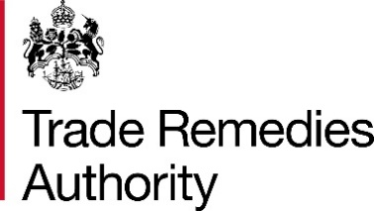

Extension – Note to Public File

Note to the public file summarising a time extension granted for submission of a SEF responses to AS0067 – HVO from the US
The Trade Remedies Authority (TRA) received an application for an extension of time to file responses to the Statement of Essential Facts that was published on 28 November 2025. Having considered the application, the TRA has determined that granting an extension would not significantly impede the progress of the investigation and has therefore decided to grant an extension to the following parties:

Party Name | Reason for granting extension | Request date | Number of days granted | New date for completed questionnaire response
Valero Limited (Importer) | - Significant data to review  - Staff leave due to Christmas period | 17 December 2025 | 14 days | 2 January 2026
Diamond Green Diesel (Exporter) | - Significant data to review  - Staff leave due to Christmas period | 17 December 2025 | 14 days | 2 January 2026
St Bernard Renewables (Exporter) | - Significant data to review  - Staff leave due to Christmas period | 18 December 2025 | 14 days | 2 January 2026

Should you have any questions or comments, please do not hesitate to contact us at AS0067@traderemedies.gov.uk

