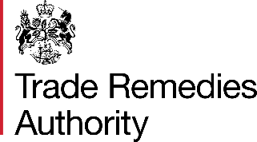

Extensions - Note to Public File
Note to the public file summarising time extensions granted for submission of responses to the Statement of Intended Final Determination (SIFD)

The Trade Remedies Authority (TRA) has received applications for an extension of time to submit responses to our SIFD.
Each application for an extension of time has been assessed individually. We have considered the reason for the request, the individual circumstances of the relevant party and the anticipated impact of the requested extension on the investigation timeline.
Having considered their applications, the TRA has determined that granting certain extensions would not significantly impede the progress of the investigation and has therefore decided to grant extensions to the following parties:

Name | New due date for completed questionnaire response
Ministry of Commerce, India | 12 March 2024
The Ministry of Trade of Republic of Türkiye | 12 March 2024

Please contact SE0041@traderemedies.gov.uk if you have any questions or comments relating to this review.

