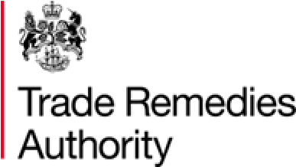
ER0081: Anti-dumping expiry review relating to Welded Tubes & Pipes originating in the Republic of Belarus and the People’s Republic of China
External timeline
This is an indicative timetable for interested parties and contributors and is in no way legally binding. We may need, at times, to deviate from the suggested timeline below dependent on the specific circumstances of the case.

Case stage: | Date:
Case initiation | 27 January 2026
Deadline to register an interest | 11 February 2026
Issue of questionnaires | February 2026
Deadline for return of questionnaires | March 2026
Verification | March to April 2026
Publication of Statement of Essential Facts (SEF) | 27 April 2026
Deadline for submissions in response to SEF | 27 May 2026
Final Recommendation | September 2026

