Trade Remedies Authority

Anti-dumping and Subsidy Investigations:
Application form

When you have completed this form, indicate the confidentiality of this document by placing an X in the relevant box below:

☐ Confidential
X Non-Confidential – will be made publicly available

Please note that you will have to provide two copies of your response – a Confidential and a Non-Confidential version. Both copies should be returned to the TRA using the Trade Remedies Service (www.trade-remedies.service.gov.uk).

Contents

Instructions 3
About The Goods 5
About the Application 17
About Other Interested Parties 19
Representativeness 26
Subsidised imports 27
Injury 42
Causal link between the imported goods and injury to your industry 50
Declaration 53
Checklist 54

Instructions

About us
The Trade Remedies Authority (TRA) is an arm length body of the UK’s Department for Business and Trade. It carries out trade remedies investigations to find out if a new trade measure may be needed to counter dumped or subsidised imports or a sudden surge in imports.
The legislative framework that the TRA operates under is found in the Taxation (Cross-border Trade) Act 2018) (‘the Act’) and the Trade Remedies (Dumping and Subsidisation) (EU Exit) Regulations 2019 (‘the Regulations’).

About you
You can apply to us to open an investigation if you are a UK producer of goods or a representative of a UK producer and you have evidence of unfair trade practices relating to the dumping or subsidy of goods imported into the UK.
You must provide sufficient evidence of dumped or subsidised goods being imported in the UK and that the dumped or subsidised imports have caused or are causing injury to the UK industry (in compliance with the Act)
You can find out more about our remit and how we work by reading our guidance on trade remedies investigations.

About this form
Complete this form and the relevant annexes if you want to apply for a new anti-dumping or subsidy investigation. This form will give us the information we need to decide whether to initiate an investigation into your concerns. You can find more information on how we assess applications in our guidance.
You must submit your application online through the Trade Remedies Service (https://www.trade-remedies.service.gov.uk). When you submit your application, you must also submit a non-confidential version (including the annexes) which doesn’t contain any data you think is sensitive (for instance, commercial data about your company), as we are required to publish a copy of the application form. You can find out more about what can be considered confidential and how to prepare a non-confidential version of your documents in our guidance.
If you are considering submitting an application and would like to discuss it with someone first, please email contact@traderemedies.gov.uk. You can find more on completing this application in our Pre-Application Office and application assessment guidance.

What happens next
Once you have completed this application form you can share a confidential version with the Pre-Application Office to get feedback before you formally submit your application. When you formally submit your application, you will need to submit a confidential and a non-confidential version of this form. Please upload these through our Trade Remedies Service at www.trade-remedies.service.gov.uk.
Once you have done this:
- you will receive an email confirming the documents have been uploaded successfully;
- the assessor(s) of your application will contact you if further information is required; and
- the assessor(s) of your application may contact you to arrange a visit to verify the information contained in your responses.

How to complete this application form
Please read and follow all the instructions carefully. You will need to provide evidence to support your concerns. You may need to attach supporting documents in appendices to supplement the answers you give.
Please also note the following points:
- Try to avoid leaving any questions blank. If the question isn’t relevant to you, please try to explain why.
- If the answer to a question is “zero”, “no”, “none” or "not applicable”, please write this rather than leaving the answer blank.
- If you feel you can’t present the information as requested, please contact the Pre-Application Office by emailing contact@traderemedies.gov.uk.
- If there is not enough space in any part of the application form to provide a full answer, please attach appendices. Please ensure that any attachments are given a corresponding appendix reference in the title of the document and that these are referenced in the boxes provided.
- If you include any documents not in English, please provide an English translation.
- Provide all dates in the format DD/MM/YYYY (e.g. 23/05/2019).
- For all numerical figures, where appropriate please express every third number with a comma (e.g. ‘1,300’ for one-thousand three hundred, ‘1,300,000’ for one million and three-hundred thousand).
- Limit all sales/currency/income figures to two decimal places and use the appropriate currency symbol (e.g. £1,300.00).
- All figures should be reported net of tax unless otherwise stated.
- For definitions of the incoterms used throughout this document, please visit the International Chamber of Commerce.

About The Goods
This section of the application form is about the imported goods you want us to investigate. These imported goods will be referred simply to as ‘the goods’.
You can only ask us to investigate imported goods if you (or the industry you represent) produce ‘like goods’. Like goods are defined as goods which are similar to the goods under investigation in all respects or have characteristics which closely resemble them. When we decide what are like goods, we will consider the following non-exhaustive list of criteria:
- physical likeness, such as physical characteristics
- commercial likeness, including competition and distribution channels
- functional likeness, such as end-use or if the goods can be substituted for each other
- similarities in production, such as method and inputs
- other relevant characteristics

The Imported Goods
      - Describe the imported goods you are concerned about (if possible, please attach digital versions of images, brochures, catalogues, etc which show the goods in question).
Carboys, bottles, flasks, jars, pots, phials, and other containers, of glass, of a kind used for the conveyance or packing of goods; preserving jars of glass. Not including ampoules; containers made of tubular glass; glass containers with a nominal capacity of 2.5 litres or more; or stoppers, lids, and other closures (of any kind, whether sold with glass containers or sold separately)
As part of the application, we would like to request registration of imports due to the significant risk of stockpiling.
Many UK wholesalers are using Turkish Imports, and this will hopefully offer some protection.
Appendix reference:

      - Explain where the imported goods you are concerned about are being exported from.
Turkey
Appendix reference:

      - Provide the tariff classification(s) for the imported goods.
- 70109010: Preserving jars (sterilising jars)
- 70109041: Food and drink / Bottles of colourless glass / 1 l or more
- 70109043: Food and drink / Bottles of colourless glass / More than 0.33 l but less than 1 l
- 70109045: Food and drink / Bottles of colourless glass / 0.15 l or more but not more than 0.33 l
- 70109047: Food and drink / Bottles of colourless glass / Less than 0.15 l
- 70109051: Food and drink / Bottles of coloured glass / 1l or more
- 70109053: Food and drink / Bottles of coloured glass / More than 0.33 l but less than 1 l
- 70109055: Food and drink / Bottles of coloured glass / 0.15 l or more but not more than 0.33 l
- 70109057: Food and drink / Bottles of coloured glass / Less than 0.15 l
- 70109061: Food and drink / Other / 0.25 l or more
- 70109067: Food and drink / Other / less than 0.25 l
- 70109071: For pharmaceutical products of a nominal capacity / exceeding 0.055 l
- 70109079: For pharmaceutical products of a nominal capacity / not exceeding 0.055 l
- 70109091: Other / of colourless glass
- 70109099: Other / of coloured glass
Appendix reference: I1 ‘raw data’ tab, column E

      - Give details regarding whether the imported goods are currently subject to any anti-dumping/countervailing/safeguard measures or ongoing investigations in other countries.
We are not aware of any existing investigations against Turkish container glass products.
Appendix reference:

The Like Goods
      - Describe the like goods produced by the UK industry (if possible, attach digital versions of images, brochures, catalogues, etc).
Carboys, bottles, flasks, jars, pots, phials, and other containers, of glass, of a kind used for the conveyance or packing of goods; preserving jars of glass. Not including ampoules; containers made of tubular glass; glass containers with a nominal capacity of 2.5 litres or more; or stoppers, lids, and other closures (of any kind, whether sold with glass containers or sold separately).

Containers are formed by melting raw materials in a continuously running glass furnace and using channels and gravity to distribute and feed gobs of molten glass to be moulded into containers by press and blow machinery, removal of internal stresses by annealing in lehrs, coating, inspection and packing. Moulds transfer ‘punt marks’ to identify manufacturing entity.
Glass bottles and jars are made to consumer specification, allowing other glass manufacturers to produce a similar product when it comes to appearance and quantity. The manufacturing process and raw materials used will influence the products weight and quality.
The full glass manufacturing process is described in appendix A1. Total energy use is around 2 MWh per tonne of packed glass product. The glass forming process diagram from Emhart and the steps of the forming process can be found using the following link: Making Glass Containers | Bucher Emhart Glass
See UK catalogues within appendix A3
Appendix reference: A1 and A3

Comparability between the Goods
      - Explain how the like goods produced by the UK industry are like the imported goods. Please cover the following aspects of the goods.
The physical, technical, chemical and any other characteristics that describe the goods – explain any differences:
The goods are made of the same material, are of the same capacity, shapes, colour and intended use. The production process in Turkey is the same as in the UK. Although UK manufacturers will generally use more recycled glass in the process.

Appendix reference:

      - If the goods can be subdivided into separate models – provide details about each of the models, such as their product literature and technical documentation:
- Type | Contents | Colour | Nominal volumes | Codes
Bottles and jars | Pharmaceutical products | Coloured and colourless | 10 – 1000 ml | 70109071, 70109079, 70109091,  70109099
Bottles and jars | Food (inc milk) | Coloured and colourless | 22 – 1500 ml | 70109010, 70109041, 70109043, 70109045, 70109047, 70109051, 70109053, 70109055, 70109057, 70109061, 70109067, 70109091,  70109099
Bottles | Soft drinks and water | Coloured and colourless | 200 – 750 ml | 70109041, 70109043, 70109045, 70109051, 70109053, 70109055, 70109091, 70109099
Bottles | Beers, ciders and flavoured alcoholic drinks | Coloured and colourless | 330 – 660 ml | 70109043, 70109045, 70109053, 70109055, 70109091, 70109099
Bottles | Spirits and liquors | Coloured and colourless | 100 – 1500 ml | 70109041, 70109043, 70109045, 70109047, 70109051, 70109053, 70109055, 70109057, 70109091,  70109099
Bottles | Still and sparkling wine | Coloured and colourless | 137 – 1500 ml | 70109041, 70109043, 70109045, 70109047, 70109051, 70109053, 70109055, 70109057, 70109091,  70109099
Product codes 70109010, 70109091 and 70109099 are included because they are codes that can be used in place of the correct codes without attracting any challenge.
Product sub-categories can be defined by inserting the table column values into the text below:
<TYPE> for the conveyance of <CONTENTS>, of <COLOUR> glass of nominal volumes <VOLUMES>, of any shape and size, with a range of neck diameters and finishes to accommodate standard closures, with or without design or functional enhancements (including, but not limited to, handles, embossing, labelling, or etching). Included within the HS codes: <CODES>
Appendix reference:

      - Give the tariff classification of the goods (customs commodity code) – if there are multiple models, provide the customs commodity code for each model:
- Type | Contents | Colour | Nominal volumes | Codes
Bottles and jars | Pharmaceutical products | Coloured and colourless | 10 – 1000 ml | 70109071, 70109079, 70109091,  70109099
Bottles and jars | Food (inc milk) | Coloured and colourless | 22 – 1500 ml | 70109010, 70109041, 70109043, 70109045, 70109047, 70109051, 70109053, 70109055, 70109057, 70109061, 70109067, 70109091,  70109099
Bottles | Soft drinks and water | Coloured and colourless | 200 – 750 ml | 70109041, 70109043, 70109045, 70109051, 70109053, 70109055, , 70109091, 70109099
Bottles | Beers, ciders and flavoured alcoholic drinks | Coloured and colourless | 330 – 660 ml | 70109043, 70109045, 70109053, 70109055, , 7010909, 70109099
Bottles | Spirits and liquors | Coloured and colourless | 100 – 1500 ml | 70109041, 70109043, 70109045, 70109047, 70109051, 70109053, 70109055, 70109057, 70109091,  70109099
Bottles | Still and sparkling wine | Coloured and colourless | 137 – 1500 ml | 70109041, 70109043, 70109045, 70109047, 70109051, 70109053, 70109055, 70109057, 70109091,  70109099
Product codes 70109010, 70109091 and 70109099 are included because they are codes that can be used in place of the correct codes without attracting any challenge.
Product sub-categories can be defined by inserting the table column values into the text below:
<TYPE> for the conveyance of <CONTENTS>, of <COLOUR> glass of nominal volumes <VOLUMES>, of any shape and size, with a range of neck diameters and finishes to accommodate standard closures, with or without design or functional enhancements (including, but not limited to, handles, embossing, labelling, or etching). Included within the HS codes: <CODES>

Appendix reference:

      - Summarise the production process of the goods in the UK and in the exporting country/countries. Make sure you explain if there are different production processes within the UK and/or the exporting country/countries concerned:
Batch materials are stored, conveyed and mixed, then fed into a furnace. Glass is melted at approximately 1500⁰C and refined in a gas / oil / electric fired furnace. Molten glass is delivered via gravity to a two-step forming process in IS machines which may be driven by either electric motors or compressed air. Glass bottles are then annealed in a gas or electric lehr to allow them to cool slowly, inspected for quality and packaged for delivery.
The goods are made of the same material, are of the same capacity, shapes, colour and intended use. The production process in Turkey is the same as in the UK. Although UK manufacturers will generally use more recycled glass in the process.

Appendix reference:

      - Provide a general description of the UK market for the goods including the nature and conditions of competition within the overall market. In your answer please refer to:
- general users/consumers/customers;
- market segmentation;
- government regulation or tax;
- distribution and marketing (for example, how is the product sold and is quality or price the deciding factor);
- the nature of competition within the overall market;
- the degree of price sensitivity;
- the trends and drivers of demand, including causes of demand fluctuations and any factors contributing to overall market growth or decline;
- developments in technology affecting the characteristics, demand or the production process of the goods;
- other commercially significant goods which could be substituted for your goods and the goods being imported into the UK; and
- any other factors that influence the market.

General users/consumers/customers;

Glass packaging is used by any consumer who buys products packaged in glass. UK manufacturers produce containers that are for the conveyance of food, drink and pharmaceuticals and other uses. Glass packaging is generally sold at large volumes to a brand, retailer or filler, who then fills the container with their product and either sells this to the retailer or retails the product directly. Smaller glass volumes typically may also be sold to wholesalers/ distributors who store and sell to brands and retailers.
Typically, there is up to 10% imports and exports of glass containers. It previously was not considered viable due to the high volume, low value and potential for breakage. This is particularly true of larger items where the internal capacity of the container makes transportation less efficient, although this is shifting as freight costs vs production cost disparity balances change.
Market segmentation;

There are six large container manufacturers in the UK:
All companies compete in the same markets and have the capability to manufacture the same products in terms of the codes defined by the import tariffs.
Government regulation or tax

UK manufacturers are subject to several environmental regulations and taxes that add costs. Glass manufacturing is a gas-intensive process (significant electrification is planned to achieve decarbonisation), but electricity is also currently required in the process typically in the ratio 6:1 per MWh and 2:1 in costs.
- Environmental permitting legislation requires glass manufacturers to operate within the environmental limits set out in their operational permit's issues by the Local Authority. They are required to operate to ‘best available techniques’ (BAT) as set out in the glass BREF (BAT ref) agreed at EU level based on all EU operators. This results in UK glass manufacturers having extra cap ex for abatement plants and op ex costs to run them (ammonia, lime, power).
- The UK Emissions Trading System mandates glass manufacturers to monitor, report and supply allowances to cover their CO2 emissions from fuel use and decomposition of raw materials in the melting process. A certain number of free allowances are issues in recognition of the potential for carbon leakage, but this is diminishing. Benchmarks are set at EU level (until 2026) and include plants run on nuclear and hydro derived electricity, which are not available in the UK. As a result, the UK container glass industry needs to purchase around a third of their emissions at a total cost to the sector of £29m per year this year and rising (based on 2021 allocation vs emissions and £80.15 / UKA). Based on PRN 2021 production data this equates to an extra £12 / tonne glass.
- Glass container manufacturers pay an indirect cost on their electricity passed through from the generators for the costs they incur from the UKETS and Carbon Price Floor.
- Corporation tax of applies to profits made by glass manufacturers.

Distribution and marketing (for example, how is the product sold and is quality or price the deciding factor);
Glass manufacturers generally offer flexible time-bound contracts to customers to supply glass. As furnaces operate continuously, 24/7 and cannot be turned off, glass manufacturers will seek to enter into longer-term contracts to ensure continuous production. The price may also be variable to reflect aspects of production costs such as energy and therefore agreed on an algorithm-based price rather than a fixed price.

The nature of competition within the overall market;
Glass container manufacturers compete not only with each other, but also with alternative packaging materials; aluminium, cartons, plastic etc. Inter-material competition is aggressive, but glass is still considered premium packaging and viewed positively by consumers over alternatives.
The degree of price sensitivity;
Product prices in the UK are marginal with very low unit profit-making. Manufacturing costs extremely sensitive to all elements of increased cost of sales. The majority of production costs are covered under energy purchasing, raw materials purchasing and staff wages.

The trends and drivers of demand, including causes of demand fluctuations and any factors contributing to overall market growth or decline;

During recent decades glass packaging has lost market share to other materials, particularly on low value products. Demand can be driven by the public perception of glass as packaging material to choose glass over eg plastic for ethical reasons while the price is relatively similar.
Factors contributing to demand fluctuations include:
- Energy price volatility: can lead to both material switching and/or importing glass. UK energy prices were particularly volatile in the period after Russia’s invasion of Ukraine. Prices remain higher than pre: 2022-levels for glass manufacturers because many had secured long-term energy prices through hedging contracts in the (then) competitive energy market. Energy companies are generally not offering these long-term contracts at present, largely due to the impact of the energy crisis on the UK energy market.
- Covid-19 impact on stock levels: some stockpiling of glass packaging was seen during and shortly after the pandemic, with customers running down stocks as confidence increased and inflationary pressure.
- Availability: there may have been an artificial short-term demand increase at the beginning of the Russian invasion due to the closure of Ukraine glass manufacturing facilities.
Factors contributing to overall market growth or decline:
- The amount of glass packaging placed on the UK market has remained relatively stable in recent history.
Developments in technology affecting the characteristics, demand or the production process of the goods;

In line with the UK Government’s ambitions, the UK glass container manufacturing sector is aggressively developing a route to net zero. A great deal of time, finance and resource is poured into this activity and could result in fundamental changes to the furnace designs of UK furnaces.
We hope that improvements in waste collection and sorting technology will increase the amount of post-consumer waste glass (cullet) that is suitable for remelt. Whilst this should reduce carbon intensity by removing carbonates from the raw materials, changes to the process may be required to accommodate the higher levels.
Other commercially significant goods which could be substituted for your goods and the goods being imported into the UK; and any other factors that influence the market.

Glass container manufacturers compete not only with each other, but also with alternative packaging materials; aluminium, cartons, plastic etc.
Appendix reference:

      - We give goods in our investigations Product Control Numbers (PCNs) which are identifiers unique to our work and are created on the basis of the main characteristics differentiating the goods from other goods. We use PCNs to allow comparison between products made by domestic and foreign producers. The accuracy of the TRA’s PCN structure is directly proportionate to information supplied by the applicant. If the goods concerned covers a range of goods with different characteristics that would affect comparability:
- Please describe the key physical characteristics that have a consequential and material effect on prices, with the list of characteristics going from most to least consequential
- Please provide evidence to substantiate that these physical characteristics have a consequential and material effect on prices. This evidence could be in reference to specific unit costs, if those costs effect price comparability
- Use this information to delineate between models of not only the goods produced by the UK industry, but by the exporting producers, giving the information requested in the subsequent sections in refence to each model rather the goods category as a whole. The annex will indicate where information is being asked for on an individual model basis.
- If you already have a view on a PCN structure, please propose that here.

Costings
A costing would normally come through to production with a CAD drawing of the bottle, with the weight & the quantity required.
Our next steps would be:
- Identify a similar container which is currently in production and has been costed previously.

- Determine which machine it will be made on which depends on:
- Colour,
- Bottle diameter,
- Quantity required,
- How many runs and how long (i.e. how many days for each run & whether double or triple gob for longer runs),
- Bottle weight/best fit,
- Palletised or Europack.

- Determine an efficiency for the job – considerations are mainly:
- Shape,
- Weight.

- The speed of the job:
- Size/shape,
- Weight,
- Pull (forehearth).

- Other considerations are:
  - How will the job handle on the specified line,
  - Is it a job that will make certain faults (i.e. sharp radii on the shoulder will make smear bottom of the neck, deep twist off necks are difficult to maintain neck integrity, etc).
Financial side of costings
Once production have decided upon weight, speed, efficiency, and machine (6 or 8 sections and double/triple), this drives the amount of costs going into each product based on individual rates. The rates are calculated as follows:
As part of the costing process, we split budgeted costs into the following areas:
- Materials – Total cost of glass manufacturing materials (excluding packaging dealt with on case-by-case basis) based on 100% production for the full year.
- Melting – Furnace and mixing related costs (e.g. labour, gas, depreciation, overheads, etc).
- Forming – Any costs which are not attributable to melting or sorting which is mainly hot end (e.g. labour, electricity, depreciation, overheads, etc)
- Sorting – Cold end related costs (e.g. labour, depreciation, overheads, etc)
The above costs are then split between the different glass colours produced as accurately as possible.
The individual colour costs are then spread over the relevant units:
- Materials – Total good tonnes produced by colour.
- Melting – Total furnace pull tonnage by colour.
- Forming – Total machine running hours by colour.
- Sorting – Total labour hours by colour.
These rates are then used in conjunction with the weight, speed, sections, gobs (double/triple), and efficiency provided by production to obtain the final cost of a container per 1,000 (including packaging added separately).
Appendix reference:

About the Application
Individuals or groupings of companies, individuals and trade bodies can all be applicants. Generally, an industry that is concerned about a set of imported goods should make only one application to us for an investigation. When we assess your application, we will consider information about all the companies which make up the group that is applying. When you are answering questions about the goods you produce, please include information about the goods produced by all the companies and individuals who are submitting this application.

Applicant Information
Name of Applicant
(Confidential – personal information)
Address
(Confidential – personal information)
Email
(Confidential – personal information)
Telephone
(Confidential – personal information)
Contact Name
(Confidential – personal information)
Company Ownership (provide broad details of shareholding)
(Confidential – personal information)
Name of Lawyer/Representative
(Confidential – personal information)

Period of Investigation
For the subsequent sections, please use the same 12-month period for every question and indicate below which 12-month period you are using. This period should not end more than six months before the date this application is submitted. This period will be referred to as ‘the period of investigation (POI)’ for the rest of the application. The 36-month period preceding the POI, will be referred to as the injury period. Please indicate the 12-month POI in the box below.
1st July 2024 – 30th June 2025

Please give the volume and value of like goods you produced in the UK for the POI.
Data below is from the Injury Factors Workbook, using output figures ratioed from data reported under 2024 and the first half of 2025 to consider the POI above:
Volume (Kg): (Confidential – commercially sensitive)

Value (£): (Confidential – commercially sensitive)

About Other Interested Parties

UK Producers
Your application must be supported by other UK producers who represent at least 25% of total UK production. This is based on production physically located in the UK. The level of support for the application must be greater than the level of opposition among UK producers.
If there are other UK producers, you will need to contact them and ask them whether they support or oppose this application. Please attach their written responses to your application OR their details should be provided below. Use a separate table for each producer.
We understand that other producers may be concerned about providing confidential information for this form. If necessary, you can ask an independent third party to confidentially combine information from the individual companies. Alternatively, the other producers can send the information separately to the TRA for us to combine.

UK producer
Legal name of company: | Ardagh Glass Limited
Name (point of contact): | (Confidential – personal information)
Role: | (Confidential – personal information)
Address: | Ardagh Glass Limited, Headlands Lane, Knottingley, West Yorkshire, WF11 0HP
Telephone No: | 01977 674111
Email: | info@ardaghglass.com
Company website: | https://www.ardaghgroup.com/
Goods produced
Please list all the UK-made goods this producer makes which are sold on the UK market and are like the imports this application is about
(Confidential – commercially sensitive)
Position regarding application (delete as applicable) | (Confidential – commercially sensitive)

UK producer
Legal name of company: | Verallia UK Ltd
Name (point of contact): | (Confidential – personal information)
Role: | (Confidential – personal information)
Address: | 69, South Accommodation Road, Leeds LS10 1NQ
Telephone No: | (0)113 245 1568
Email: | N/A
Company website: | https://www.verallia.com/en/
Goods produced
Please list all the UK-made goods this producer makes which are sold on the UK market and are like the imports this application is about
(Confidential – commercially sensitive)
Position regarding application (delete as applicable) | (Confidential – commercially sensitive)
UK producer
Legal name of company: | Encirc Limited
Name (point of contact): | (Confidential – personal information)
Role: | (Confidential – personal information)
Address: | Ash Rd, Elton, Chester CH2 4LF
Telephone No: | 01928 725300
Email: | info@encirc360.com
Company website: | https://www.encirc360.com/
Goods produced
Please list all the UK-made goods this producer makes which are sold on the UK market and are like the imports this application is about
(Confidential – commercially sensitive)
Position regarding application (delete as applicable) | (Confidential – commercially sensitive)

UK producer
Legal name of company: | O-I Manufacturing UK Limited
Name (point of contact): | N/A
Role: | (Confidential – personal information)
Address: | Edinburgh Way  Harlow  Essex  CM20 2UG
Telephone No: | (0) 1279 422222
Email: | N/A
Company website: | https://www.o-i.com/
Goods produced
Please list all the UK-made goods this producer makes which are sold on the UK market and are like the imports this application is about
(Confidential – commercially sensitive)
Position regarding application (delete as applicable) | (Confidential – commercially sensitive)

UK producer
Legal name of company: | Stoelzle Flaconnage Limited
Name (point of contact): | (Confidential – personal information)
Role: | (Confidential – personal information)
Address: | Weeland Rd, Knottingley WF11 8AP
Telephone No: | 01977 607124
Email: | officeSTF@stoelzle.com
Company website: | https://www.stoelzle.com/stf/
Goods produced
Please list all the UK-made goods this producer makes which are sold on the UK market and are like the imports this application is about
(Confidential – commercially sensitive)
Position regarding application (delete as applicable) | (Confidential – commercially sensitive)

UK producer
Legal name of company: | Beatson Clark
Name (point of contact): | (Confidential – personal information)
Role: | (Confidential – personal information)
Address: | The Glass Works,  Greasbrough Road  Rotherham, S60 1TZ
Telephone No: | 01709 828141
Email: | sales@beatsonclark.co.uk
Company website: | http://www.beatsonclark.co.uk/
Goods produced
Please list all the UK-made goods this producer makes which are sold on the UK market and are like the imports this application is about
(Confidential – commercially sensitive)
Position regarding application (delete as applicable) | (Confidential – commercially sensitive)

UK representative trade body
Legal name of company: | British Glass Manufacturers Confederation
Name (point of contact): | (Confidential – personal information)
Role: | (Confidential – personal information)
Address: | 9 Churchill Way, Chapeltown, Sheffield S35 2PY
Telephone No: | 0114 290 1850
Email: | (Confidential – personal information)
Company website: | https://www.britglass.org.uk/
Goods produced
N/A
Position regarding application (delete as applicable) | (Confidential – commercially sensitive)

Other Parties
      - Provide details of all known producers/exporters in the exporting country or producer/exporter associations in the exporting country, including:

Name: | Ciner (Park Cam)
Address: | Bozuyuk Organized  Industrial Area  3rd Street No: 12  PB 11300  Bozüyük / Bilecik
Email: | parkcam@parkcam.com.tr
Telephone Number: | +90 228 316 36 00

Name: | GCA
Address: | 1. OSB 1.Cadde No: 1, 43100 1. Organize Sanayi Bölgesi/Kütahya Merkez/Kütahya, Türkiye
Email: | info@gca.com
Telephone Number: | +90 274 277 01 20

Name: | Sisecam
Address: | Site 1:  75. Yıl OSB, 26110 Odunpazarı/Eskişehir, Türkiye  Site 2:  Nacarlı OSB, Atatürk Caddesi Organize Sanayi Bölgesi No.133400, 33010 Akdeniz/Mersin, Türkiye  Site 3:  O.S.B. Tabakhane Mh. Şişecam Cd. No:2, 16900 Yenişehir/Bursa, Türkiye
Email: | N/A
Telephone Number: | +90 850 206 50 50

Name: | Baştürk Cam
Address: | 1.Cadde No:52/6, 1. OSB, Yeşilyurt/Malatya, Türkiye
Email: | info@basturkcam.com.tr
Telephone Number: | +90 422 502 10 10

      - Provide the details of all known importers of the goods in the UK or any associations of importers in the UK, including:

Name: | Aegg
Address: | Oaksmere Business Park, Castleton Way, Eye IP23 8BW
Email: | info@aegg.co.uk
Telephone Number: | 01722 416401
Contact person (if available) | N/A
Nature of their business (retailer/agent etc) | Packaging wholesaler

Name: | Pattesons Glass Ltd
Address: | Hewitts Business Park, Blossom Ave, Humberston, Grimsby DN36 4TQ
Email: | sales@pattesonsglass.co.uk
Telephone Number: | 01472 340005
Contact person (if available) | N/A
Nature of their business (retailer/agent etc) | Wholesale of glass jars, bottles and closures to fit

Name: | Rawlings & Sons (Bristol) Ltd
Address: | 3 Crown Rd, Warmley, Bristol BS30 8JJ
Email: | hello@rawlingsbristol.co.uk
Telephone Number: | 0117 960 4141
Contact person (if available) | N/A
Nature of their business (retailer/agent etc) | Packaging Supplier

Name: | Croxsons
Address: | The Old Post Office, 19 Grove Rd, Sutton SM1 1BB
Email: | hello@croxsons.com
Telephone Number: | 020 8337 2945
Contact person (if available) | N/A
Nature of their business (retailer/agent etc) | non-specilised wholesale trade

Name: | Glassworks International
Address: | Saffron House, 67 High St, Saffron Walden CB10 1AA
Email: | info@glassworksinternational.com
Telephone Number: | 01799 533400
Contact person (if available) | N/A
Nature of their business (retailer/agent etc) | Glass packaging suppliers

      - Provide the details of all known suppliers, users and consumers of the goods in the UK, or associations of suppliers, users or consumers including:

It would be unfeasible to name every supplier, user, and consumer of the like goods in the UK, therefore provided below are the details of all known associations for the like goods:
Name: | British Retail Consortium
Address: | The Form Rooms, 22 Tower Street, London, WC2H 9NS
Email: | info@brc.org.uk
Telephone Number: | (0)20 7854 8900
Contact Person (if available) | N/A

Name: | Food and Drink Federation (FDF)
Address: | 6th Floor, 10 Bloomsbury Way, London, WC1A 2SL
Email: | https://www.fdf.org.uk/fdf/contact-us/
Telephone Number: | 020 7836 2460
Contact Person (if available) | N/A

Name: | Wine and Spirits Association (WSTA)
Address: | 9, Baden Place, Crosby Row, London SE1 1YW
Email: | info@wsta.co.uk
Telephone Number: | 020 7089 3877
Contact Person (if available) | N/A

Name: | Scotch Whiskey Association (SWA)
Address: | 12 Caxton Street, London, SW1H 0QS
Email: | info@swa.org.uk
Telephone Number: | (+44) 131 222 9200
Contact Person (if available) | N/A

Name: | British Soft Drinks Association
Address: | Sustainability London, 20-22 Bedford Row, London WC1R 4EB
Email: | bsda@britishsoftdrinks.com
Telephone Number: | 020 7405 0300
Contact Person (if available) | N/A

Name: | British Beer and pub association
Address: | BBPA  61 Queen Street  London  EC4R 1EB
Email: | contact@beerandpub.com
Telephone Number: | 020 7627 9173
Contact Person (if available) | N/A

Representativeness

Summary of UK Producer support or opposition for this application
We need to know about the total volume of UK production for UK markets by the producers who support your application. Please complete Annex 1, which will guide you through the calculation of whether representativeness requirement is met in terms of volume and value. If any figures are estimates, please explain how you worked out this information.
Annex 1, which is compiled of UK production data (Confidential – commercially sensitive), shows that glass packaging production in 2024 was around 1,995,000 - 2,310,000 tonnes of glass packed (non-confidential range).

(Confidential – sensitive contextual information)

Market Share
      - The applicant UK industry/industries should have at least a 1% share of the UK market for the goods, irrespective of where the goods were produced. Please demonstrate this by completing Annex 2. If you have other specific market share information, please also provide that.
Annex 2 applicant market share:
Volume – (Confidential – commercially sensitive)
Value – (Confidential – commercially sensitive)

UK Industry market share:
Volume (non-confidential range) - 77% - 88%
Value (non-confidential range) - 71% - 84%

      - Please note that the requirement can be waived in certain circumstances, for example if your application is about imports preventing a UK industry from being established for a 1% market share. If you think the requirement should be waived, explain why.
NA

Related Persons
If you know that the Applicant or any other known UK producer of the goods is related (as defined under Regulation 128 of the Customs (Import Duty) (EU Exit) Regulations 2018 (a)) to an exporter or an importer of the goods, describe the company and the relationship.
(Confidential details of a related company)

Subsidised imports
Complete this section if you are making an application for a subsidy investigation.
In order for us to investigate whether the goods are subsidised, we must be satisfied that the application contains enough evidence:
- that the goods are being imported
- that the goods are subsidised
- that the goods are causing injury to UK industry
- that the volume of goods and injury is more than negligible and the amount of subsidy is more than minimal
- that the market share is met or waived.
‘Minimal’, for developed countries, means a subsidy amount that is less than 1% of the estimated value of the goods (2% in the case of a developing country).
‘Negligible’ is where the exporting country accounts for less than 3% of imports of the goods in question into the UK (less than 4% in the case of a developing country). The other exception to this is where the exporting countries individually account for less than 3%, but collectively account for more than 7% of imports of the goods being imported.

Volume of subsidised imports
      - List all countries (or territories) that export the goods to the UK, noting whether they are the country of origin or just the exporting country; in the latter case, please provide the identity of the country of origin.
Australia
Austria
Barbados
Belarus
Belgium
Bosnia & Herz.
Brazil
Bulgaria
Canada
Chile
China
Croatia
Cuba
Czechia
Denmark
Egypt
Estonia
France
Germany
Greece
Hong Kong
Hungary
India
Indonesia
Ireland
Italy
Japan
Latvia
Lithuania
Maldives
Mexico
Moldova
Montenegro
Morocco
Myanmar
Netherlands
New Zealand
Oman
Pakistan
Poland
Portugal
Romania
Sao Tome-Princ.
Saudi Arabia
Singapore
Slovakia
Slovenia
South Africa
South Korea
Spain
Sri Lanka
Sweden
Switzerland
Taiwan
Thailand
Turkey * for the purposes of the application, our case is on Turkish Export to UK only.
UAE
Ukraine
United States
Uzbekistan
Vanuatu
Vietnam

Note: The above list relates to the country of dispatch.
Appendix reference:

      - Complete the Annex 2, giving the volume and value of the imported goods for the POI, to demonstrate percentage of total imports.

      - Provide details and evidence of how the volume and value of subsidised imports have been calculated.
GOV.UK’s website UK Trade Info (https://www.uktradeinfo.com/trade-data/ots-custom-table) was used to find UK trade data from HM Revenue & Customs on imports by total value and weight for the specific commodity codes for container glass. The subsidised Turkish imports as a percentage of total imports by volume would be 11.7% and 5.26% by value.
Appendix reference: Annex 2

Countervailable subsidies in the exporting country
A subsidy exists if there is a financial contribution by a foreign authority which confers a benefit on the recipient (usually an industry or business manufacturing goods) or a form of income or price support received from a foreign authority which confers a benefit on the recipient. Forms of income and price support are defined in Article XVI of the General Agreement on Tariffs and Trade 1994 (part of Annex 1A to the WTO Agreement).
Not all subsidies are countervailable. A subsidy is countervailable if it is specific to certain companies or industries (rather than general) and when it is granted either directly or indirectly for the manufacture, production, export or transport of goods.
Please refer to our guidance on How we carry out a subsidy investigation for further information.`
      - Using the table below, list all known countervailable subsidy programmes in the exporting country which relate to the production and/or sale of the goods you are asking us to investigate. Subsidy programmes can include, but are not limited to:
- Grants
- Loans and loan guarantees
- Tariff/tax exemptions (including VAT/Sales Tax)
- Debt for equity swaps
- Land use rights
- Export credits and financing
- Equity infusions
- Provision of goods and services
- Purchase of goods
- Income or price support arrangements.
Subsidy programmes
Subsidy name | Subsidy type
Organised industrial zones, as outlined in Organized Industrial Zones Law No. 4562.  All the glass manufacturing sites in Turkey are situated in these zones.  - No VAT for land acquisitions.  - Exemption from real estate duty for five years starting from the date of completion of the plant construction.  - Low water, natural gas, and telecommunication costs.  - No tax is payable in cases of merging and/or separation of plots.  - Exemption from municipality tax for the construction and usage of the plant.  - Exemption from the municipality tax on solid waste if the OIZ does not avail of the municipality service. | - Loans and loan guarantees  - Tariff/tax exemptions (including VAT/Sales Tax)  - Land use rights  - Provision of goods and services
Regional Investment Incentive Scheme  General Incentives (Available in All Regions)  - VAT Exemption  - Customs Duty Exemption  - Land Allocation  Tax Incentives  - Tax Reduction Rate (%): increases from 50% (Region 1) to 90% (Region 6)  - Reduced Tax Rate (%): decreases from 10% (Region 1) to 2% (Region 6)  - Contribution Rate (%): increases from 15% (Region 1) to 50% (Region 6)  SSP Support – Employer’s Share  - Term of Support (years): 2 (Region 1) to 10 (Region 6)  - Cap for Support (% of Investment): 10% (Region 1) to No Limit (Region 6)  Interest Rate Support  - TL Loans (points): not available in Regions 1–2; increases from 3 (Region 3) to 7 (Region 6)  - FX Loans (points): 1 point (Regions 1–2), 2 points (Regions 3–6)  - Cap for Support (Thousand TL): not available in Regions 1–2; increases from 500 (Region 3) to 900 (Region 6)  Additional Supports (Region 6 Only)  - SSP Support – Employees’ Share: 10 years  - Income Tax Withholding Support: 10 years | • Grants  • Loans and loan guarantees  • Tariff/tax exemptions (including VAT/Sales Tax)  • Land use rights  • Income or price support arrangements
Free Zones as outlined in Free Zones Law 3218  - Income & Corporate Tax Exemption: Earnings from goods produced in the zones are exempt until Türkiye becomes a full EU member.  - Income Tax Exemption on Wages: For firms exporting at least 85% of production.  - No Stamp Duties or Fees: Including property tax for buildings/land in the zones.  - VAT Exemption: On logistical services to third countries and purchases from Türkiye.  - Customs Duty Exemptions: For goods entering or leaving the zones.  - Profit Transfer Freedom: No restrictions on transferring earnings abroad.  - Long-Term Operating Licenses: Up to 45 years for manufacturer-investors.  - Land Lease on Treasury Property: Up to 49 years. | - Tariff/tax exemptions (including VAT/Sales Tax)  - Land use rights  - Export credits and financing
+Add/remove additional rows as required.

To understand if there has been a financial contribution, we need to identify if:
- there has been a direct transfer of funds from a foreign authority, including making money and financial resources available;
- there has been a potential direct transfer of funds from a foreign authority, including a commitment to transfer funds;
- revenue that is rightfully due to government has not been collected (waived or deferred), including, taxes, debt, derivatives, or dividends;
- goods and services have been provided for by a foreign authority, at a lower amount than normally would have been paid;
- goods were purchased from a producer by a foreign authority, that artificially increases the revenue gained from selling the goods; or
- a foreign authority has:
- made payments through a financial mechanism, or
- entrusted or directed a private body to carry out any of the above functions.
      - For all subsidy programmes listed above, please explain and provide documentary evidence of the subsidy programme (the financial contribution), including:
- the subsidy programme’s commencement date;
- the subsidy amount or value; and
- the frequency of subsidy i.e. one-off or re-occurring.
Benefits accrued through presence in OIZ

All major Turkish producers of the goods subject to this application are present in Organised Industrial Zones. This is detailed in Appendix F1 Turkey glass sites and regions info; however, the relevant companies and regions can be found in the following table.

Company | Site | Organised Industrial Zone  (Organize Sanayi Bolgesi) | Region
Ciner (Park Cam) | Buzuyuk | Bozuyuk OIZ | 2
GCA | Kutahya | Kutahya OIZ | 3
Sisecam | Eskisehir | Eskisehir OIZ | 1
Sisecam | Mersin | Mersin Tarsus OIZ | 3
Sisecam | Yenisehir | Yenisehir OIZ | 1
Baştürk Cam | Malatya | Malatya I. OIZ | 4

All of these companies will have benefits conferred upon them by the government of Turkey by their presence in these zones. As detailed above this includes no VAT for land acquisitions, exemptions from real estate duty and low water and gas costs, among other savings.

Factor | Non-OIZ rate | OIZ rate | Frequency of subsidy
VAT land acquisition | 20% | 0% | Ad hoc
Real estate duty | 0.1-0.6% | 0% | Ad hoc
Natural gas cost | 0.4683 $/sm³ | 0.4215 to 0.3746 $/sm³ | Continuous

The land acquisition VAT exemption offers a substantial saving to new sites being set up or extensions to existing sites. Although the majority of this benefit will be felt in the initial period there will a continued benefit beyond this period as the money saved will be able to be invested in the rest of the business. Real Estate Duty exemption will have a similar effect but at a much lower magnitude.

VAT exemption on land acquisition is particularly relevant given that there has been around a 50% increase in production capacity in the last 5 years through building of new sites and the expansion of existing sites. As reported by industry analysts, ‘the Turkey Container Glass Market size is estimated at 789.61 kilotons in 2025, and is expected to reach 989.64 kilotons by 2030, at a CAGR of 4.62% during the forecast period (2025-2030).’

Natural gas is one of the major cost elements for glass production. It typically accounts for around 30% of total costs. Therefore, any saving received by a Turkish producer because of their presence in an OIZ will have a significant impact on pricing and profitability, giving them a competitive advantage over their global peers.

Assuming this saving is in line with our liberal estimate above of a 20% saving over typical market rate natural gas prices this will lead to a 6% saving on overall cost of the goods subject to this application. On our conservative estimate of a 10% saving this would amount to a 3% saving on overall cost of the goods subject to this application. This enables Turkish glass producers to significantly undercut UK glass producers on price, as will be estimated below.

In fact, this may be underestimating the overall cost saving as Turkish producers may use more energy due to their lower use of recycled glass which requires less energy to melt. This is because of the lower glass recycling rate and high production volume which is exported.

Benefits accrued through the Regional Investment Incentive Scheme

The Regional Investment Incentive Scheme in Turkey is designed to encourage economic development in less developed areas. It aims to reduce regional disparities by offering benefits such as corporate tax reductions, VAT exemptions, social security premium support, and land allocation. The benefits to producers typically increase in less developed areas. As can be seen in the table above around half of the Turkish producers are located in less developed regions (regions that are not 1 and 2) and therefore accrue larger benefits.

Factor | Non-regional investment rate | Regional investment rate | Frequency of subsidy
VAT exemption | 20% | 0% | Ad hoc
Customs duty exemption | Unknown - Turkish customs duties are not publicly available online | Unknown - Turkish customs duties are not publicly available online | Ad hoc
Corporate tax deduction | 25% | 10 to 2% dependant on region | Continuous
Social security premium | 2 to 11% depending on circumstances | Varies according to investment | Continuous
Land allocation | Varies | Varies | Ad hoc
Interest rate support | 40.5 % | 3 to 7 percentage point saving | Continuous

The 20% VAT exemption on machinery amounts to a significant cost saving for Turkish producers of glass, since machinery is a significant capital expenditure for glass production e.g. glass furnace, I.S Machines for glass forming, annealing lehrs, compressors, batch plant components and forehearths. Although this will be an immediate saving it overall reduces the cost of new machinery and enables Turkish producers to implement the latest technology. E.g. the new furnace installed at Basturk Cam.

Much of this machinery is imported and therefore Turkish producers also benefit from the customs duty exemption. This will also apply to any raw materials they need to import. Although it has not been possible to calculate the specific benefit, as the import duties are not publicly available, we assume this is a large saving compared to Turkish importers outside the scheme.

The corporate tax reduction available to recipients of the regional investment incentive scheme is one of the most significant elements of the overall subsidy. Around half of the identified glass producers are in a region that would receive a reduction of 70% or more versus the typical 25% corporate tax rate. This saving will be significant for glass producers which operate at a relatively high profit margin due to the need to replace their furnaces and other equipment every 12 to 15 years. E.g. Türkiye Şişe Ve Cam Fabrikalari A.Ş. reports earning a profit rate of 22.6%.

The interest rate savings related to industries involved in the scheme are also significant. The Turkish Central Bank lending rates are high at around 40.5% and so claimants will be benefiting from the full amount of the subsidy. In the case of Basturk Cam located in region 4 this would be a 4% reduction.

An example of this (which is detailed in the calculation below) shows a certificate granted to Park Cam in 2020 valid for at least 6 years (Appendix F5, page 33, line 410). This contains the following benefits which align with region 4 incentive measures shown in appendix F4, page 34, even though Park Cam is located within region 2:
- Employer’s share of insurance premium for 6 years.
- Tax deduction 70%
- APR 30%
- Customs Duty Exemption
- VAT Exemption
- Interest support

As indicated in appendix F5, the total investment amount for Park Cam was 1.153 billion Turkish Lira. Also displayed is a column for imported machinery and equipment at 117,941,632, however, the units for this are unknown.

An additional certificate saved as appendix F9, page 15, line 221, details a similar programme for Ciner Glass in 2021.

Benefits accrued through Free Zones

Our understanding is that no factories producing container glass are located in free trade zones, however, we believe that some of the glass producers have logistics hubs located in these zones and we would encourage the TRA to investigate as the benefits are substantial.

Example from a particular producer

Please see the calculation section below. However, we anticipate that there are additional subsidies granted to Turkish container glass producers which are purposely not publicly disclosed as seen here.

Appendix reference: F1
Appendix F4, page 34
Appendix F5, page 33, line 410
Appendix F9, page 15, line 221

      - For all subsidy programmes listed above, please explain and provide documentary evidence that the subsidy has been (or is still being) provided by a foreign authority.
As outlined in the previous section all of the subsidies listed are administered by the Turkish Government and are listed on the website. The previous section also lists the relevant laws for their establishment.
Appendix reference:

As well as establishing that a subsidy is in place, we need to understand the benefit it confers on the recipient. A benefit cannot exist theoretically – it has to be received by a recipient. It is important to note that the recipient of the benefit doesn’t necessarily need to be the same recipient that received the financial contribution. For example, a subsidy provided to an upstream industry provides a benefit to a downstream industry.
      - For all subsidy programmes listed above, please explain and provide documentary evidence of the effect of the subsidy on the production and sales of the goods being imported to the UK.
This has been detailed in question 2.
Appendix reference:

      - For all subsidy programmes listed above, please explain and provide documentary evidence of the specific nature of the subsidy, including:
- conditions of eligibility to receive the subsidy;
- all known recipients of the subsidy;
- whether the subsidy is only available to certain regions or territories within the exporting country.
All of the subsidies listed above have been allocated on a geographical basis restricted to certain sites and regions. This is explained in more detail in section 2, please see appendix F1 for Turkish sites applicable and the respective regions.
Appendix reference: F1

Calculating how much subsidy the imported goods attract
We need to understand the amount of subsidy which the subsidised imports receive. If we establish that a measure is needed to counteract the injury the goods are causing to the UK market, this will help us determine what sort of measure to recommend and at what level.
To make this calculation, we will need to establish:
- the total amount of the countervailable subsidy;
- the amount of the countervailable subsidy that can be attributed to the POI; and
- which goods the countervailable subsidy can be allocated to during the POI.
      - For all subsidy programmes listed above, please explain and provide documentary evidence about the total amount of countervailable subsidy that the imported goods attract. You will need to explain the calculation methodology used. It is the benefit to the recipient that matters, not the cost (or opportunity cost) to the foreign authority. You should refer to our How we assess the benefit a subsidy provides guidance to understand what is required.
Example from a specific producer

The majority of Turkish glass producers do not publish financial reports publicly, therefore we have based our calculation of the subsidy amount on a sustainability report from 2023 by Park Cam. This report did not contain profit or costs and therefore we have calculated these on the basis of the rate of profit reported by Sisecam group for 2024 (22.64%). Sisecam were not a good candidate for the calculation as they operate in multiple glass sectors and countries, were as Park Cam is a single site in Turkey producing container glass.

In this example we have elected to focus on the natural gas cost saving because of Park Cams presence in an OIZ, their corporate tax rate reduction from their participation in the regional investment incentive scheme, and their declared financial support from the government in the sustainability report. We’ve also based our calculation on data from 2023 as this was the most recent available data to us. However, we expect a similar amount in the POI.

For the natural gas cost saving we first calculated overall cost by subtracting the estimated rate of profit from the net sales to estimate overall costs. We then used our liberal estimate of the natural gas saving available to OIZ above to estimate the amount of benefit conferred on the producer. This amounts to a saving of 6% on overall costs.

Although we believe the Park Cam facility is based in region 2 which attracts a 55% corporate tax reduction for recipients of the regional investment incentive scheme, we found that the certificate issued to Park Cam granted a 70% reduction in corporate tax which is consistent with region 4 incentives (Appendix F4 & F5). We therefore calculated the benefit conferred based on the reported tax reduction of 70%.

Finally, we added these two benefits to the reported financial aid the company received to calculate the estimated countervailable subsidy. We then worked this out as a percentage of net sales to calculate the subsidy margin. Our assumption is that the subsidy will be equally apportioned across all products produced by Park Cam including those exported to the UK.

We believe that this is representative of the Turkish container glass industry as a whole for the POI.

 |  | 2021 | 2022 | 2023
Net sales | (TL) | 1,023,853,021 | 2,401,073,398 | 2,851,063,617
Estimated rate of profit | (%) | 22.64% | 22.64% | 22.64%
Estimated cost | (TL) | 792,052,697 | 1,857,470,381 | 2,205,582,814
Natural gas saving | (TL) | 47,523,162 | 111,448,223 | 132,334,969
Taxes | (TL) | 43,316,076 | 59,484,660 | 69,970,920
Estimated tax full rate | (TL) | 144,386,920 | 198,282,200 | 233,236,400
Estimated tax saving | (TL) | 101,070,844 | 138,797,540 | 163,265,480
Financial aid | (TL) | 7,217,044 | 20,594,411 | 1,219,792
Wages and benefits | (TL) | 89,777,655 | 166,386,811 | 323,128,299
Exchange rate | (TL to £) | 12.234 | 20.39 | 29.7131
Estimated countervailable subsidy | (TL) | 155,811,050 | 270,840,174 | 296,820,241
Estimated subsidy margin | (%) | 15.22% | 11.28% | 10.41%

See appendix F8 for the full calculations from the table above.
Appendix reference: F6, F7, F8
Appendix F4, page 34
Appendix F5, page 33, line 410

      - For all subsidy programmes listed above, please explain and provide documentary evidence relating to the amount of the countervailable subsidy that can attributed to the period of investigation, including the calculation methodology you used. You should refer to our guidance on Determining the amount of the subsidy that can be attributed to the period of investigation when completing this section.

Please see question 1 above
Appendix reference:

      - For all subsidy programmes listed above, please explain and provide documentary evidence relating to the goods the countervailable subsidy that can be attributed to during the period of investigation, including any calculation methodologies used. You should refer to our guidance on Determining the amount of the subsidy that can be attributed to the period of investigation when completing this section. We will be specifically looking at whether the subsidy is linked to the export of certain goods, the sale of certain goods, or to sales to a certain market.

Please see question 1 above.

As noted we have based our calculation on data from 2023 not the POI, however, we know that the OIZ, reginal investment scheme and free zones all still exist as detailed on the Turkish Government website and therefore will still apply in the POI.
Appendix reference:

Injury
This section is about injury which the imports may be causing to the UK industry for the goods.
Injury as defined by the Act can refer to:
- Material injury, or the threat of material injury to the industry, or
- Material retardation of the establishment of the industry.
If your industry has suffered or is suffering material injury, all companies/associations involved in this application must complete the section G1 separately. This section should also be completed to represent the entire UK industry. Label each completed section clearly showing who it relates to.
If your industry is threatened with material injury but there is no injury yet, all companies/associations involved in this application must complete the section G1 separately. This section should also be completed to represent the entire UK industry. Label each completed section clearly showing who it relates to.
If your industry is nascent and is being or has been materially retarded, please contact us at contact@traderemedies.gov.uk.

Material Injury
Material injury is determined through a number of injury indicators. Not all the injury factors need to indicate material injury, but all the factors need to be considered in order to establish material injury. These include, but are not limited to:
- Actual and potential decline in: sales, profit, output, market share, productivity, return on investments, or use of capacity;
- Factors affecting domestic prices of the goods;
- The magnitude of the margin of dumping and/or the amount of subsidy; and
- Actual and potential negative effects on: cash flow, inventories, employment, wages, growth, ability to raise capital, or investments.

      - Please describe, with appropriate figures, how the UK industry for these goods has performed in terms of each of the above injury indicators for the POI, and injury period.
- Explain how you have calculated the figures and substantiate your figures with evidence.
- Provide evidence for each indicator.
- If you don’t know the exact figures for other UK producers, provide an estimate based on reasonable assumptions.
- State the methodology and assumptions that you used.

The tables from the injury factors workbook contain industry data from all UK container glass manufacturers. Data from UK manufacturers is displayed on an annual basis, therefore H1 2025 data is unavailable for the first four graphs.

Sales:
There is a consistent decline in sales volume from period 2 to period 4 where it is at its lowest. Value remains stable since its increase from period 1 to 2 but has decreased over the previous two years. The increase in domestic sales from 2021 to 2022 and 2023 was because of (confidential information on business activities and financial performance).

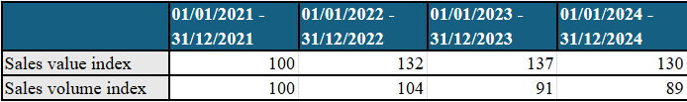

Output:
The output volume is stable from 2021 to 2022, following which there is also a consistent decline in output volume.
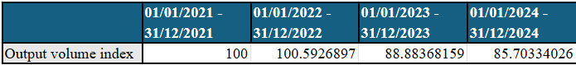

Profit:
Net operating profit after tax (NOPAT) from like goods fluctuated across periods one to three, but in period four (2024) there shows a steep drop on NOPAT. The reason for the increase of profit for 2023 (confidential information on business activities).

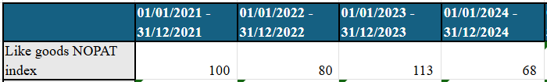

Wages:
Wages across the UK container glass industry have risen slightly between each period, however; this appears not to align with inflation. (Commercially sensitive comment on wages).

Market share:
The UK container glass market share for volume of glass dropped significantly from period 1 to period 2, where it has remained at a similar level for the following two periods (2023 & 2024). (Commercially sensitive comment on UK market share).

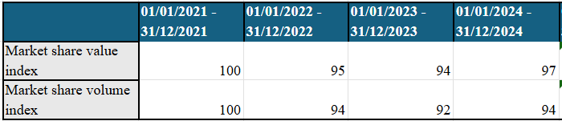

Production capacity:
Production capacity data is not available for the entire industry, (Confidential – commercially sensitive information on the status of the sector). If a furnace closes, then this will permanently reduce the amount of output the UK container glass industry is able to produce. Glass furnaces must remain active 24 hours a day and therefore cannot be turned off when demand reduces, therefore when furnaces are not producing at their full capacity the costs of running will remain higher compared to other industries.

      - Is your company suffering injury which you believe to have been caused by the imported goods? If so, please describe the injury. You may want to include the prices, volumes or profits associated with your production and sale of the goods you manufacture or describe other aspects of your business. Please specify and substantiate your claims with evidence. Please estimate the date when the injury began to affect your business. Explain how it has developed since this date.
(Confidential – commercially sensitive comment on the source of the data)

Sales:
Similar to full industry data, there is a consistent decline in sales volume, and value remains stable but has decreased over the previous two years. The increase in domestic sales value across periods 1 (2021) to 3 (2023) mirrors the data in output value below showing a necessity for sales prices to remain sustainable with the increasing costs of production. Domestic sales by volume also closely mirror the trends with the output volume data below.

The applicant has (confidential information on business activities).

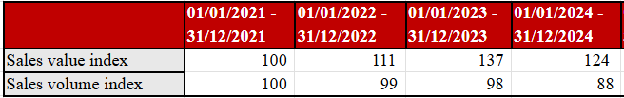

Output:
The output value shows a consistent increase across all periods showcasing the rise in cost for the production of like goods. Alongside which the output volume shows a consistent decline from period 2 (2022) to period 4 (2024). This shows evidence of how the cost to produce like goods is increasing yet production by volume is decreasing simultaneously, further showing a higher production cost per tonne of like goods. (confidential information on business activities) (see annex 10).

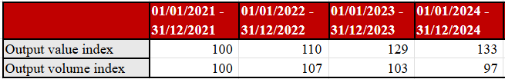

Profit:
Total net operating profit after tax (NOPAT) remained stable across the first three periods between 2021 and 2023, however there is a sharp NOPAT decline for period 4 (2024). The Average net operating profit after tax (NOPAT) margin from like goods (%) which based on target profit margins, are low throughout the entire period and see their steepest drops over period 4 and 5. The trends in profit, (confidential information on business activities).

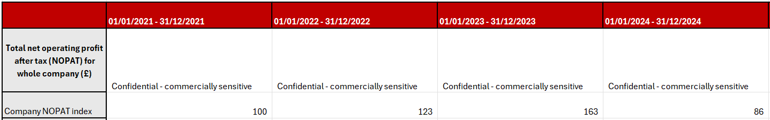

Market share:
The market share has fluctuated over the four periods with notable drops in period 2 (2022), and period 4 (2024).

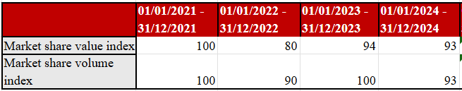

Employees & Productivity:
Number of employees rose yearly between 2021 and 2024, however; it is noted that (confidential information on business activities). Heads increased without impacting production output levels. (confidential information on business activities) the Average output in volume per employee for like goods (FTE) steadily declines across the whole period.
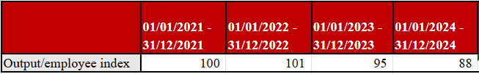

Production capacity:
Production capacity utilisation for like goods has decreased over periods 4 (2024) and 5 (2025) compared to previous periods which incurs the costs of production without profitable levels of output. The drops in production capacity utilisation into 2024 and 2025 is because (Confidential – commercially sensitive information) ultimately caused by cheaper imported Turkish and Chinese glass delivered to the UK market both directly and via distributors/wholesalers.

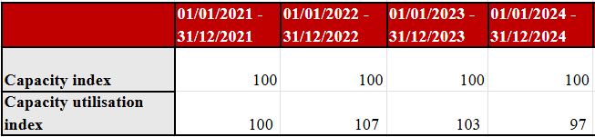

Stock:
Stocks remain relatively stable by volume across all periods, however; it can be seen that the value of stock across periods 2 to 5 has increased year on year evidencing the sales opportunities which have been taken away.

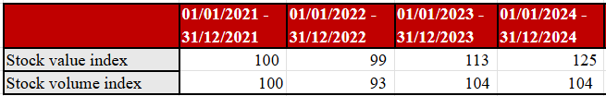

Cash flow:
Since period 2 (2022) Net cash flow for all goods (£) has significantly reduced.

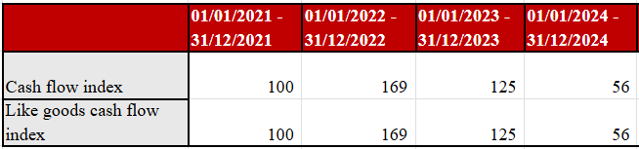

Wages:
Wages have declined from periods 1 & 2 to period 3, with a slight increase in periods 4 & 5. (Commercially sensitive comment on wages).

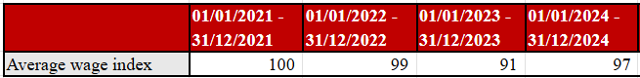

Investments:
The level of investment appears stable, other than period 3 (2023) which shows a large decline. Considering the UK glass industries commitment towards decarbonisation which would require the installation of the UKs first electric melting furnaces and the infrastructure to power them, the commitment for investment will have to be high.

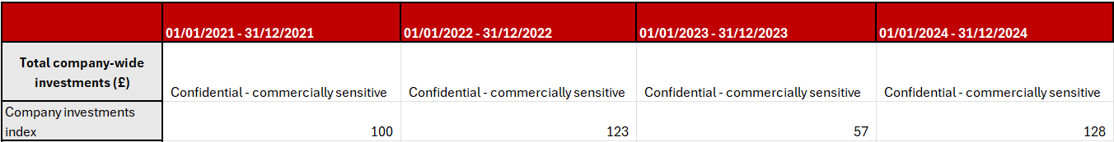

      - Report your total cost to make and sell like goods in the UK. Please clearly separate your costs of production (direct manufacturing costs and indirect costs), from your administrative, selling and general expenses (AS&G). Provide costs for each model that you produce. When giving your labour costs, please ensure you include all labour costs, directly or indirectly incurred by any activity related to the goods.
The cost of production for direct manufacturing was recently (Confidential – commercially sensitive) as indicated in the injury factors workbook under company output (£). The AS&G costs for the same period were (Confidential – commercially sensitive).

The following data shows the cost to produce some of the applicant's products:
(Confidential – commercially sensitive)

(Confidential – commercially sensitive photo of accounts removed)

      - For the goods that you produce, please state what level of profit, before tax and as a percentage of turnover, your company would expect to achieve if there was no injury from the imported goods and explain how you arrived at this figure.
The target profit margin for the applicant is 18% - 28% (non-confidential range), which is based on the need to invest heavily in replacement equipment such as electric furnaces. Existing furnaces run on natural gas and hold a lifecycle of around 15 years. Once existing UK container glass gas powered furnaces reach their end-of-life, plans are to install new electric furnaces which is a new technology to the industry and will demand investment through infrastructure in addition to the cost of equipment.

      - Explain if your current sales prices for the goods are the same as your target sales prices. If not, please explain the reasons for this.
The current sales prices for the applicant are on average (Confidential – commercially sensitive) per tonne of goods sold. The current target sales margin for [the applicant] is set as (Confidential – commercially sensitive) % which is currently not being met through the existing sales price per tonne. This is because [the applicant] must maintain their current sales price to remain competitive. Pricing is being eroded due to competition, including from imports, resulting in lower margins, which does not support the ability to make future investments.

      - Provide details of any price undercutting and and/or if the prices of the dumped and/or subsidised imports are reducing or negatively affecting prices in the UK. Compare the sales prices of the dumped and/or subsidised imports with the sales prices of your goods on the UK market. Include any supporting evidence.
As explained in question 5 above, the current sales prices for the applicant are on average (Confidential – commercially sensitive) per tonne of goods sold. Available import statistics from Turkey detailed in appendix I1 shows how over the same period Turkish container glass imports are entering the UK market at around £393.00 per tonne under the same like goods codes. This shows a clear disparity in the abilities between the applicant and Turkish container glass imports for allowing the applicant to operate in the UK container glass market on a fair and competitive basis. If the applicant were to even totally eradicate their sales margin they would still not be able to come close to matching the sales price of the subsidised Turkish imports entering the UK container glass market, showing a clear disparity in competitiveness.

Causal link between the imported goods and injury to your industry
For the TRA to initiate an investigation, there must be evidence of a causal relationship between the injury to the UK Industry and the alleged dumping and/or subsidisation.
      - If your company is suffering injury, please explain and provide evidence that shows how this has been caused by the goods you want us to investigate. Describe how the volumes and prices of the imported goods have affected your industry, basing your answer on the injury indicators in the previous section.
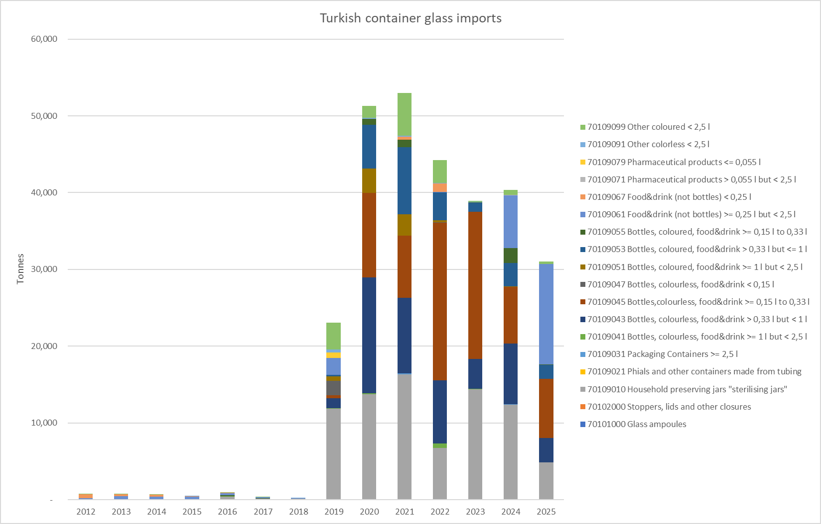
Mass:
The import of container glass from Turkey to the UK begin with any significance in 2019 which corresponds closely to the period of injury towards the UK container glass industry. Between 2021 and 2024 the sales and output of the applicant were at their lowest in 2021 which correlates to the peak of Turkish imports by mass. The figures for 2025 on the tonnages graph and value graph are up to July 2025 as per the availability of current data. When looking at tonnes of container glass imports from Turkey as of July 2025 it is evident that if imports for 2025 continue at their current rate, then they are on target to surpass the peak of import tonnages in 2021.

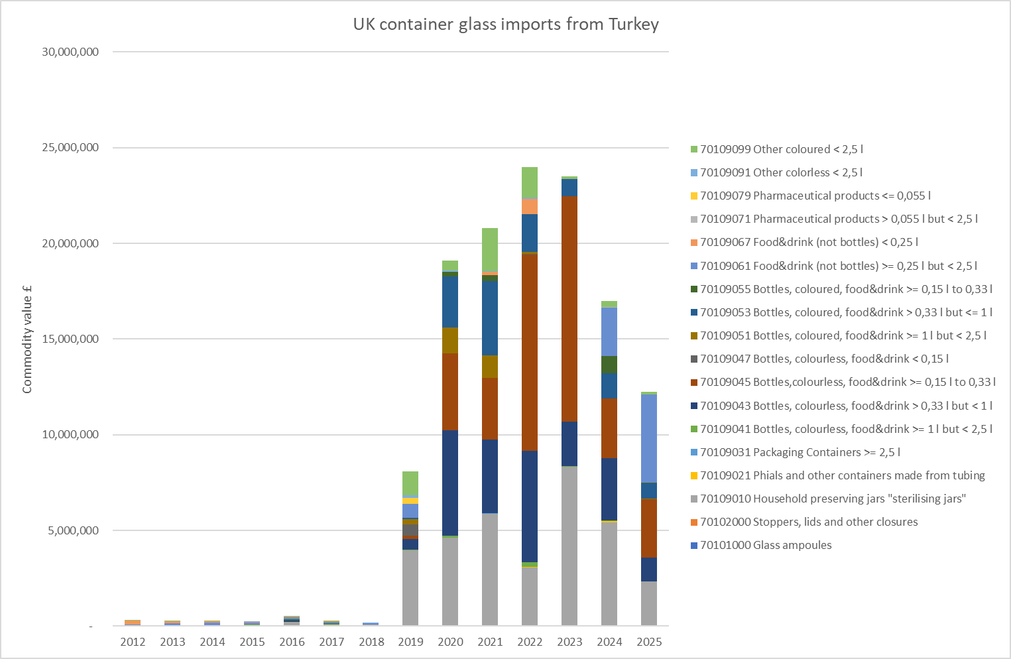
Value:
The value of Turkish container glass imports peaks in 2022 which is the same year the UK container glass industry as a collective, share their worst market share throughout periods one to four.

The following prices show the average value per tonne of container glass imports from Turkey to the UK based off publicly available imports data:

2021: £392.49 per tonne
2022: £540.80 per tonne
2023: £604.05 per tonne
2024: £420.83 per tonne
2025 (up to July): £393.29 per tonne

As established in question 6 of the Injury section, the prices above for imports of container glass from Turkey undercut the UK industry heavily, evidencing Turkey as the source of injury. Furthermore, (Confidential information on business activities) and therefore conclude that Turkish container glass imports are a direct source of injury to UK container glass manufacturers.

      - Please indicate if the injury to your industry could be attributable in part or in full to any factors other than dumped or subsidised imports, for example:
- volume and prices of imports not sold at dumped prices;
- contraction in demand or changes in patterns of consumption;
- restrictive trade practices of, and competition between, third country and UK producers;
- developments in technology; and
- export performance and the productivity of the UK industry.
- This may be relevant as an industry weakened by other events may be more susceptible to injury from dumped or subsidised goods.

      - Please provide evidence to support this information.

The UK demand for glass remains at a stable level putting full emphasis on the injury caused by subsidised imports opposed to any changes in internal consumer trends or demands. In addition to the injury, we believe the UK is suffering from Turkish subsidised imports, we also believe dumped imports from China have caused injury. An application has been submitted to the TRA to investigate this.
The UK container glass industry was not as negatively affected as other industries during the start of the COVID 19 pandemic. This was partly down to the increased demand for household food and beverages, and it is therefore believed that COVID 19 was not a source of injury for the UK container glass industry.
Technological developments are championed in the UKs container glass market, specifically in regards to decarbonisation and electrification as discussed previously within the application. Access to these technologies is fully available in the UK, provided the required profit margins are met to generate the necessary investment. We therefore believe that the UK industry’s technology is the same or at a higher level to that present in the Turkish industry.
Exports from the UK also remain at a consistent level.
We are not aware of any other current source of injury affecting the UK container glass industry.

Declaration
This application is made by, or on behalf of, a UK industry that produces like goods to those that are the subject of this application.
This UK industry has at least 1% market share, taking into account the goods and particular market for those goods.
This application has the support of that UK industry as required in the Trade Remedies (Dumping and Subsidisation) (EU Exit) Regulations 2019. Specifically, producer support for this application is greater than producer opposition and represents at least 25% of all UK production of the like goods.
The information contained in this application:
- provides evidence that goods have been or are being dumped and/or evidence that subsidised goods have been or are being imported into the UK (as per schedule 1(g) and 2(g) of the Trade Remedies (Dumping and Subsidisation) (EU Exit) Regulations 2019);
- provides evidence that the dumped and/or subsidised goods are causing injury to the UK industry (as per schedule 1(i) and 2(i) of the Trade Remedies (Dumping and Subsidisation) (EU Exit) Regulations 2019);
- is sufficient to initiate an anti-dumping and/or subsidy investigation as per schedule 4 paragraph 9(1)(b) of the Taxation (Cross-border Trade) Act 2018; and
- is accurate and complete.

Name: | (Confidential – personal information)
Company/Association: | (Confidential – personal information)
Position: | (Confidential – personal information)
Company Registration number (if applicable): | (Confidential – personal information)
Date: | 24/10/2025
Signature: | (Confidential – personal information)

Checklist
Important
Please ensure that you have completed this application fully and refer to any attached documents using the corresponding appendix reference.
Complete the checklist above, to demonstrate you have covered all of the points, and attach evidence to support your claims and calculations.
Keep a copy of this application for your reference in case any queries arise when we are assessing the application. You will also need to refer to it if we initiate an investigation.
- The details of the UK producers making the application and level of UK industry support for the application
- The details of all known UK producers/associations of UK producers of like goods
- The volume and value of the domestic production of the like goods both by producers making the application and all other known UK producers
- Information that the market share requirement is met
- A complete description of the imported goods
- The names of countries/territories of origin and export of the imported goods
- The details of the exporters or overseas producers of the imported goods
- The details of the companies or individuals known to be importing the goods
- Normal values of the goods Dumping applications only
- Export prices of the goods Dumping applications only
- Details of subsidy programmes associated with the imported goods Subsidy applications only
- The amount of countervailable subsidy attributable to the alleged subsidised goods imported into the UK Subsidy applications only
- Changes in import volumes of the goods
- Effects of the imported goods on prices of like goods produced in the UK
- Impact of the imports have caused to the UK industry

https://www.invest.gov.tr/en/investmentguide/pages/investment-zones.aspx https://ozbekcpa.com/organized-industrial-zones-in-turkey/ https://www.berkerberker.com/en/organized-industrial-zones-under-turkish-law/
Appendix F3 OIZ Law 4562
Appendix F1 Turkey glass sites and regions info
https://www.trade.gov.tr/investment/schemes/regional-investments
https://www.trade.gov.tr/free-zones/advantages-of-the-turkish-free-zones
http://www.lawsturkey.com/law/free-zones-law-3218?s=OSB+regulation#
https://mfylegal.av.tr/en/articles/turkey-vat-exemption-real-estate-purchase/#:~:text=The%20VAT%20applicable%20to%20the,20%25%20VAT%20is%20usually%20applied
https://immigrantinvest.com/blog/taxes-in-turkey/
https://www.invest.gov.tr/en/investmentguide/pages/cost-of-doing-business.aspx
This is based on an estimated bulk discount of 10 to 20 % for an OIZ. Although the government website states that gas prices are the same within or outside of an OIZ, other Turkish Government websites explicitly mention that OIZs attract lower utility costs including natural gas (https://www.invest.gov.tr/en/investmentguide/pages/investment-zones.aspx ). This is likely due to OIZs being able to negotiate preferential rates. Given the size of these zones we have estimated that this will be between 10 to 20 % discount on standard industrial gas prices.
https://www.mordorintelligence.com/industry-reports/turkey-container-glass-market
https://www.trade.gov.tr/investment/schemes/regional-investments
https://www.trade.gov.tr/investment/schemes/regional-investments
https://www.globalvatcompliance.com/vat-rates-in-turkey/#:~:text=Turkey%20applies%20a%20standard%20VAT%20rate%20of%2020%25
https://taxsummaries.pwc.com/turkey/corporate/taxes-on-corporate-income
https://www.cottgroup.com/en/payroll-calculation-in-turkey#:~:text=The%20employee%20and%20employer%20contributions%2C%20which%20are%20the%20components%20of,day%20of%20the%20following%20month
https://tradingeconomics.com/turkey/interest-rate#:~:text=September%20of%202025.-,The%20benchmark%20interest%20rate%20in%20Turkey%20was%20last%20recorded%20at,macro%20models%20and%20analysts%20expectations
https://www.hornglass.com/company/news/detail/largest-end-fired-furnace-supplied-by-horn-1854-m2
https://www.kap.org.tr/en/sirket-bilgileri/ozet/1087-turkiye-sise-ve-cam-fabrikalari-a-s
https://www.trade.gov.tr/investment/schemes/regional-investments; https://www.trade.gov.tr/free-zones/general-outlook ; https://www.invest.gov.tr/en/investmentguide/pages/investment-zones.aspx
https://parkcam.com.tr/wp-content/uploads/2024/09/2023-Park-Cam-Sustainability-Report_brr.pdf
https://www.kap.org.tr/en/sirket-bilgileri/ozet/1087-turkiye-sise-ve-cam-fabrikalari-a-s
We recognise that we do not know if the reported aid was allocated on a specific basis (and is therefore countervailable); however, whether or not this amount is included still leaves the amount above the 2% subsidy rate.

