TB0008 & TD0009 Request for Information Response, Brett Martin Daylight Systems
05/01/2022 - This document is not confidential.

We are responding to the TRA request for further submissions regarding the characteristics of the goods subject to review, as follows

Product Group A - Chopped glass fibre strands, of a length of not more than 50 mm
We have no further submission to make regarding these products

Product Group B – Glass fibre rovings
There are significant differences in manufacture, and application, between the 3 products shown:
- Assembled rovings (Product Control Number: ROAS)
- Direct rovings (Product Control Number: RODI)
- Volumenised direct rovings (Product Control Number: ROVD)
These differences affect both cost of manufacture, and suitability for various applications: they are not interchangeable due to the differences in physical make-up.
All glass fibre rovings are manufactured by drawing liquid glass from a furnace through micro-bushings where it is cooled to produce extremely fine glass fibre filaments, then coating it with a ‘size’ to provide cohesion and protect against abrasion, then bundling a large number of parallel filaments together into a roving. The diameter of each filament is measured in micron, and the weight of the roving is defined by ‘tex’, which is the weight per 1000 metres of roving (in grams).
RODI Direct rovings are produced by pulling individual filaments together directly from the bushing to form a single strand roving which is wound into the finished product in a single stage process. Filament diameter is typically 15-24 micron filament assembled and the weight of the finished roving (single strand) is at least 300 (typically 400-9600) tex (grams/1000linear metres) in a single strand.
In contrast ROAS Assembled rovings are manufactured in a 2-stage process. Firstly, filaments of a smaller diameter (typically 10-15 micron), and in lower quantity, are pulled together from the bushing to form a smaller strand, typically 40-50 tex (maximum 80), often referred to as ‘split tex’. In a separate second stage process, a number of these strands (typically 40-60 strands) are then brought together to create the final finished roving, typically with a weight of 2400tex.
ROVD are a specialised form of direct rovings, with air blown to create loops and texture in the strands.
ROAS assembled rovings are more complex to make and typically more expensive than RODI direct rovings (as the smaller filament diameter gives poorer yield from each micro bushing, and manufacture is a two stage process), and can be more difficult to process (sometimes suffering from catenary problems where there is different tension in the different strands)
ROAS assembled and RODI direct rovings offer different final product properties. They are typically chopped into short (25-50mm) lengths during manufacture of the finished product.
Since RODI direct rovings are wound into a single strand, they are firmer like a rope or wire, and do not break apart when cut. They are used in a variety of manufacturing processes (e.g. weaving, filament winding, pultrusion) to fabricate products such as pipes, turbine blades for wind energy, window and door frames, ladder rails or tool handles.
In contrast, as soon as ROAS assembled rovings are cut during the manufacture of finished product, they rapidly split apart back down into the very fine 60-80 split-tex strands. This, in conjunction with the smaller filament size, can offer better wet-out which can give better mechanical properties. Assembled rovings are essential wherever it is important that the full roving is broken down before being laminated into the final product – this includes all transparent products, to assist light transmission and ensure the full roving is not visible. Direct rovings simply will not work in these applications.
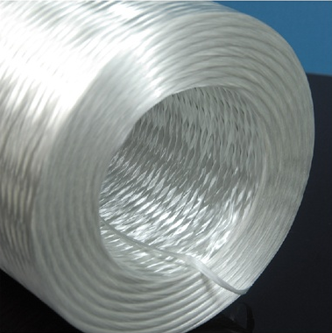 | 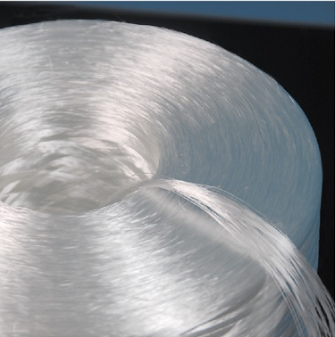
RODI direct roving showing a tight strand and rope-like appearance on end of reel. | ROAS assembled roving begins to splay apart into finer strands as it unwinds.

Whilst each type of roving may have similar weight, the key differentiator is that assembled rovings are fabricated from a large number (typically 40-60) of separate strands, each with a maximum weight of 80 tex, whilst direct rovings are formed from a single strand, with a minimum weight of 300 tex.
There is no UK based manufacturer of ROAS assembled rovings, nor of any glass fibre product suitable for use in translucent products where high light transmission and clarity are important requirements, for example in rooflights typically used in all industrial and storage buildings.

Product Group C - Mats made of glass fibre filaments
There are significant differences in manufacture, and application, between the 4 products shown:
- Chopped strand mats with emulsion binder (MCSE)
- Chopped strand mats with powder binder (MCSP)
- Continuous filament mats with emulsion binder (MCFE)
- Continuous filament mats with powder binder (MCFP)
There are 2 differences: the type of glass (chopped strands or continuous filament), and how the glass fibres are held together into a mat (emulsion or powder binder), and again these difference give different properties, and the products are generally not interchangeable.
Emulsion binder is more robust and creates a much stronger mat, and is essential wherever mat strength is important (including, for example, any hand lay-up application where mat is pushed into the resin by hand: an emulsion bound mat would simply break up and the rovings would all move out of position).
However, emulsion binder is not suitable for use in any translucent product as it would be visible and dramatically reduce light transmission; powder binder (which doesn’t hold the mat together as well, but disappears when the mat is wet out into resin) is essential for such applications
Continuous filament mats typically create a weave of uncut glass filaments. They are typically thicker direct roving filaments and can offer greater tensile strength (especially in the direction of woven fibres). However they are visible as a weave in a transparent sheet, and significantly reduce overall light transmission.
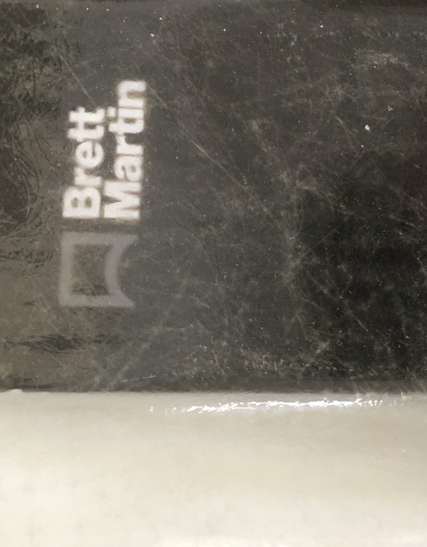 | 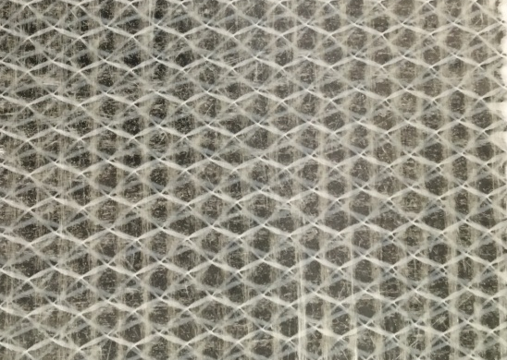
Image of transparent sheet using ROAS assembled roving (positioned in this photo over a printed company logo to illustrate clarity)  Individual strands are scattered and very thin making them difficult to see, consequently giving high light transmission. | Image of transparent sheet using MCFP continuous filament mat – this mat uses direct rovings visible as vertical lines, and only transmits any light because the mat holds these rovings apart (with the ‘honeycomb’ white stitching).  This sheet also uses ROAS assembled rovings to ensure continuous fibre coverage around the direct rovings in the mat while allowing light transmission.

